Data Mining Lab Book

### Name:- Pranav Balasaheb Bhosale

### PRN:- 2019BTEIT00038

### Class: Final Year-IT-Sem I (2022-2023)

| **Sr. No** | **Title** | **Date** | **Page No.** |
| --- | --- | --- | --- |
| 1. | Study and use of different types of graphs and charts  (use MS-XLS). | 24/08/2022 | 1 |
| 2. | Perform Normalization of data  (Min-max and Z-score). | 07/09/2022 | 6 |
| 3. | Find Info Gain of an attribute from given data. | 14/09/2022 | 15 |
| 4. | Find t and d weight of a data. | 21/09/2022 | 23 |
| 5. | Find 5 no summary of a dataset. | 28/09/2022 | 27 |
| 6. | Find frequent item sets from given transaction data. | 19/09/2022 | 33 |
| 7. | Extend program 6, to find association rules. | 26/09/2022 | 44 |
| 8. | Find correlation between items/entities. | 02/11/2022 | 56 |
| 9. | Distance and cluster | 02/11/2022 | 60 |
| 10. | Agglomerative Hierarchical Single Linkage Clustering | 09/11/2022 | 66 |
| 11. | Attribute for classification A. Gain B. Gini index | 16/11/2022 | 77 |
| 12. | WAP for Bayes classification | 23/11/2022 | 85 |
| 13. | WAP a program to implement any DM concept on complex data type | 30/11/2022 | 92 |
| 14. | Lab assignment: Top SUVs Data | 09/11/2022 | 94 |

## Experiment No 1

**Study and use different types of graphs and charts (use MS-XLS).**

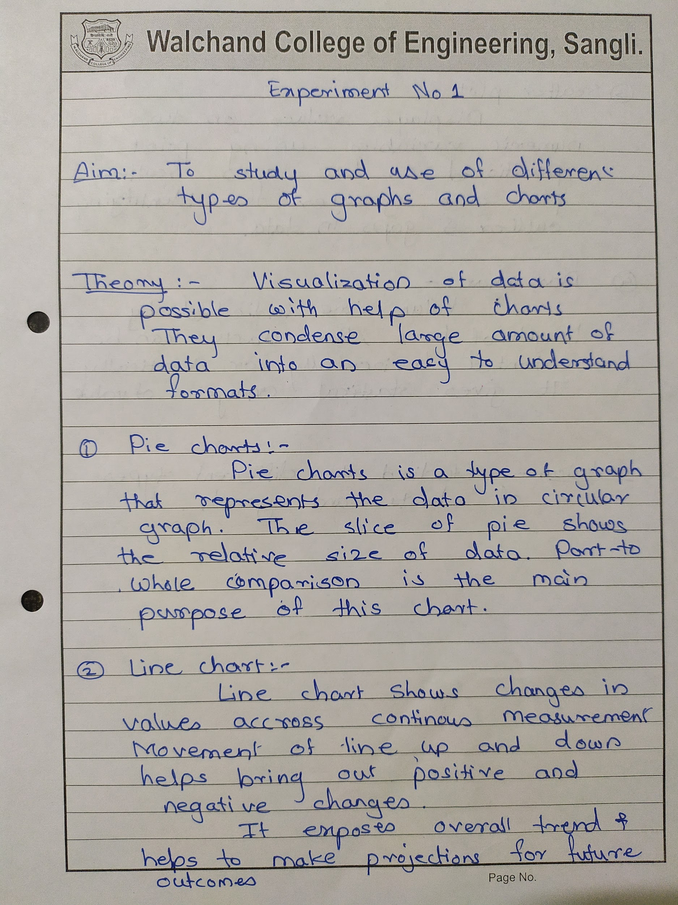

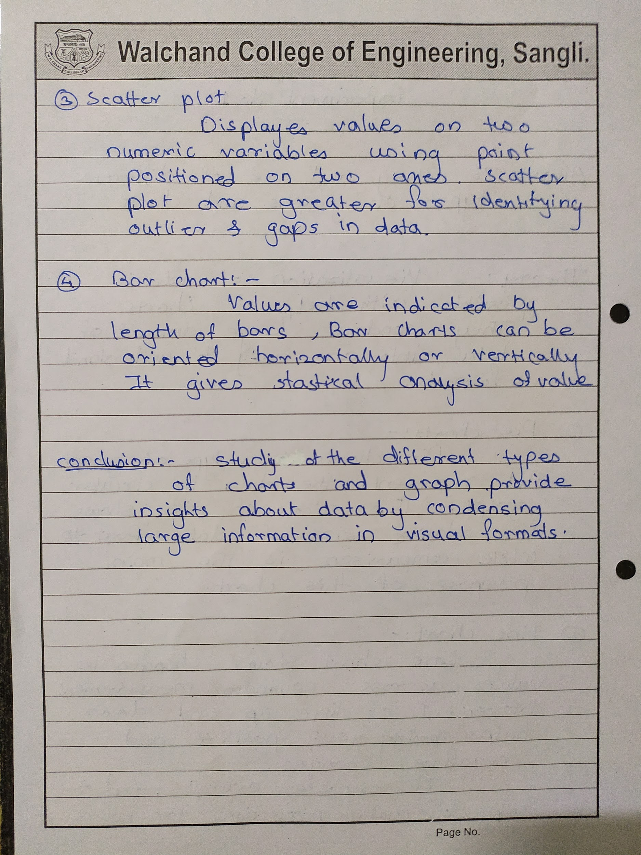

**Data set:-** English Letter Frequency (based on a sample of 40,000 words)

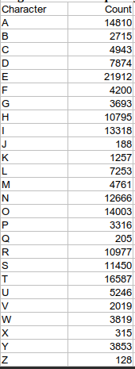

**Pie chart:-**

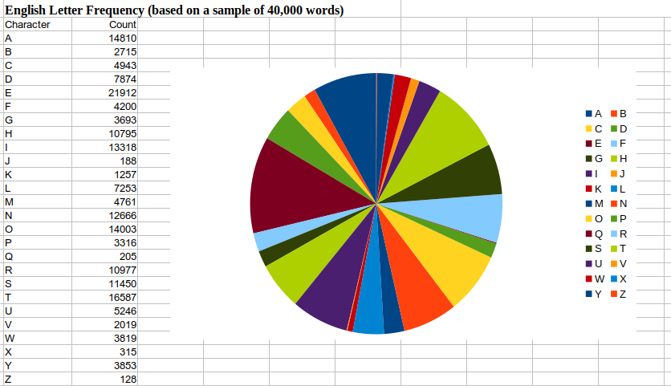

**Line Chart:-**

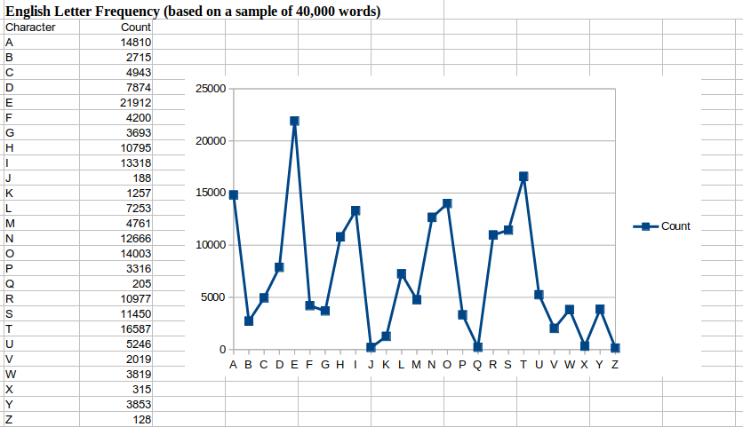

**Scatter Chart:-**

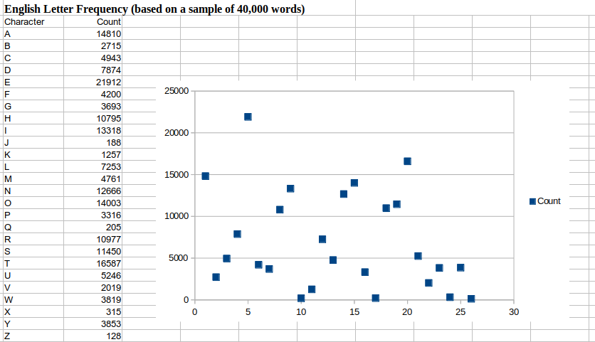

**Bar Chart:-**

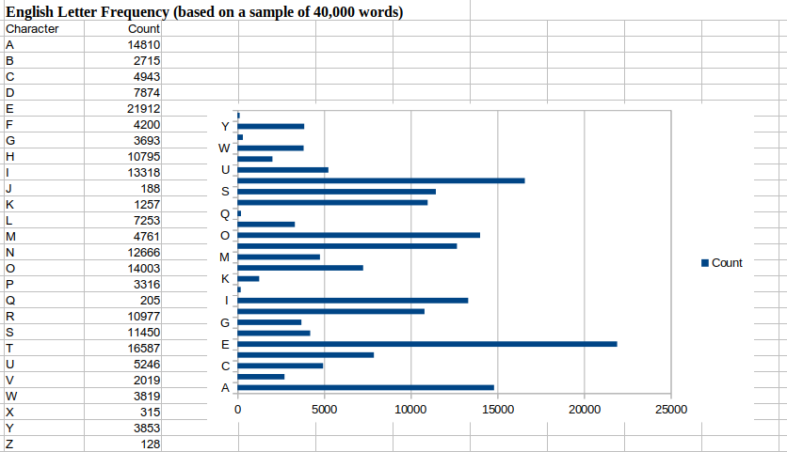

**Conclusion:-**

Graphs and charts are the best way to visualize large data. Different types of Graphs focus on particular feature comparison of data. They condense large information into easy-to-understand visual formats to provide important data insights.

## Experiment No 2

**Perform Normalization of data (Min-max and Z-score)**

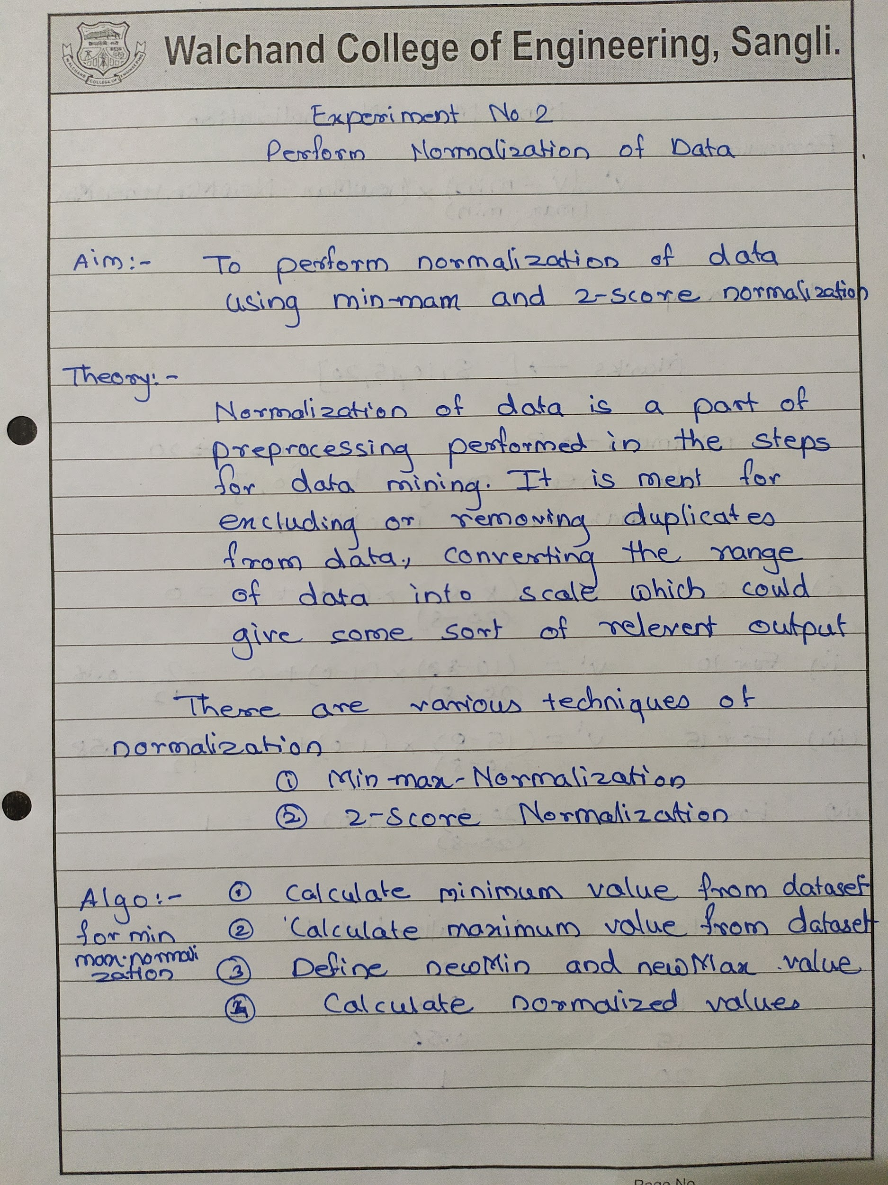

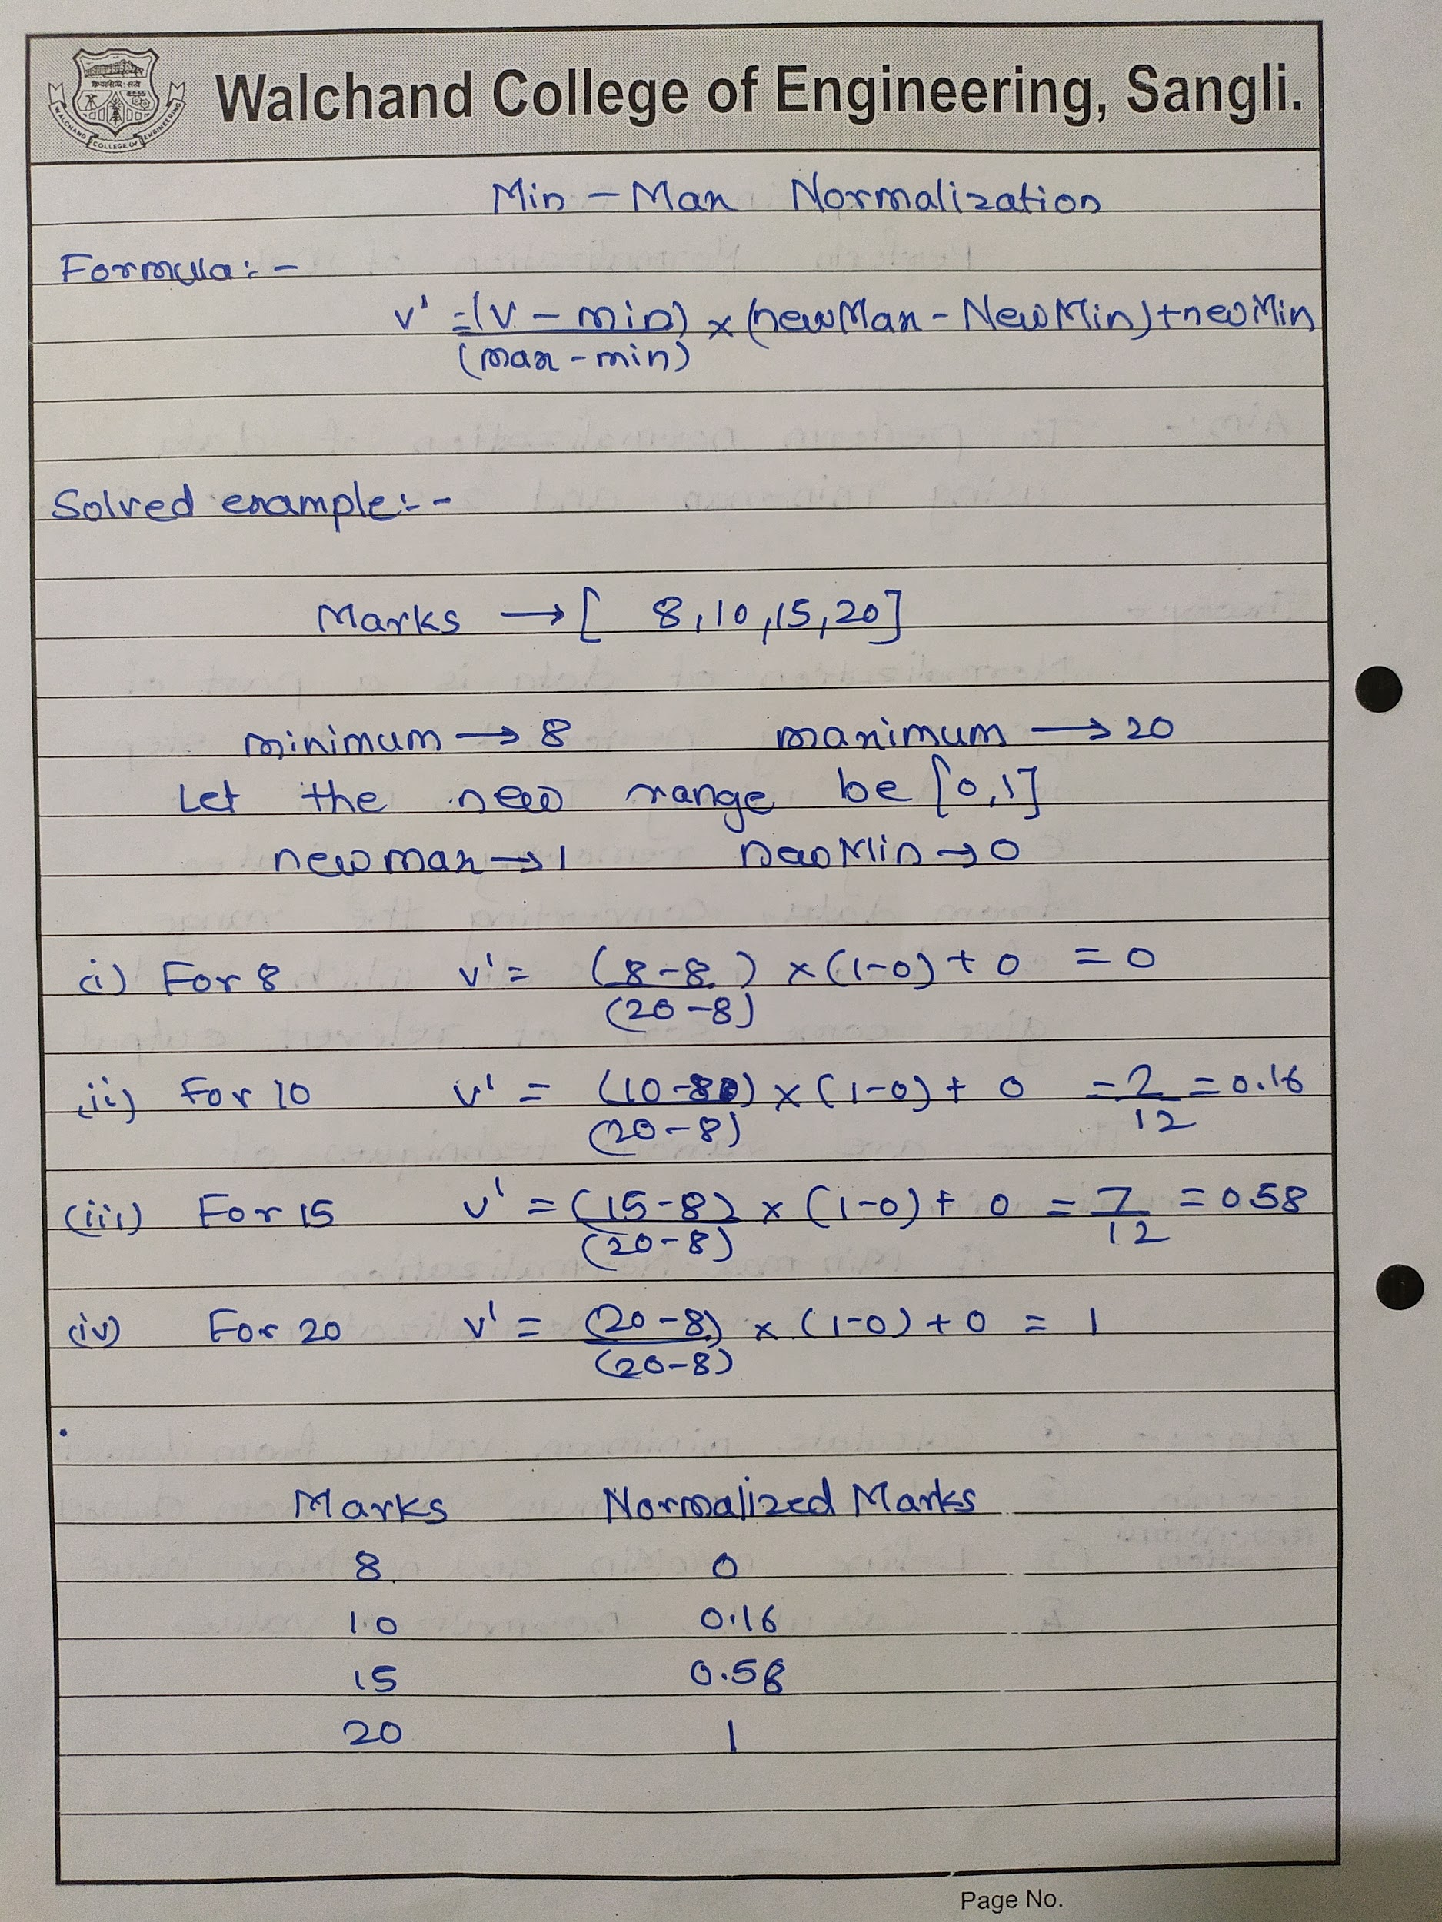

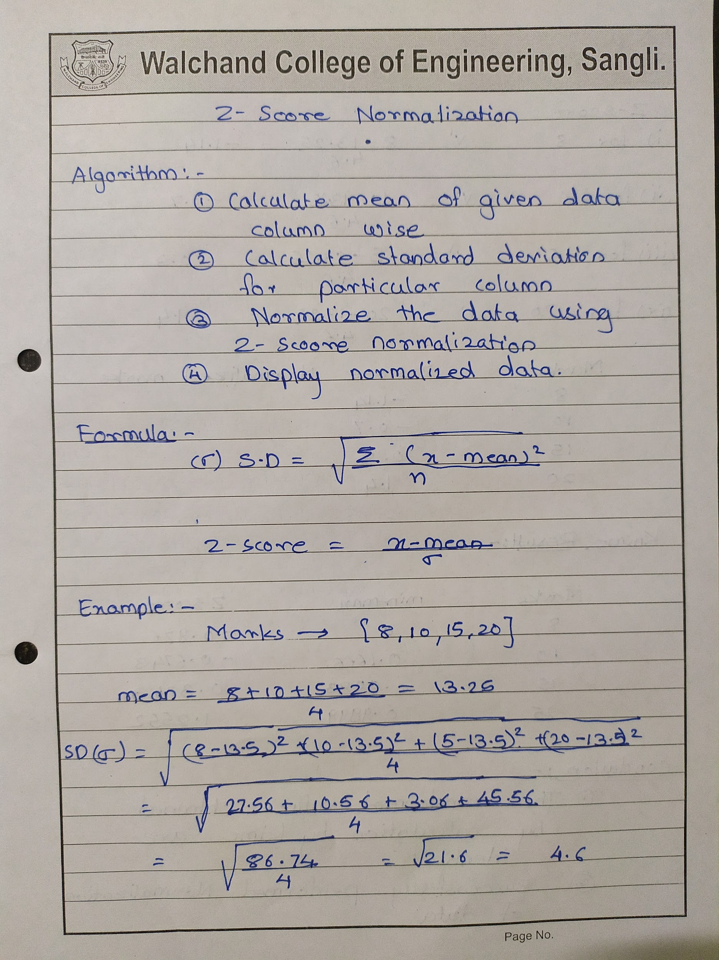

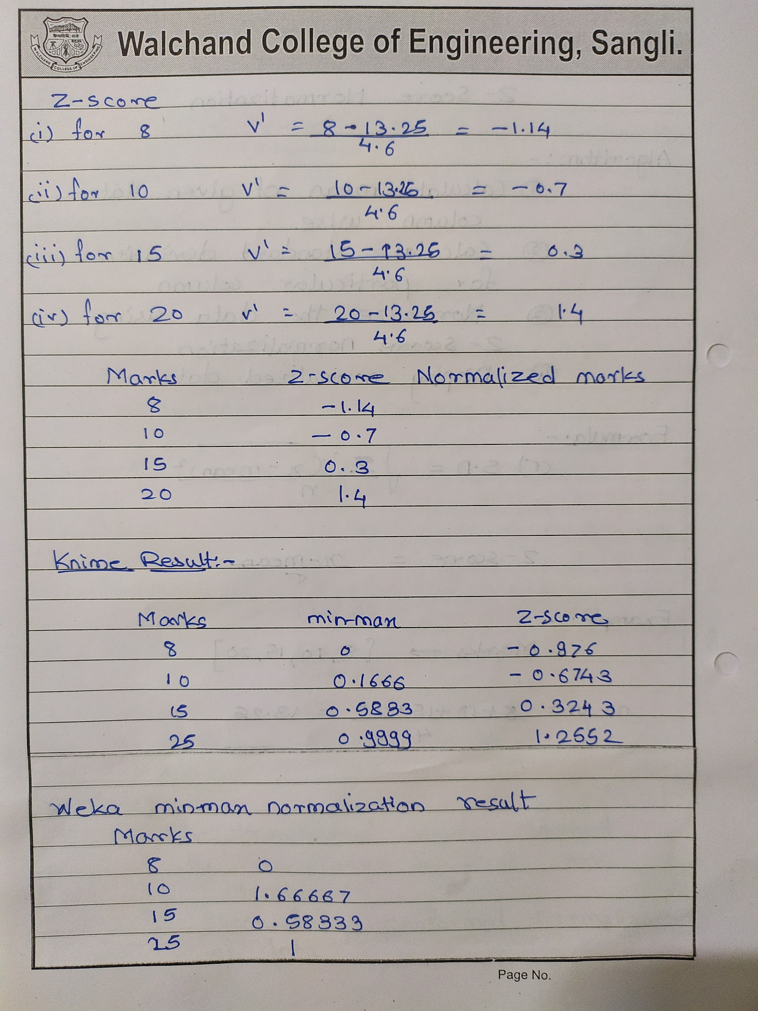

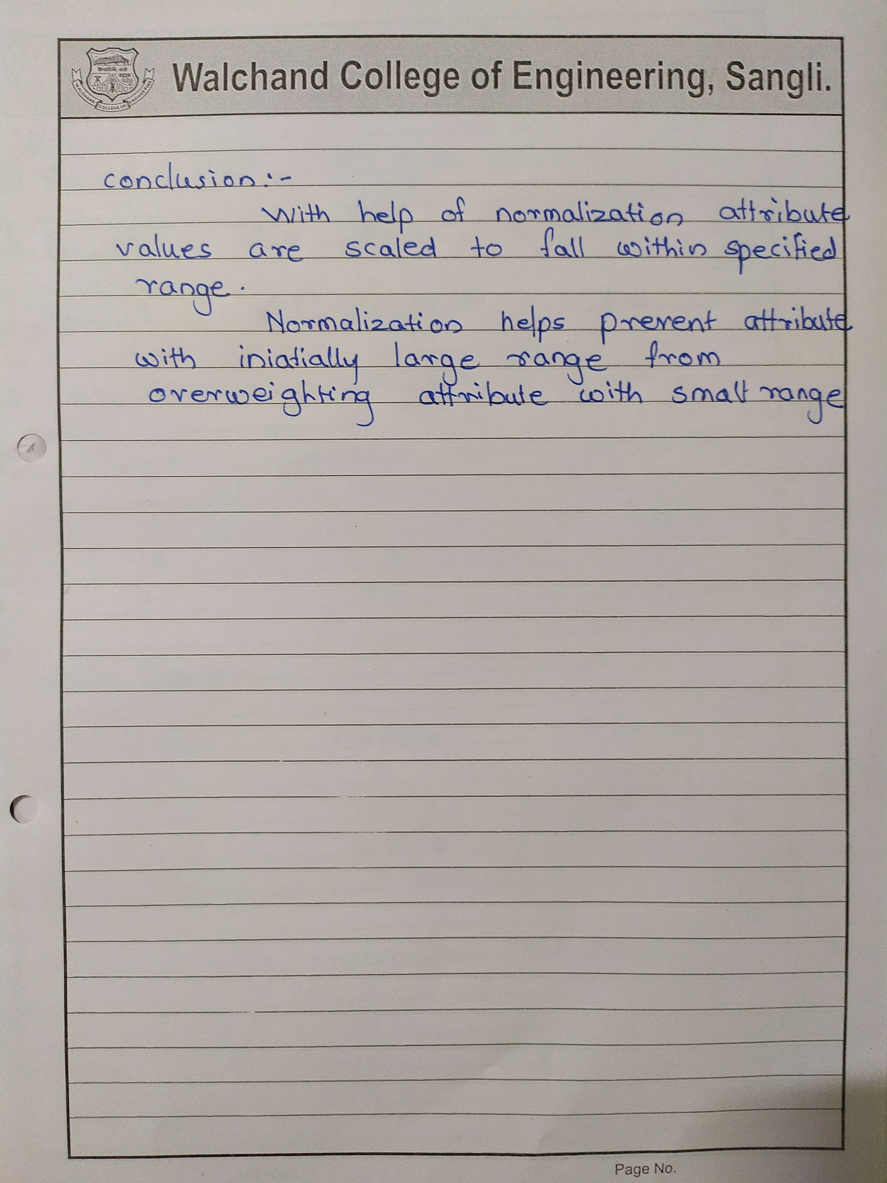

**Code:-**

const prompt = require("prompt-sync")();

const xlsx = require("xlsx");

//Reading the input file

var wb = xlsx.readFile("data.xlsx");

var ws = wb.Sheets["Student_Data"];

var data = xlsx.utils.sheet_to_json(ws);

var old_min = Number.POSITIVE_INFINITY,

old_max = Number.NEGATIVE_INFINITY;

//Finding old_min and old_max values min max normalization

for (let i = 0; i < data.length; i++) {

old_min = Math.min(old_min, data[i].Marks);

old_max = Math.max(old_max, data[i].Marks);

}

//Taking the new range of scale formin max normalization

console.log("Enter New Range For Marks ");

var new_min = parseInt(prompt("From : "));

var new_max = parseInt(prompt("To : "));

//Calculating normalized data min max normalization

var newData = data.map(function (record) {

record.min_max_normalized_marks =

((record.Marks - old_min) / (old_max - old_min)) * (new_max - new_min) +

new_min;

record.min_max_normalized_marks = record.min_max_normalized_marks.toFixed(2); //round off to two decimal digits

return record;

});

//Z -score Normalization

let n = data.length;

let sum = 0;

// calculating mean

for (let i = 0; i < data.length; i++) {

sum += data[i].Marks;

}

var mean = sum / n;

// calculating standard deviation

var sd_sum = 0;

for (let i = 0; i < data.length; i++) {

sd_sum += (data[i].Marks - mean) * (data[i].Marks - mean);

}

var std_dev = Math.sqrt(sd_sum / n);

std_dev = std_dev.toFixed(2);

// calculating z-score normalized value

var newData = data.map(function (record) {

record.zscore_normalized_marks = ((record.Marks - mean) / std_dev).toFixed(2);

return record;

});

console.log(newData);

//Creating and writing data to the result file for min max normalization and z score

var newWB = xlsx.utils.book_new();

var newWS = xlsx.utils.json_to_sheet(newData);

xlsx.utils.book_append_sheet(newWB, newWS, "Normalized Student Data");

xlsx.writeFile(newWB, "Normalized_Data.xlsx");

**Input file:**

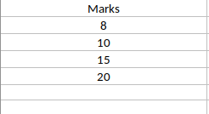

**Output file :**

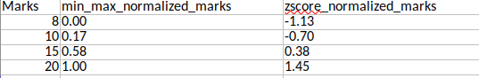

**Knime result :**

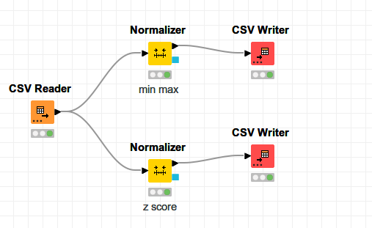

**Knime Min-max normalization**

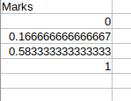

**Knime Z-score normalization**

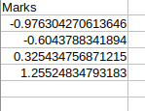

**Weka Min-Max normalization**

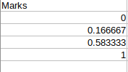

**Conclusion:**

Transformed values obtained by calculations and knime and weka are identical.

Successfully performed normalization of given data using min-max and z-score normalization.

## Experiment No 3

**Find Info Gain of an attribute from given data.**

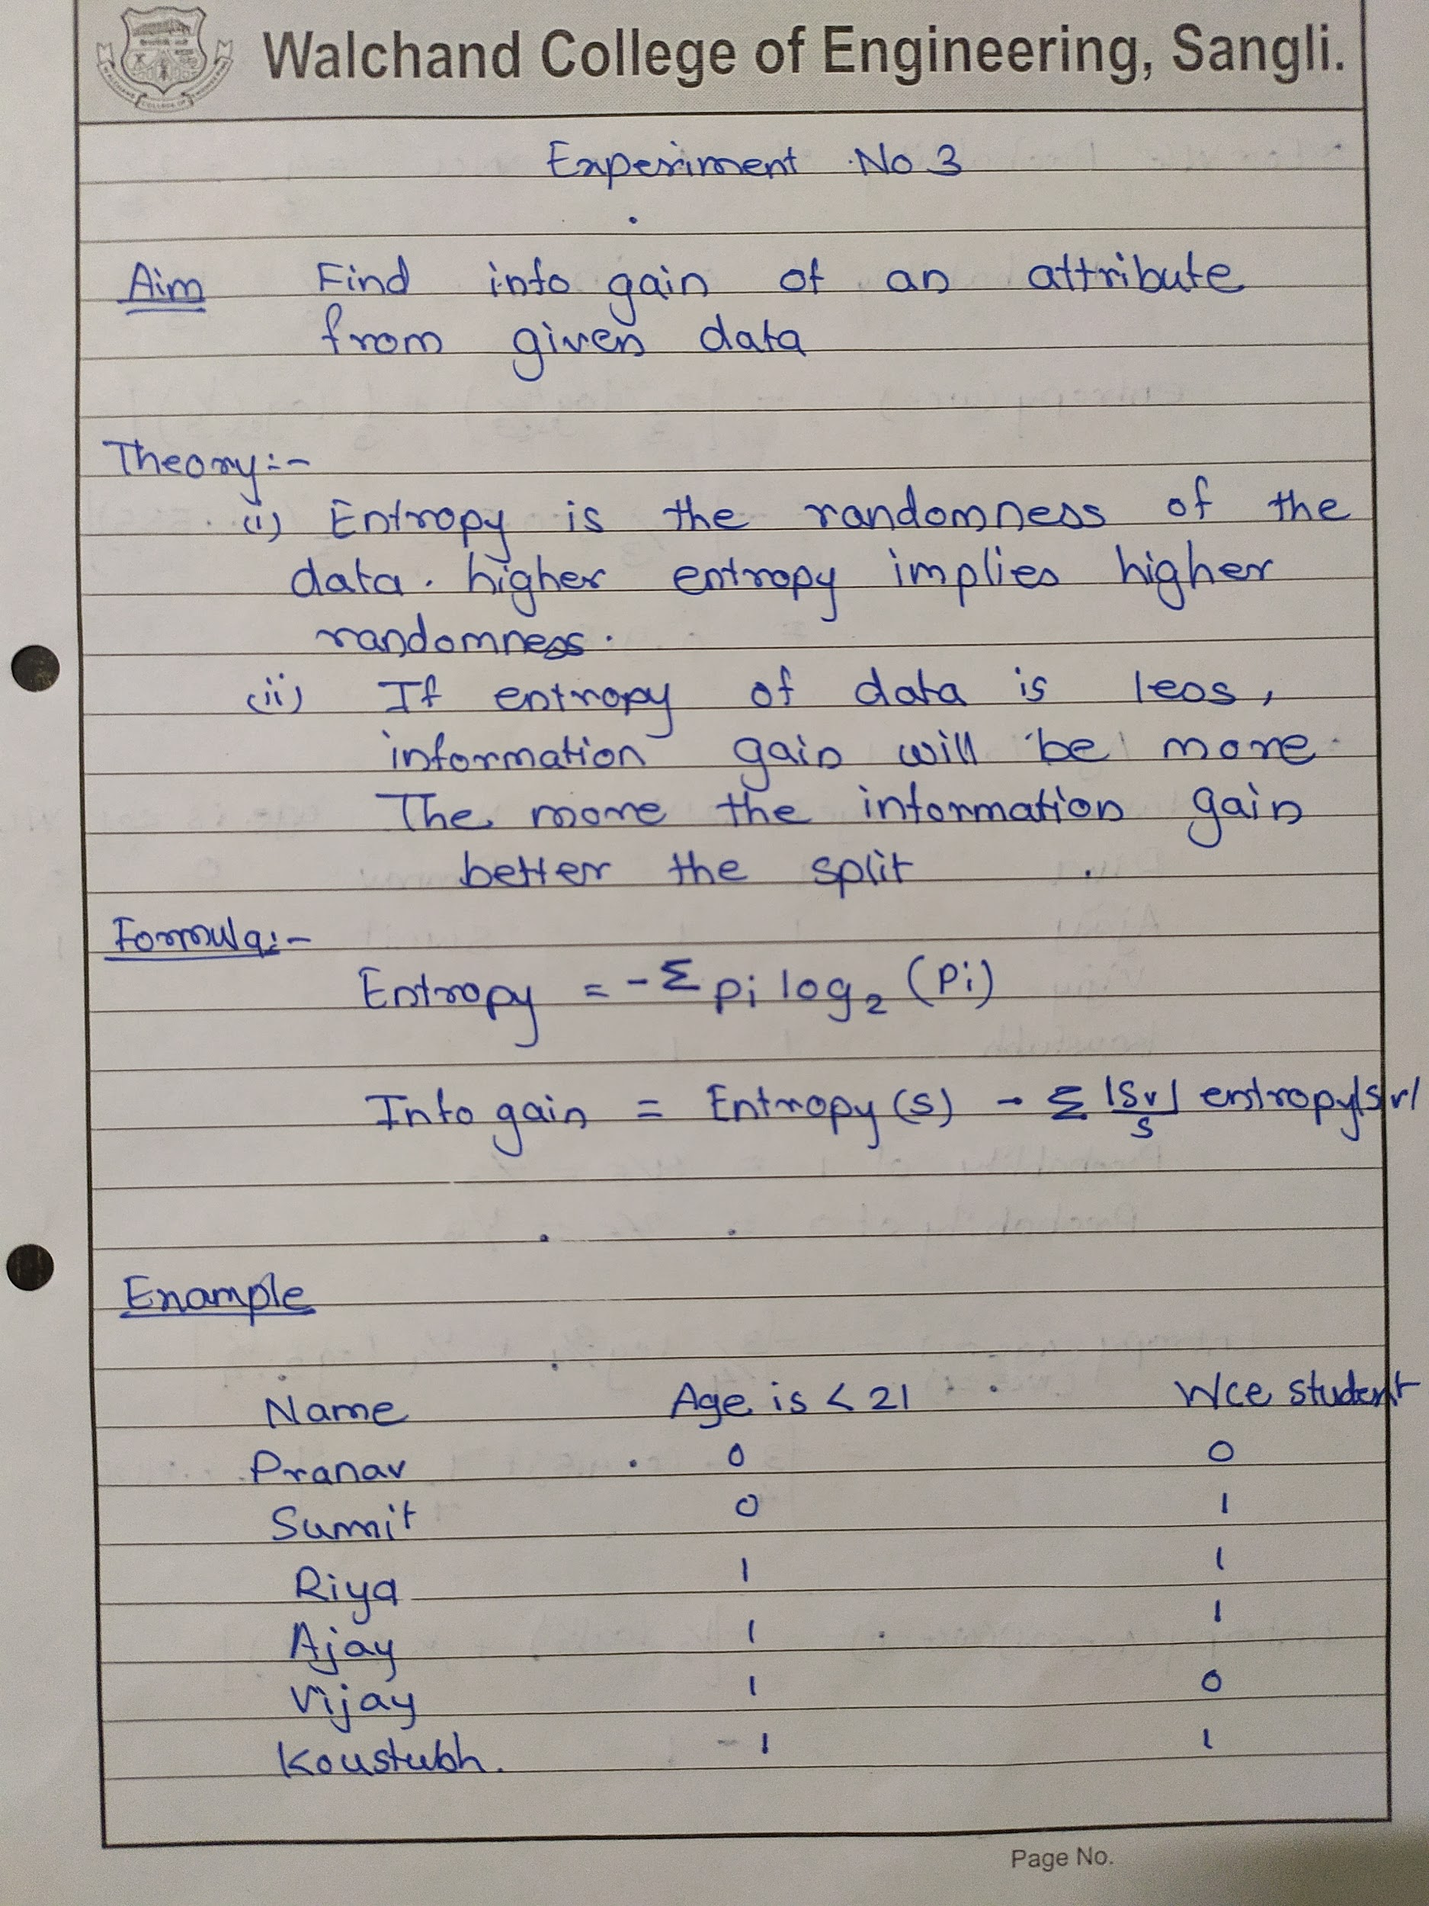

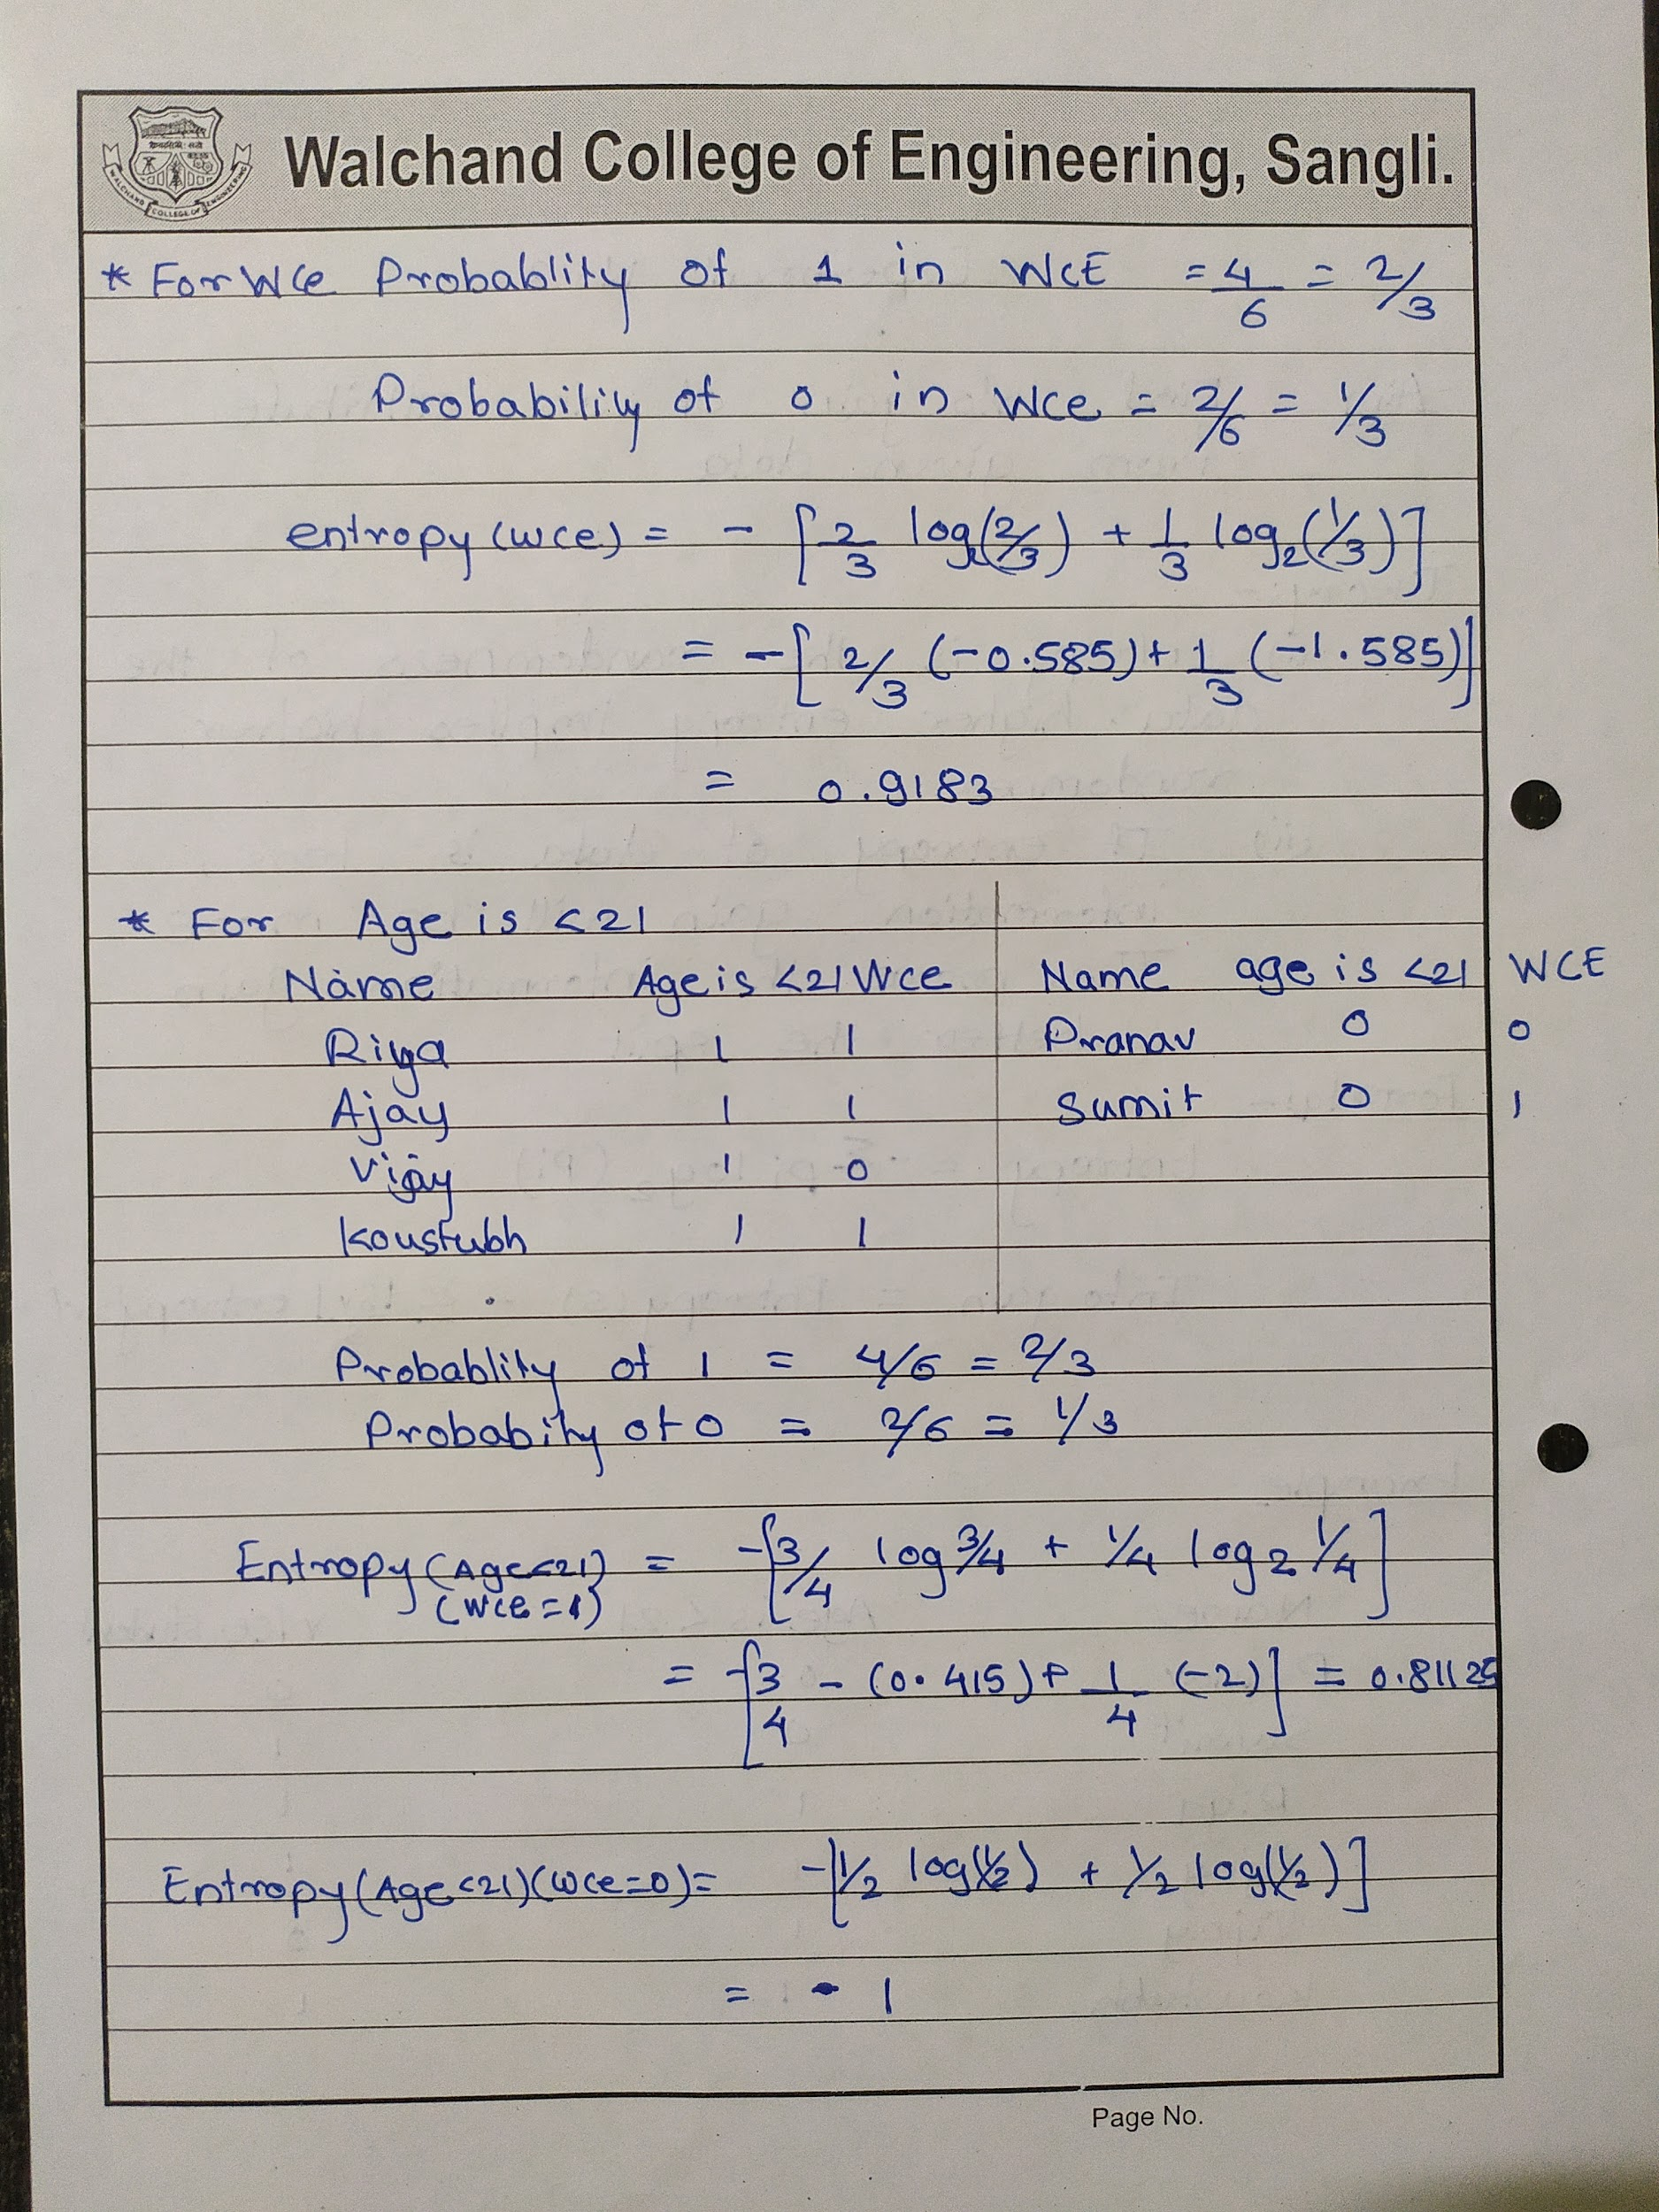

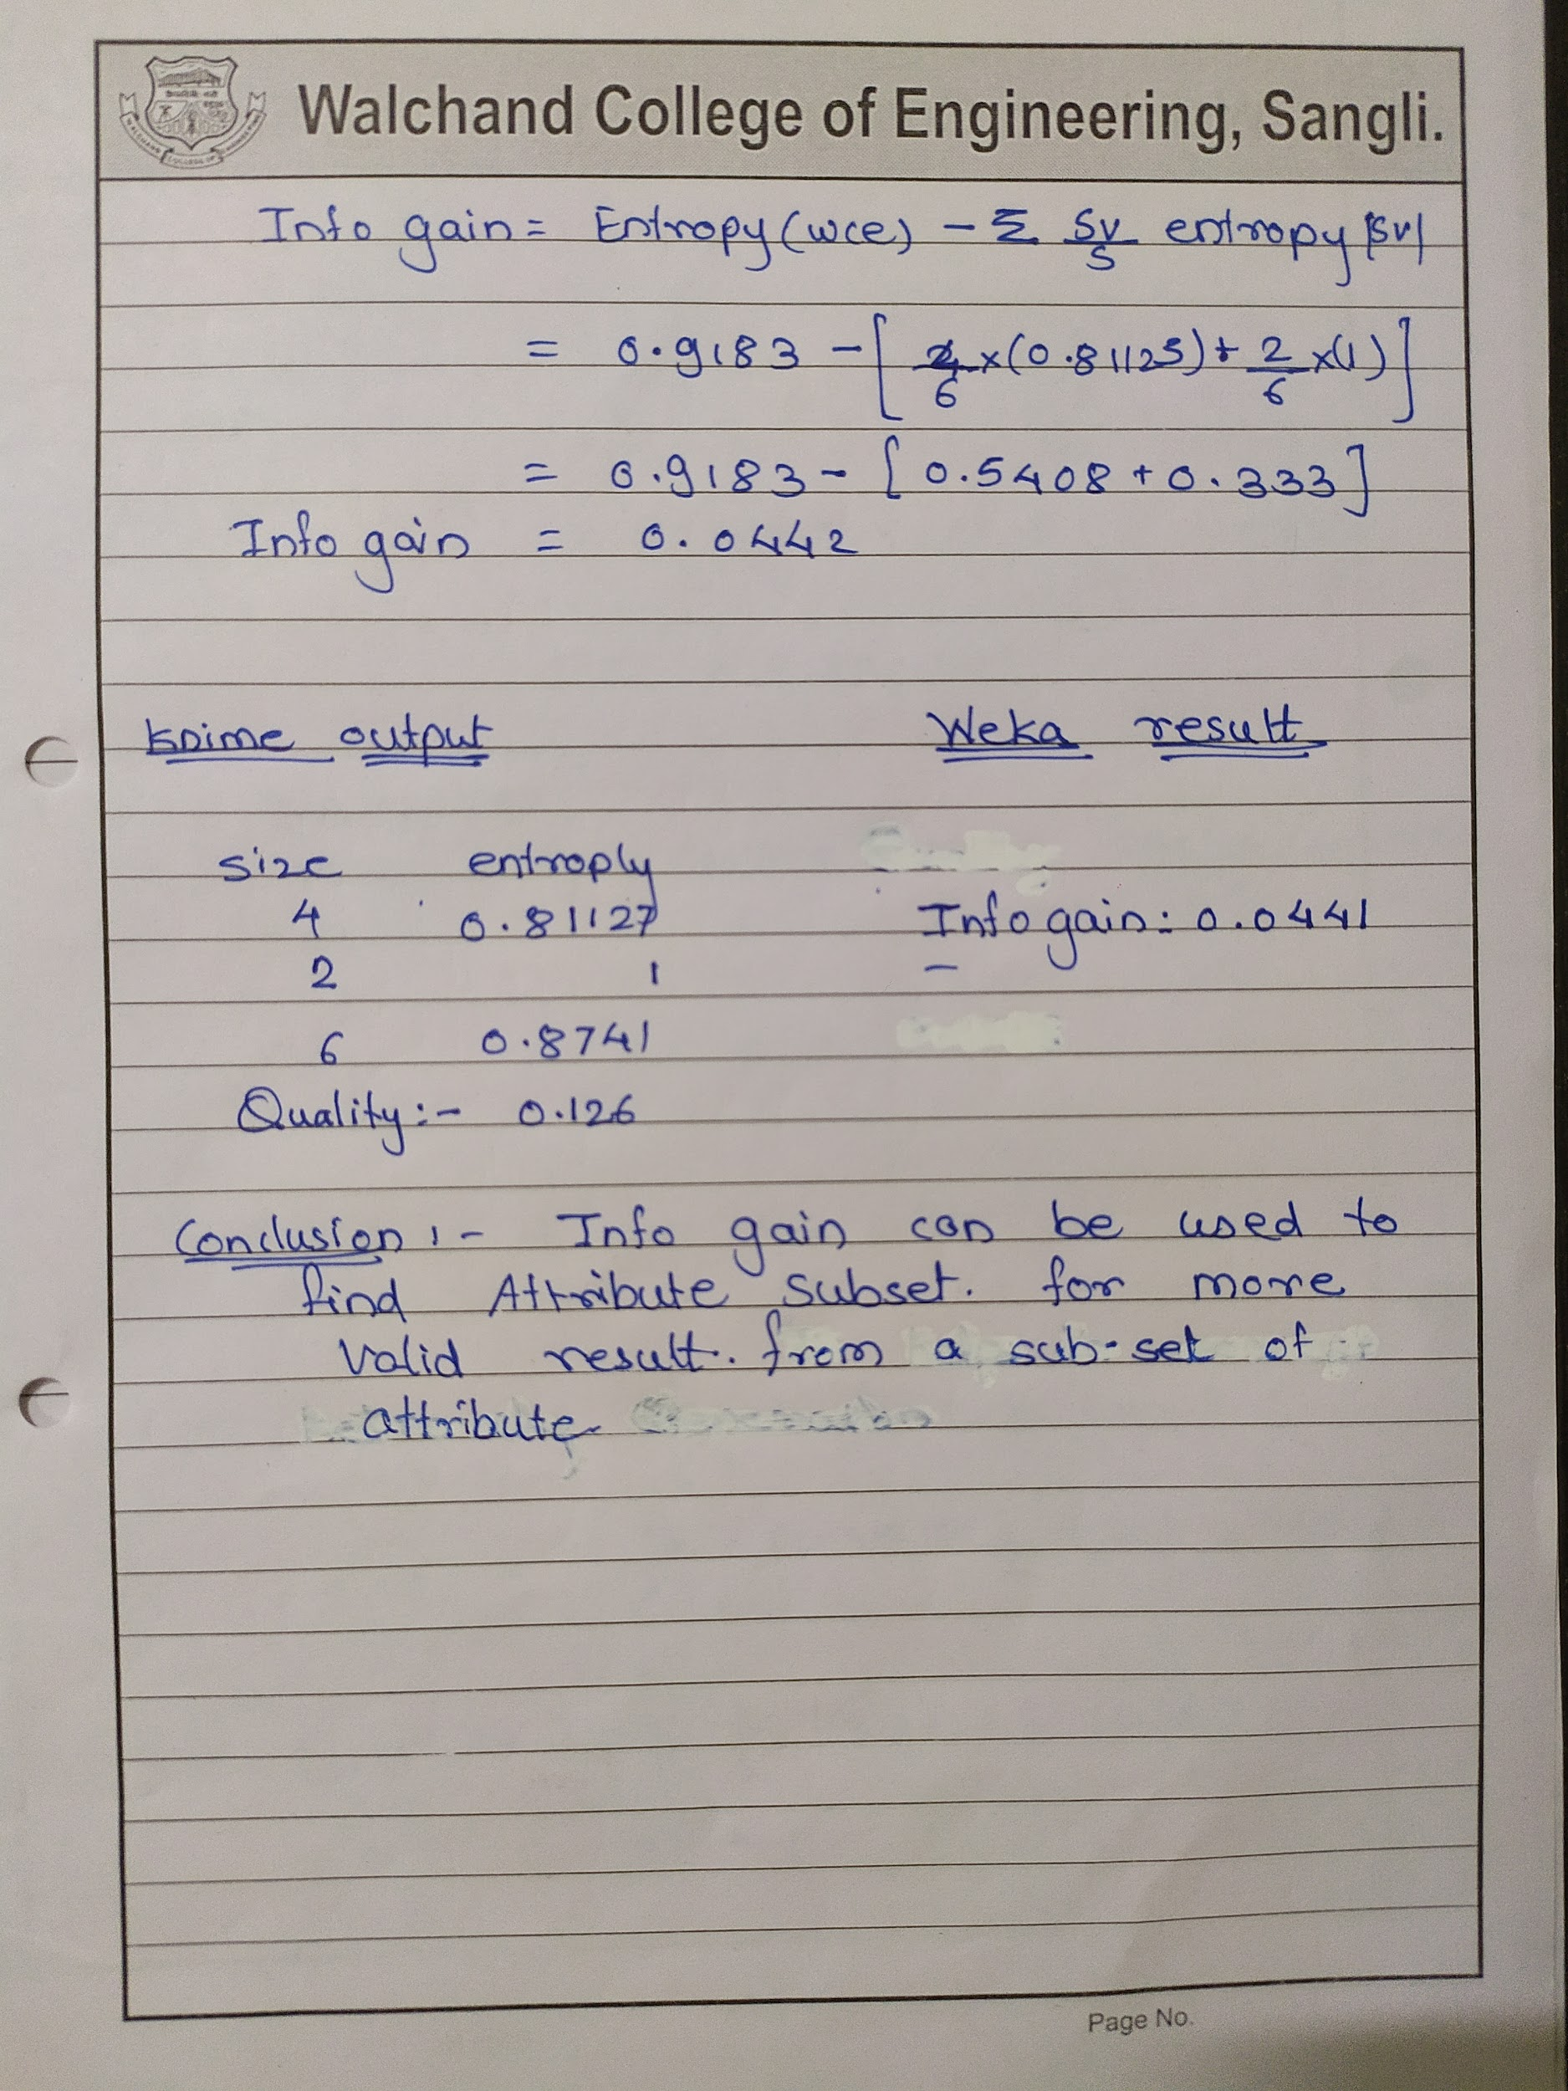

**Code:**

const xlsx = require("xlsx");

const prompt = require("prompt-sync")();

var wb = xlsx.readFile("Games.xlsx");

var ws = wb.Sheets["PlayingInfo"];

var data = xlsx.utils.sheet_to_json(ws);

var parentattri = prompt("Enter Parent attribute : ");

var childattri = prompt("Enter Child attribute : ");

var posR = 0,

negR = 0;

var arr = {};

// console.log(data);

for (let i = 0; i < data.length; i++) {

if (data[i][parentattri] == 1) {

posR++;

} else if (data[i][parentattri] == 0) {

negR++;

}

if (!(data[i][childattri] in arr)) {

arr[data[i][childattri]] = 0;

}

arr[data[i][childattri]]++;

}

//

let arr2 = {};

for (let i = 0; i < data.length; i++) {

if (!(data[i][childattri] in arr2)) {

arr2[data[i][childattri]] = { 1: 0, 0: 0 };

}

var res = data[i][parentattri];

// console.log(arr2[data[i].Wind].Yes);

if (res == 0) {

arr2[data[i][childattri]]["0"]++;

} else if (res == 1) {

arr2[data[i][childattri]]["1"]++;

}

}

// console.log(arr2);

/// Parent Entropy

var totRecord = data.length;

var entropy = -(

(posR / totRecord) * Math.log2(posR / totRecord) +

(negR / totRecord) * Math.log2(negR / totRecord)

);

entropy = entropy.toFixed(4);

// console.log(entropy);

var ent_sum = 0;

for (const key in arr2) {

var array = arr2[key];

let posRes = array["0"],

negRes = array["1"];

let totRes = posRes + negRes;

let ent =

-((posRes / totRes) * Math.log2(posRes / totRes)) -

(negRes / totRes) * Math.log2(negRes / totRes);

ent_sum += arr2[key].ent = ent * (totRes / data.length);

}

// console.log(arr2);

// console.log(ent_sum);

var infoGain = entropy - ent_sum;

// console.log(infoGain);

var newdata = [];

newdata.push({

Parent_ent: entropy,

Child_ent: ent_sum,

InfoGain: infoGain,

});

// console.log(newdata);

//Creating and writing data to the result file

var newWB = xlsx.utils.book_new();

var newWS = xlsx.utils.json_to_sheet(newdata);

xlsx.utils.book_append_sheet(newWB, newWS, "InfoGain");

xlsx.writeFile(newWB, "InfoGain.xlsx");

**Input File :**

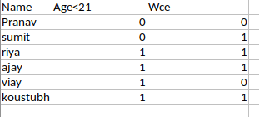

**Output file :**



**Knime result :**

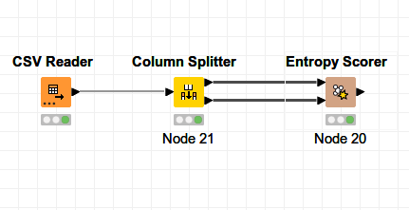

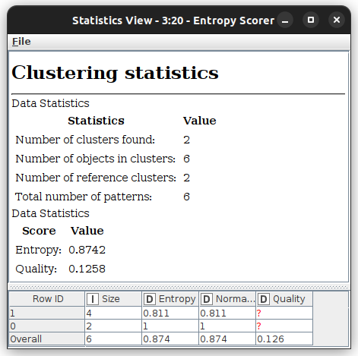

**Weka Result:**

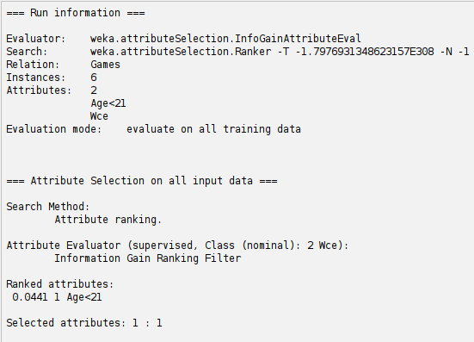

**Conclusion:**

Info gain can be used for the process of attribute subset selection to produce more valid results from a subset of attribute

## Experiment No 4

**Find t and d weight of a data.**

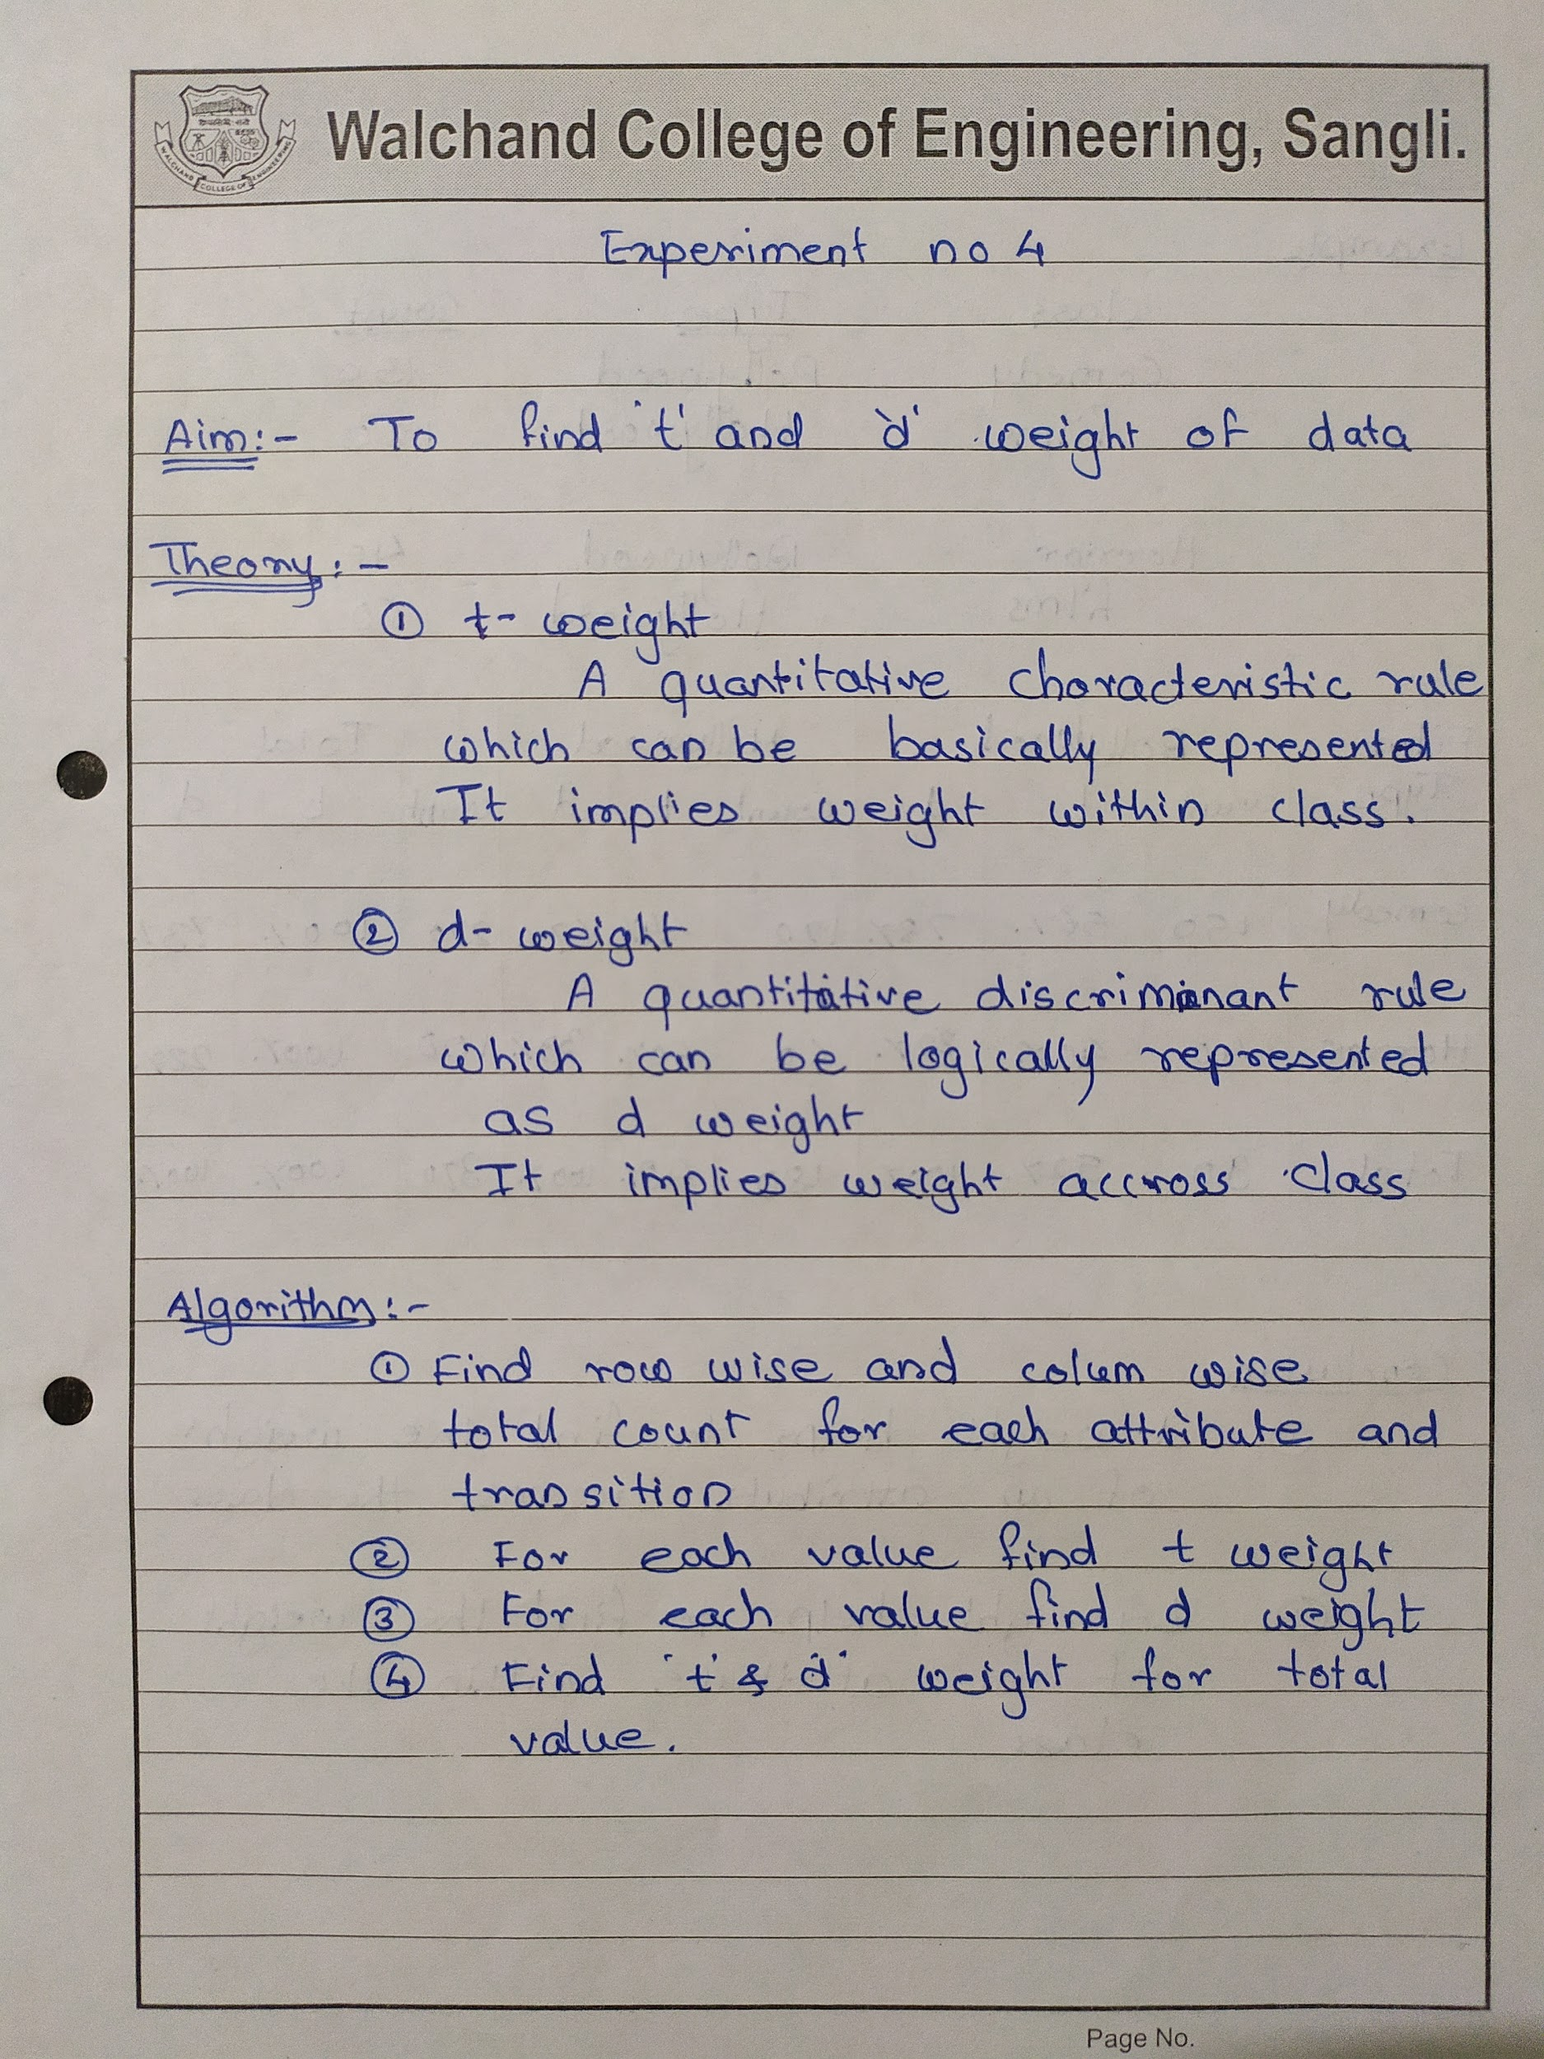

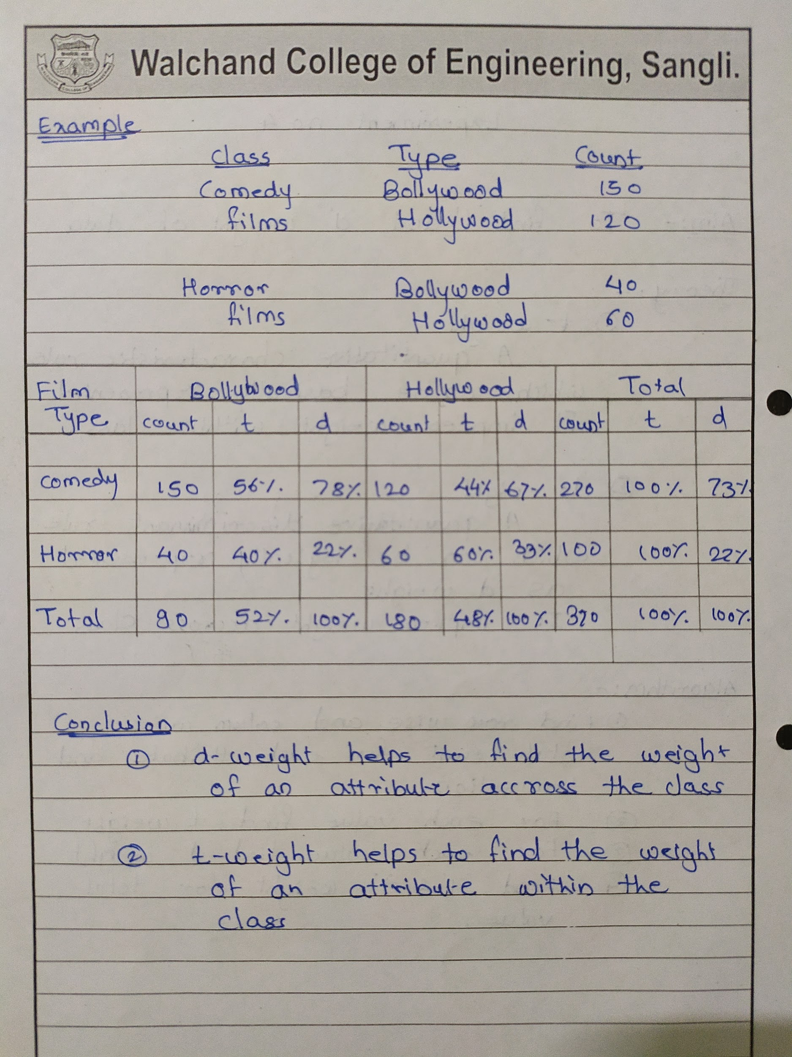

**Code:-**

const prompt = require("prompt-sync")();

const xlsx = require("xlsx");

//Reading the input file

var wb = xlsx.readFile("data.xlsx");

var ws = wb.Sheets["Movies"];

var data = xlsx.utils.sheet_to_json(ws);

console.log(data);

var tot = {};

var classNames = {};

var type = {};

for (let i = 0; i < data.length; i++) {

if (!(data[i].class in tot)) {

tot[data[i].class] = 0;

classNames[data[i].class] = 0;

}

tot[data[i].class] += data[i].count;

if (!(data[i].type in tot)) {

tot[data[i].type] = 0;

type[data[i].type] = 0;

}

tot[data[i].type] += data[i].count;

}

console.log(tot);

for (let i = 0; i < data.length; i++) {

data[i].t_weight = (data[i].count / tot[data[i].class]) * 100;

data[i].d_weight = (data[i].count / tot[data[i].type]) * 100;

}

var grandTot = 0;

for (var key in tot) {

grandTot += tot[key];

}

grandTot = grandTot / 2;

for (var key in tot) {

newdata = {};

newdata.class = "tot";

newdata.type = key;

newdata.count = tot[key];

if (key in classNames) {

newdata.t_weight = 100;

newdata.d_weight = (tot[key] / grandTot) * 100;

} else {

newdata.t_weight = (tot[key] / grandTot) * 100;

newdata.d_weight = 100;

}

data.push(newdata);

}

console.log(data);

//Creating and writing data to the result file

var newWB = xlsx.utils.book_new();

var newWS = xlsx.utils.json_to_sheet(data);

xlsx.utils.book_append_sheet(newWB, newWS, "T_D_Weight");

xlsx.writeFile(newWB, "T_D_Weight.xlsx");

**Input:-**

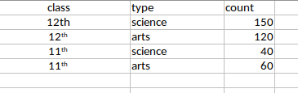

**Output:-**

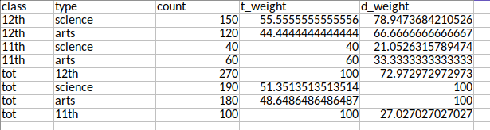

**Conclusion :**

D- weight helps to find the weight of an attribute across the class.

T- weight helps to find the weight of the attribute within the class.

## Experiment No 5

**Find 5 no summary of a dataset.**

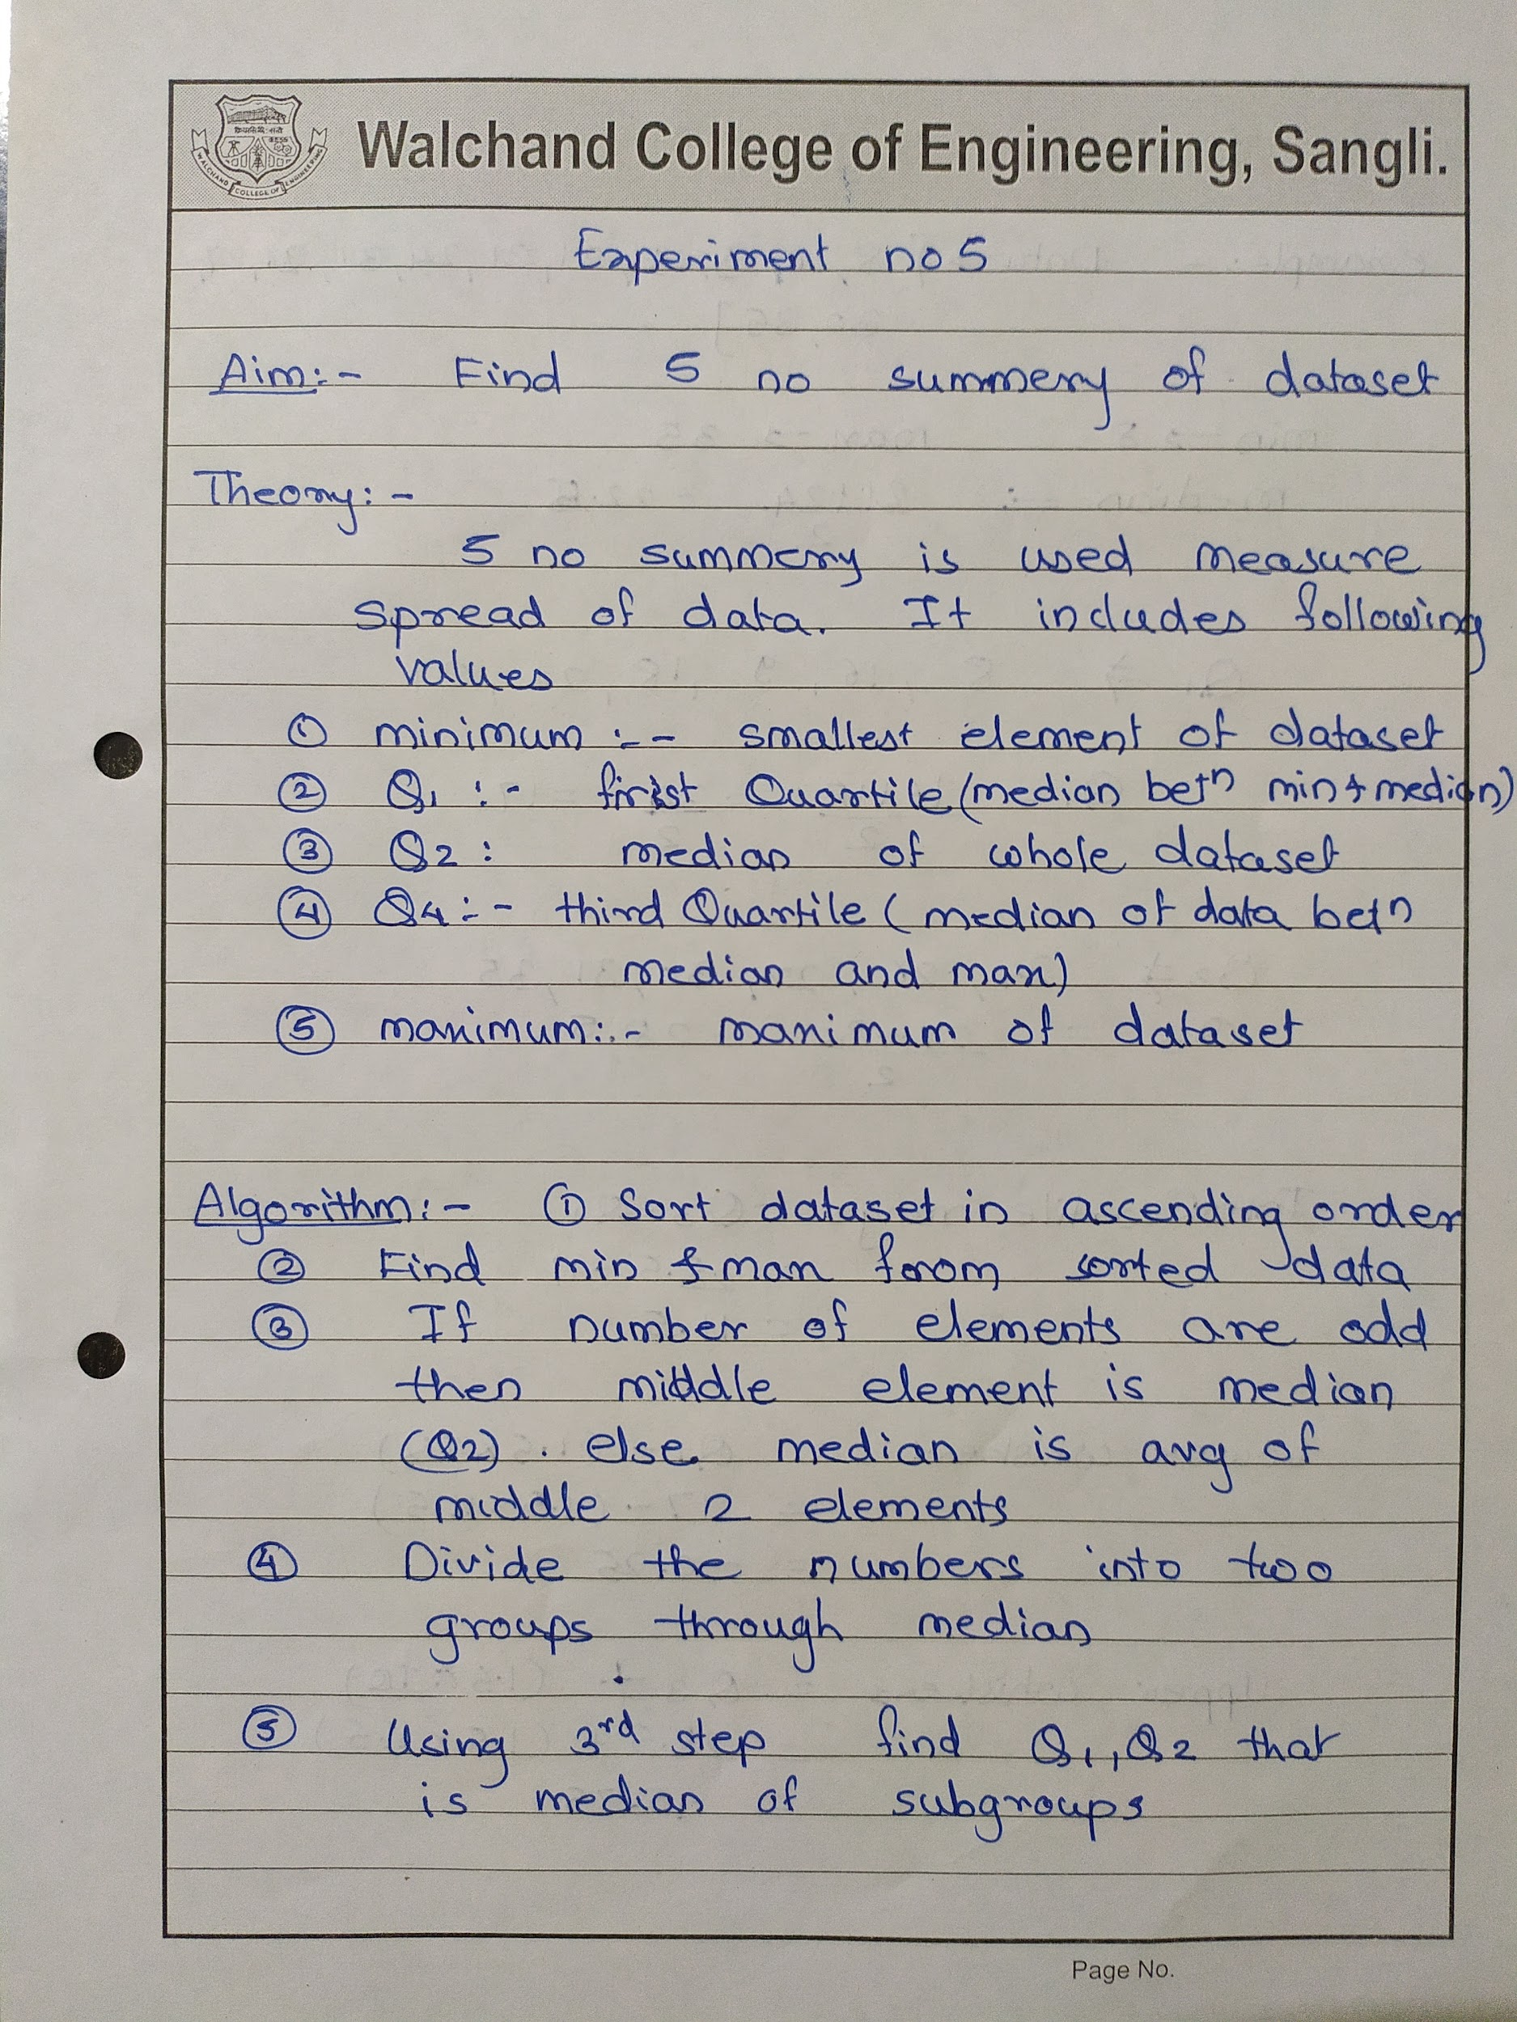

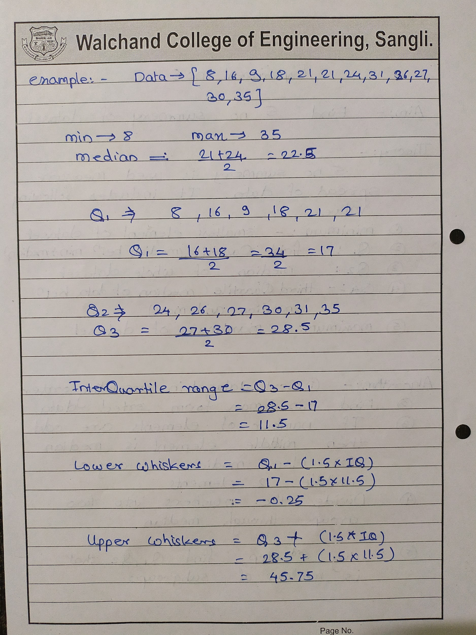

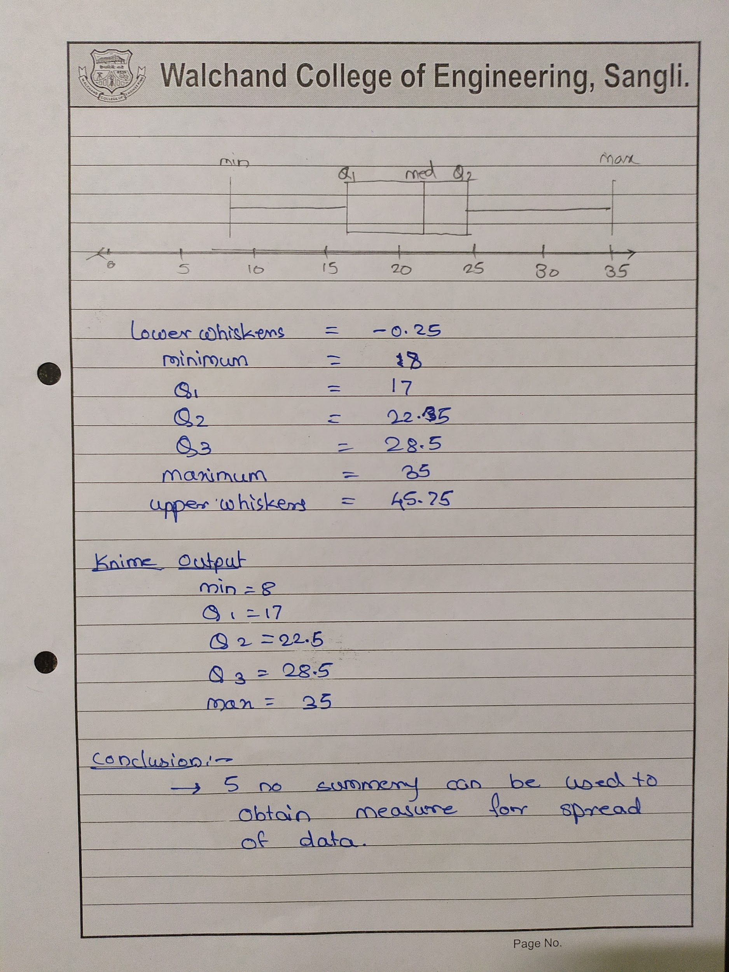

**Code:-**

const prompt = require("prompt-sync")();

const xlsx = require("xlsx");

//Reading the input file

var wb = xlsx.readFile("data.xlsx");

var ws = wb.Sheets["Student_Data"];

var data = xlsx.utils.sheet_to_json(ws);

var min_val;

var max_val;

data.sort((a, b) => (a.Marks > b.Marks ? 1 : -1));

min_val = data[0].Marks;

max_val = data[data.length - 1].Marks;

let n = data.length;

let q1Term = Math.round((25 / 100) * (n + 1));

let q1 = data[q1Term - 1].Marks;

let q2;

if (n % 2 == 1) {

q2 = data[(n - 1) / 2].Marks;

} else {

q2 = (data[n / 2 - 1].Marks + data[n / 2].Marks) / 2;

}

let q3term = Math.round((75 / 100) * (n + 1));

let q3 = data[q3term - 1].Marks;

var IQ = q3 - q1;

var lowerwhisers = q1 - 1.5 * IQ,

upperWhisers = q3 + 1.5 * IQ;

var newdata = [];

newdata.push({

Lowerwhisers: lowerwhisers,

MinimumValue: min_val,

LowerQuartile: q1,

MedianValue: q2,

UpperQuartile: q3,

MaximumValue: max_val,

UpperWhisers: upperWhisers,

});

console.log(newdata);

//Creating and writing data to the result file

var newWB = xlsx.utils.book_new();

var newWS = xlsx.utils.json_to_sheet(newdata);

xlsx.utils.book_append_sheet(newWB, newWS, "FiveNOSummery");

xlsx.writeFile(newWB, "FiveNOSummery.xlsx");

**Input:-**

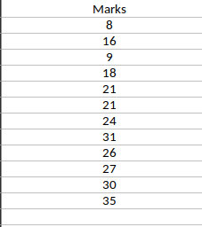

**Output:-**

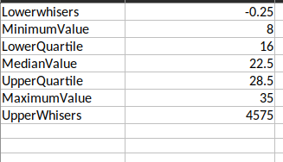

**Knime result :**

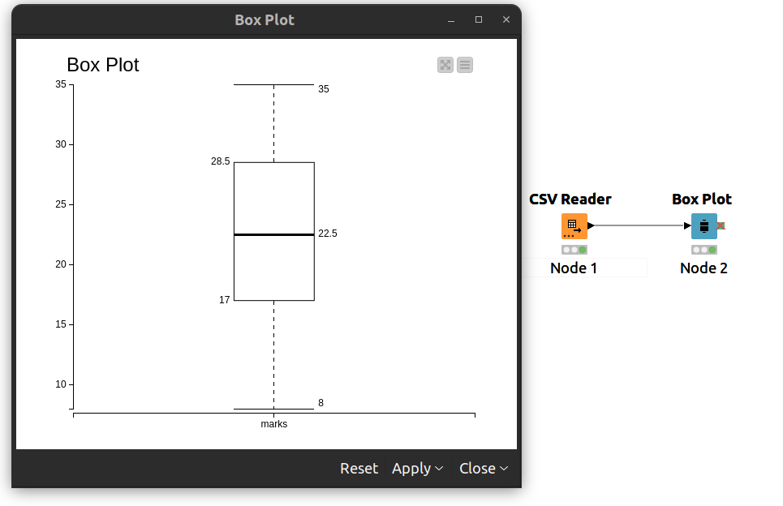

**Conclusion:**

5 number summary can be used to obtain the degree of spread of numeric data.

## Experiment 6

**Find frequent itemset from given transaction data**

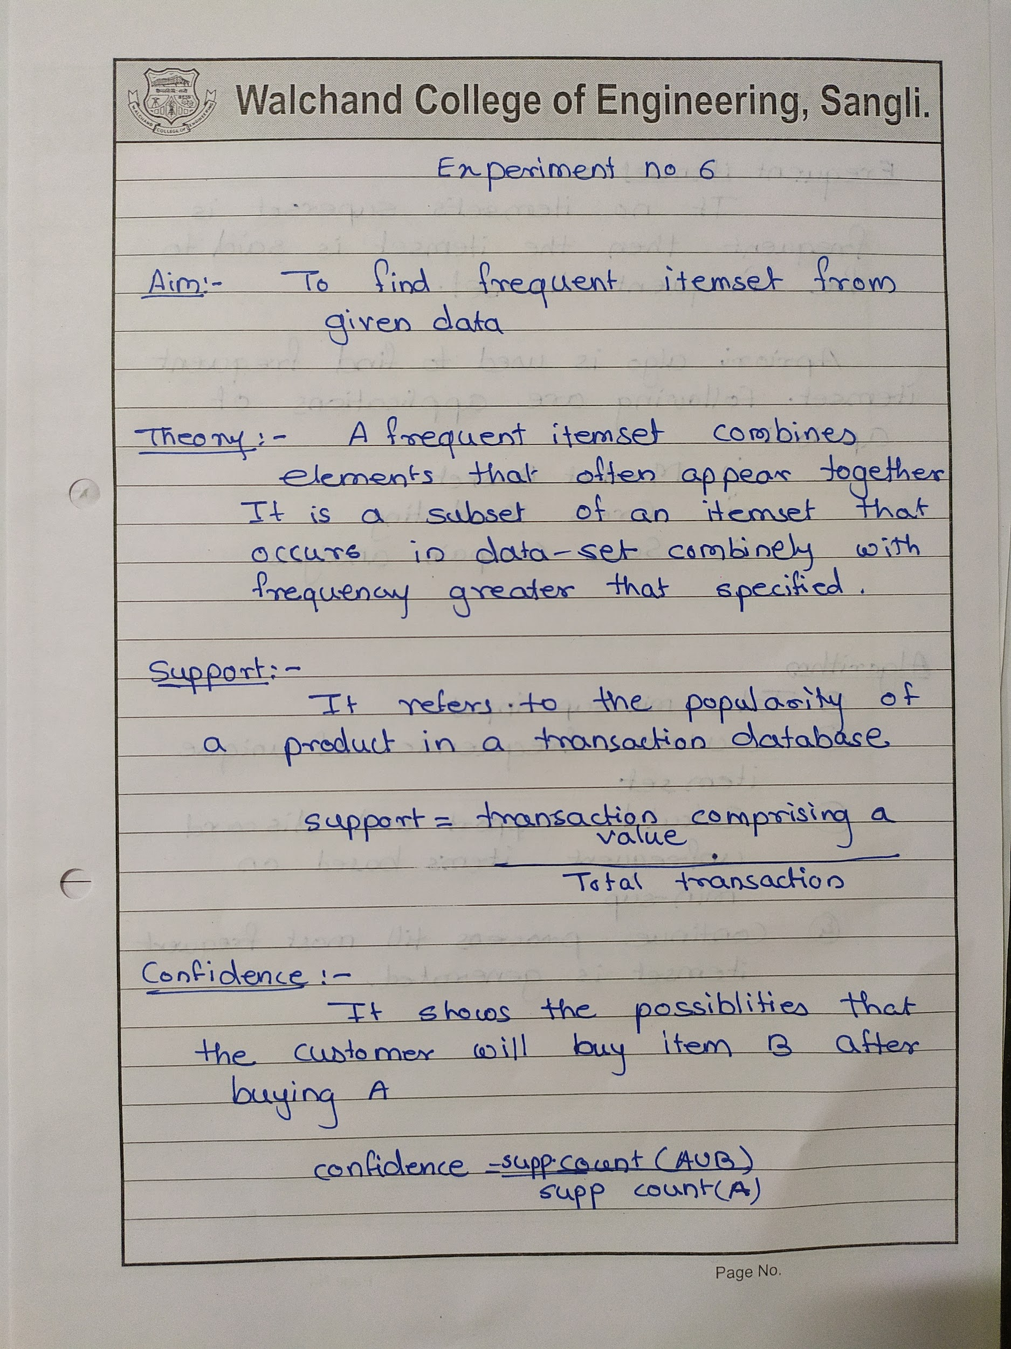

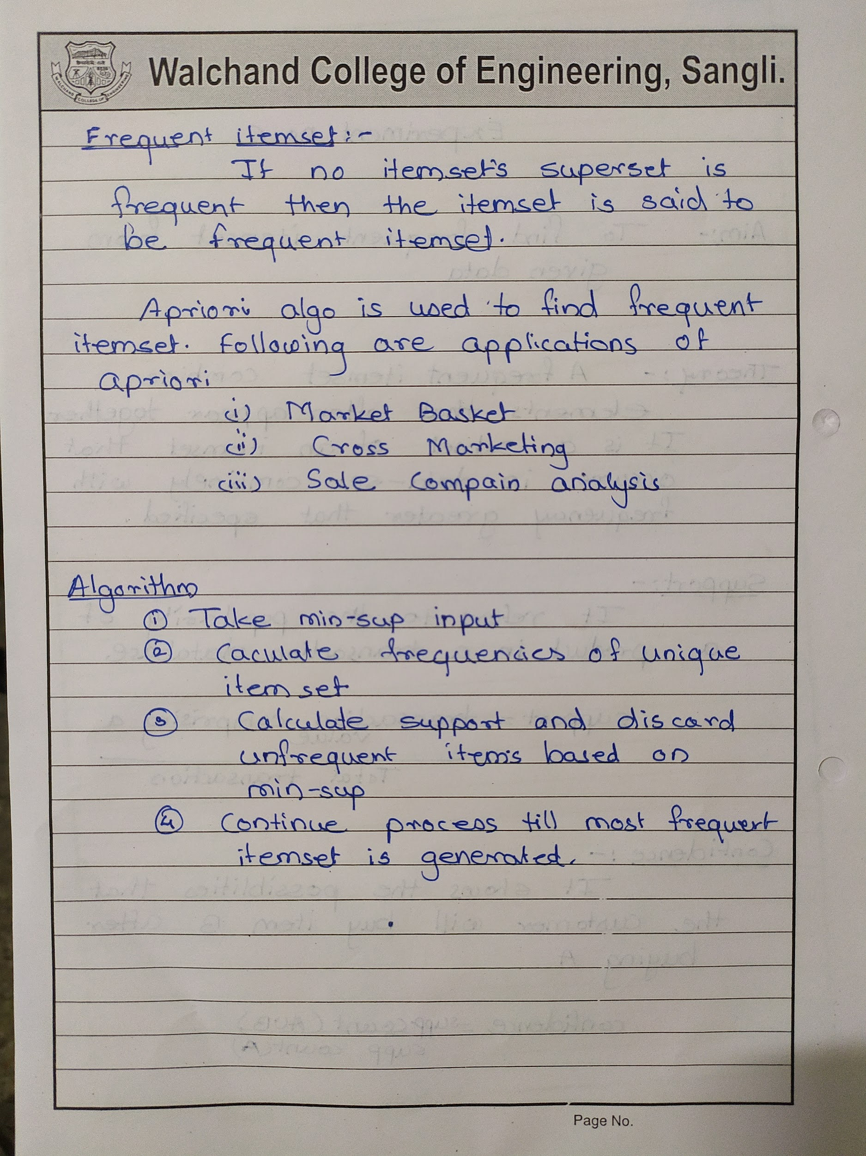

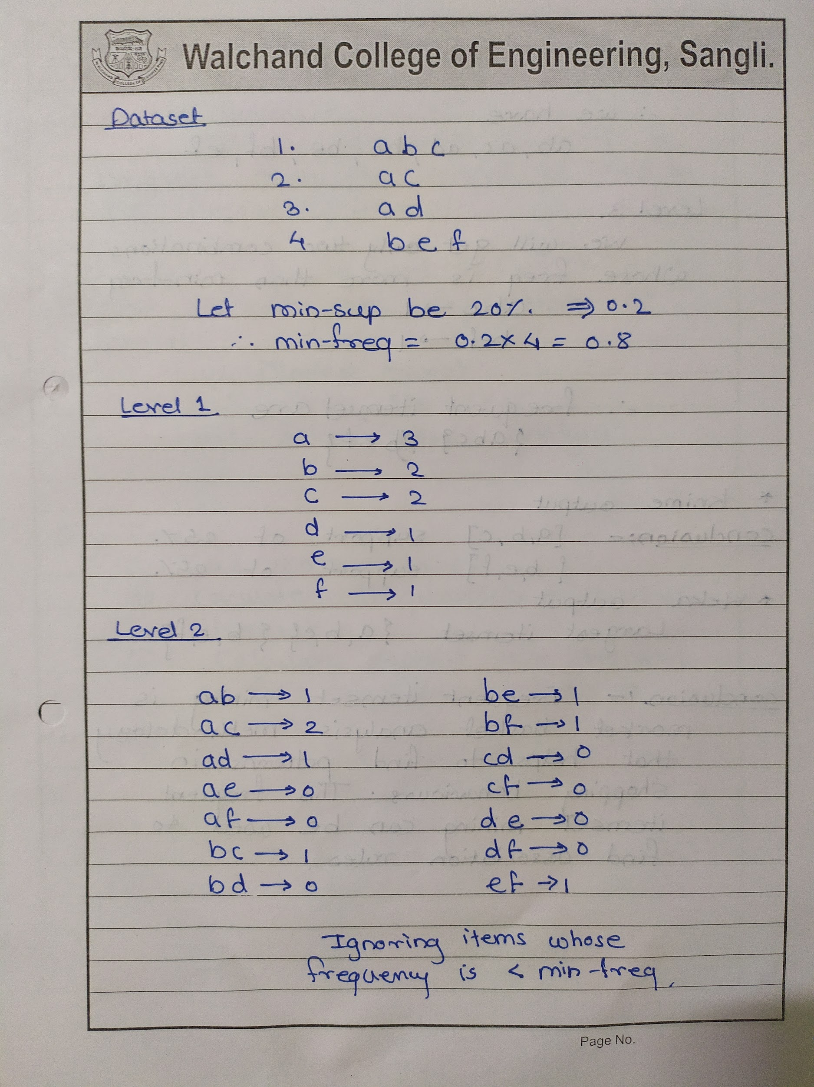

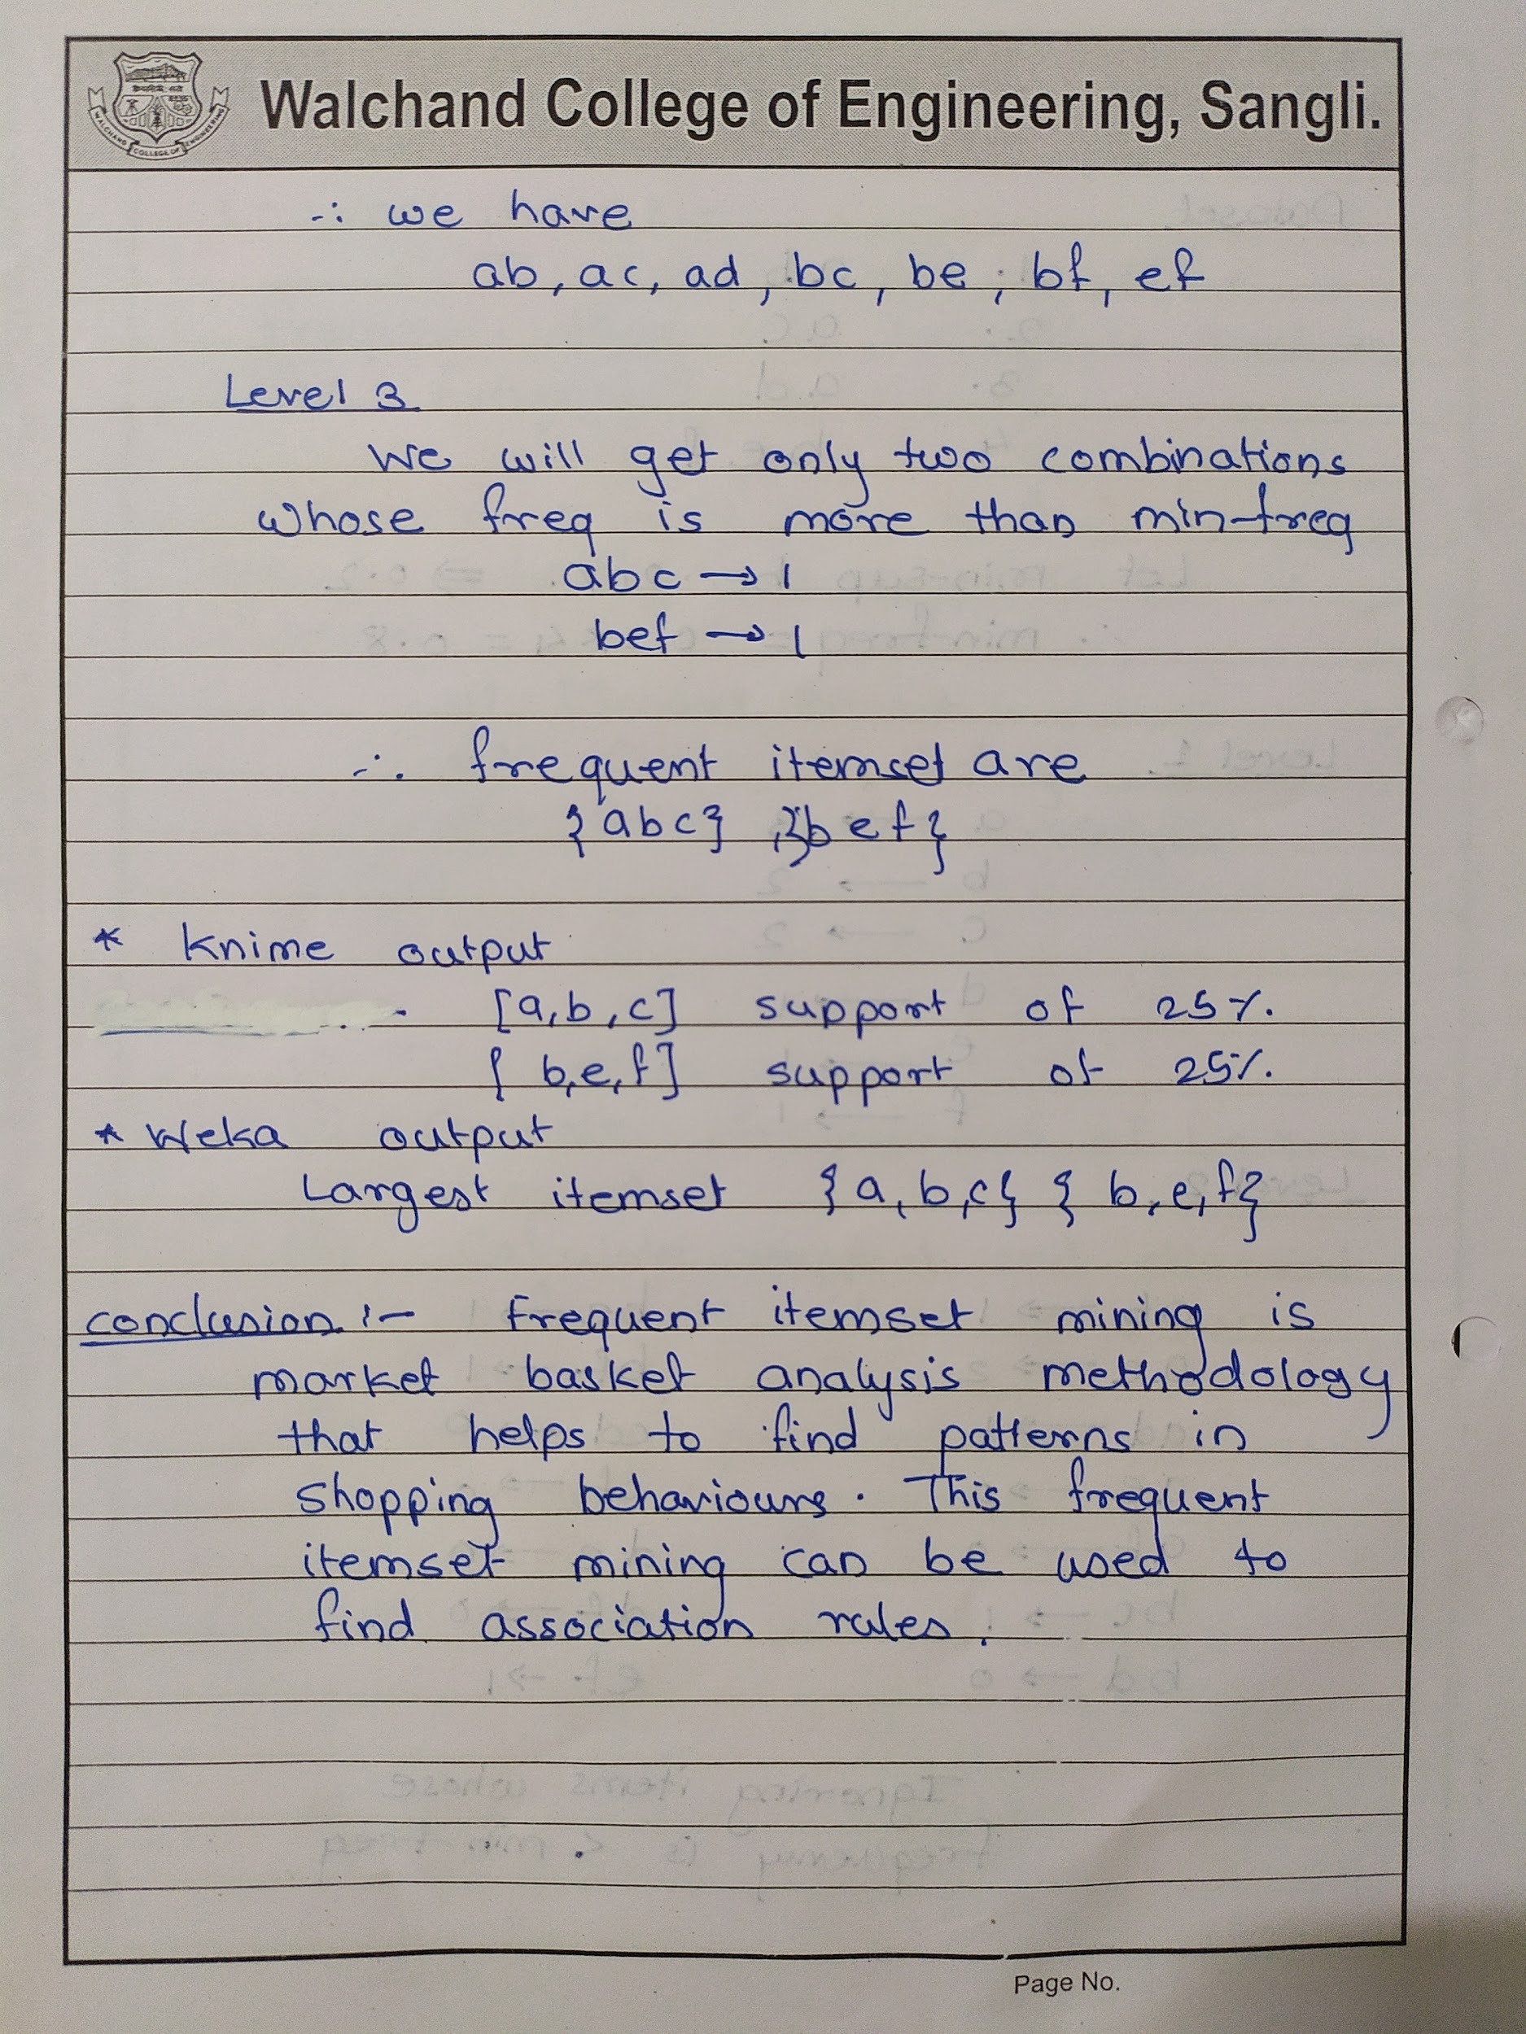

**Code :**

#include <bits/stdc++.h>

#include <map>

using namespace std;

ifstream fin;

double minfre;

vector<set<string>> datatable;

set<string> products;

map<string, int> freq;

vector<string> wordsof(string str)

{

vector<string> tmpset;

string tmp = "";

int i = 0;

while (str[i])

{

if (isalnum(str[i]))

tmp += str[i];

else

{

if (tmp.size() > 0)

tmpset.push_back(tmp);

tmp = "";

}

i++;

}

if (tmp.size() > 0)

tmpset.push_back(tmp);

return tmpset;

}

string combine(vector<string> &arr, int miss)

{

string str;

for (int i = 0; i < arr.size(); i++)

if (i != miss)

str += arr[i] + " ";

str = str.substr(0, str.size() - 1);

return str;

}

set<string> cloneit(set<string> &arr)

{

set<string> dup;

for (set<string>::iterator it = arr.begin(); it != arr.end(); it++)

dup.insert(*it);

return dup;

}

set<string> apriori_gen(set<string> &sets, int k)

{

set<string> set2;

for (set<string>::iterator it1 = sets.begin(); it1 != sets.end(); it1++)

{

set<string>::iterator it2 = it1;

it2++;

for (; it2 != sets.end(); it2++)

{

vector<string> v1 = wordsof(*it1);

vector<string> v2 = wordsof(*it2);

bool alleq = true;

for (int i = 0; i < k - 1 && alleq; i++)

if (v1[i] != v2[i])

alleq = false;

v1.push_back(v2[k - 1]);

if (v1[v1.size() - 1] < v1[v1.size() - 2])

swap(v1[v1.size() - 1], v1[v1.size() - 2]);

for (int i = 0; i < v1.size() && alleq; i++)

{

string tmp = combine(v1, i);

if (sets.find(tmp) == sets.end())

alleq = false;

}

if (alleq)

set2.insert(combine(v1, -1));

}

}

return set2;

}

int main()

{

fin.open("apriori.csv", ios::in);

if (!fin.is_open())

{

perror("Error in opening file : ");

}

cout << "Frequency % :";

cin >> minfre;

string str;

while (!fin.eof())

{

getline(fin, str);

vector<string> arr = wordsof(str);

set<string> tmpset;

for (int i = 0; i < arr.size(); i++)

tmpset.insert(arr[i]);

datatable.push_back(tmpset);

for (set<string>::iterator it = tmpset.begin(); it != tmpset.end(); it++)

{

products.insert(*it);

freq[*it]++;

}

}

fin.close();

cout << "No of transactions: " << datatable.size() << endl;

minfre = minfre * datatable.size() / 100;

cout << "Min frequency:" << minfre << endl;

queue<set<string>::iterator> q;

for (set<string>::iterator it = products.begin(); it != products.end(); it++)

if (freq[*it] < minfre)

q.push(it);

while (q.size() > 0)

{

products.erase(*q.front());

q.pop();

}

int pass = 1;

cout << "\nFrequent " << pass++ << " -item set : \n";

for (set<string>::iterator it = products.begin(); it != products.end(); it++)

cout << "{" << *it << "} " << freq[*it] << endl;

int i = 2;

set<string> prev = cloneit(products);

while (i)

{

set<string> cur = apriori_gen(prev, i - 1);

if (cur.size() < 1)

{

break;

}

for (set<string>::iterator it = cur.begin(); it != cur.end(); it++)

{

vector<string> arr = wordsof(*it);

int tot = 0;

for (int j = 0; j < datatable.size(); j++)

{

bool pres = true;

for (int k = 0; k < arr.size() && pres; k++)

if (datatable[j].find(arr[k]) == datatable[j].end())

pres = false;

if (pres)

tot++;

}

if (tot >= minfre)

freq[*it] += tot;

else

q.push(it);

}

while (q.size() > 0)

{

cur.erase(*q.front());

q.pop();

}

// cout << "Flag : " << flag << "\n";

bool flag = true;

for (set<string>::iterator it = cur.begin(); it != cur.end(); it++)

{

vector<string> arr = wordsof(*it);

if (freq[*it] < minfre)

flag = false;

}

if (cur.size() == 0)

break;

cout << "\n\nFrequent " << pass++ << " -item set : \n";

for (set<string>::iterator it = cur.begin(); it != cur.end(); it++)

cout << "{" << *it << "} " << freq[*it] << endl;

prev = cloneit(cur);

i++;

}

ofstream fw("ferquentItemsOutput.csv", ios::out);

for (auto it = prev.begin(); it != prev.end(); it++)

{

fw << "{" << *it << "}" << endl;

}

return 1;

}

**Input file :**

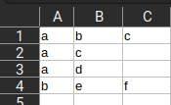

**Output :**

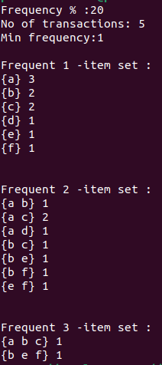

**Knime result :**

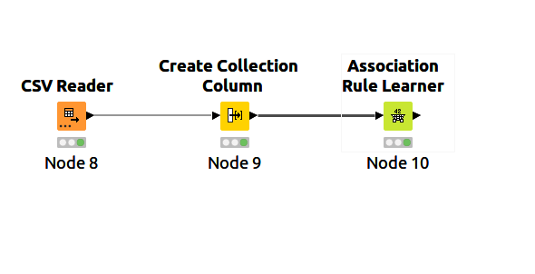

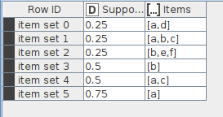

**Weka result:**

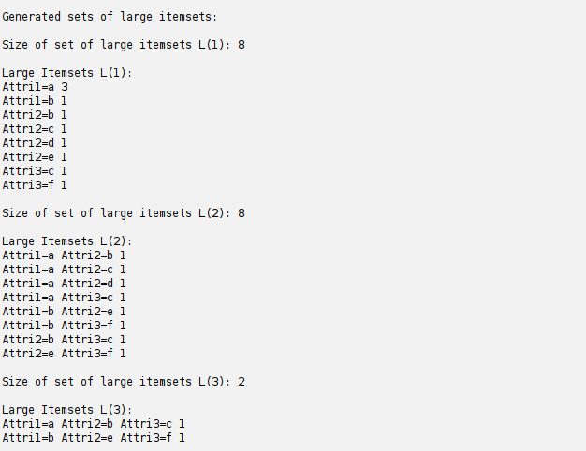

**Conclusion:**

Frequent itemset mining is a market basket analysis methodology that helps to find patterns in shopping behaviors. This frequent itemset mining can be used to find association rules.

## Experiment 7

**Extend program 6, to find association rules .**

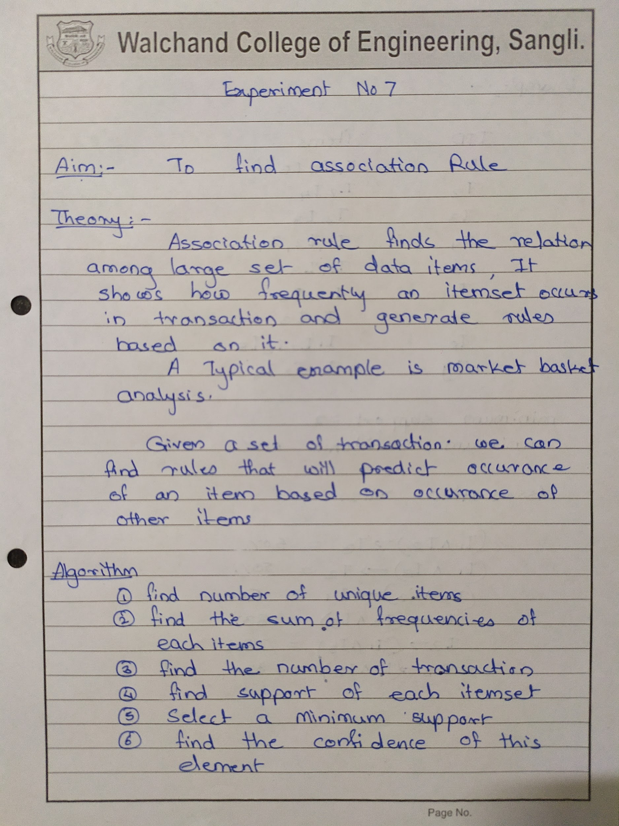

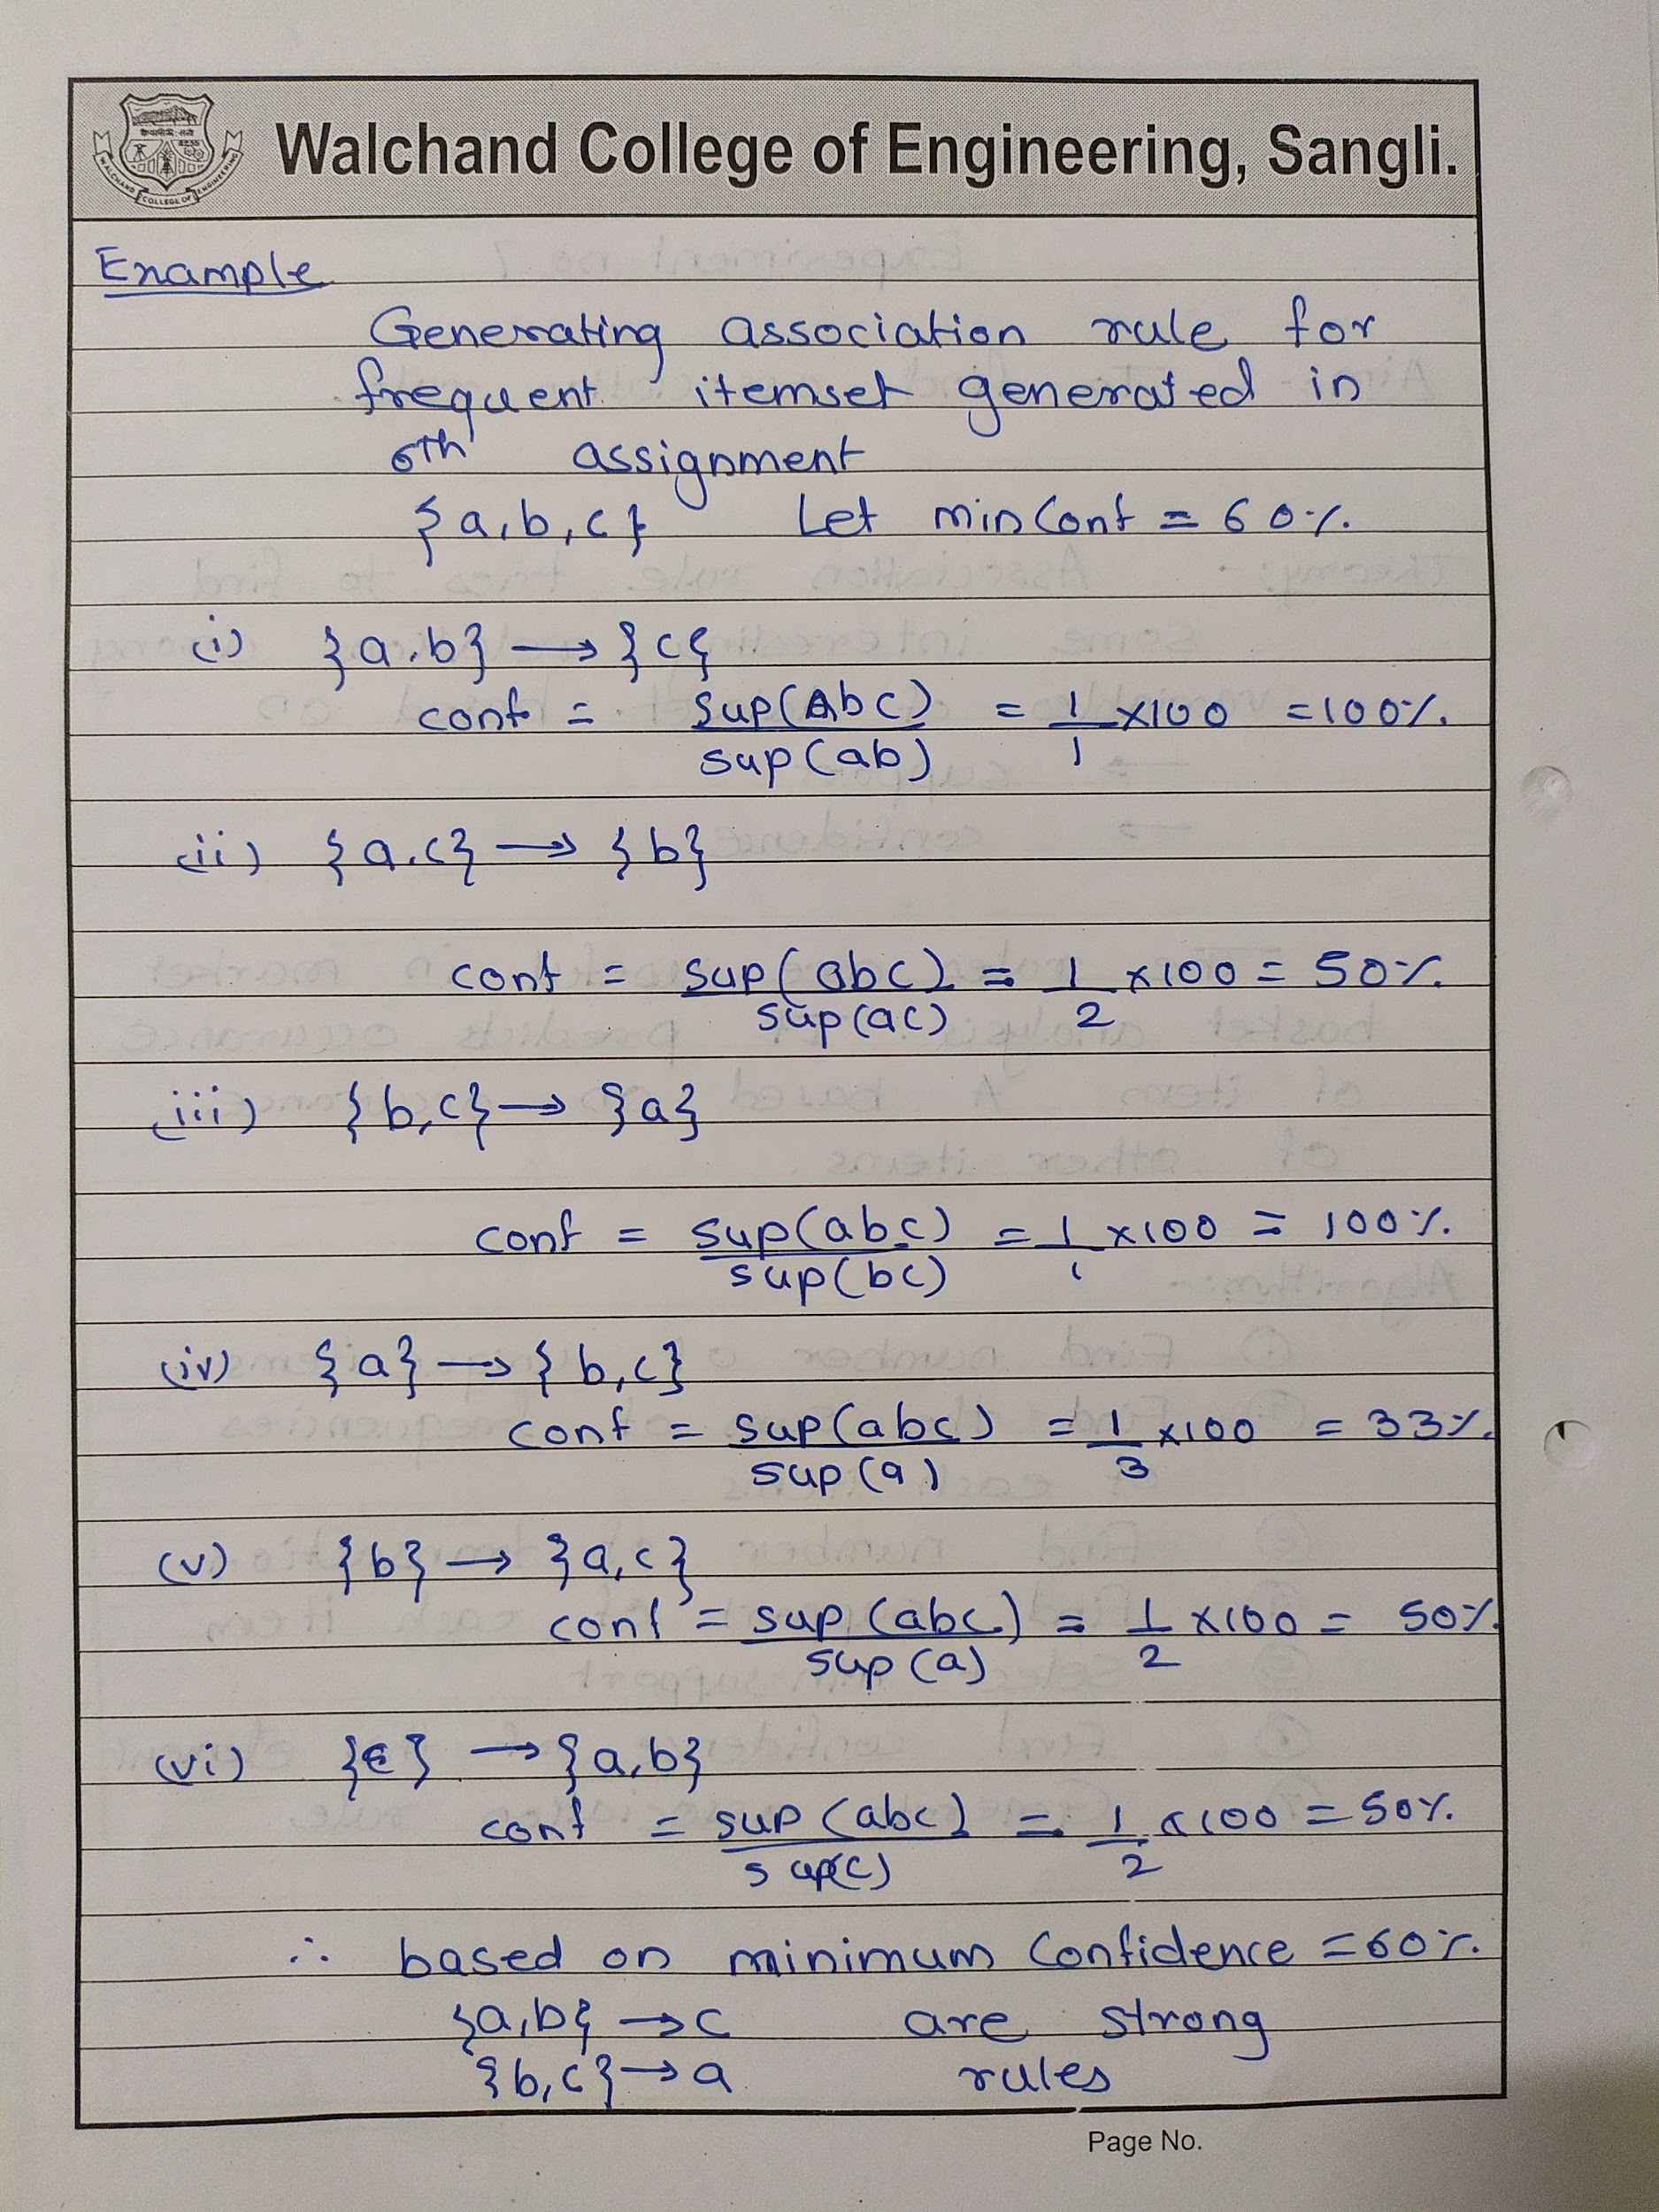

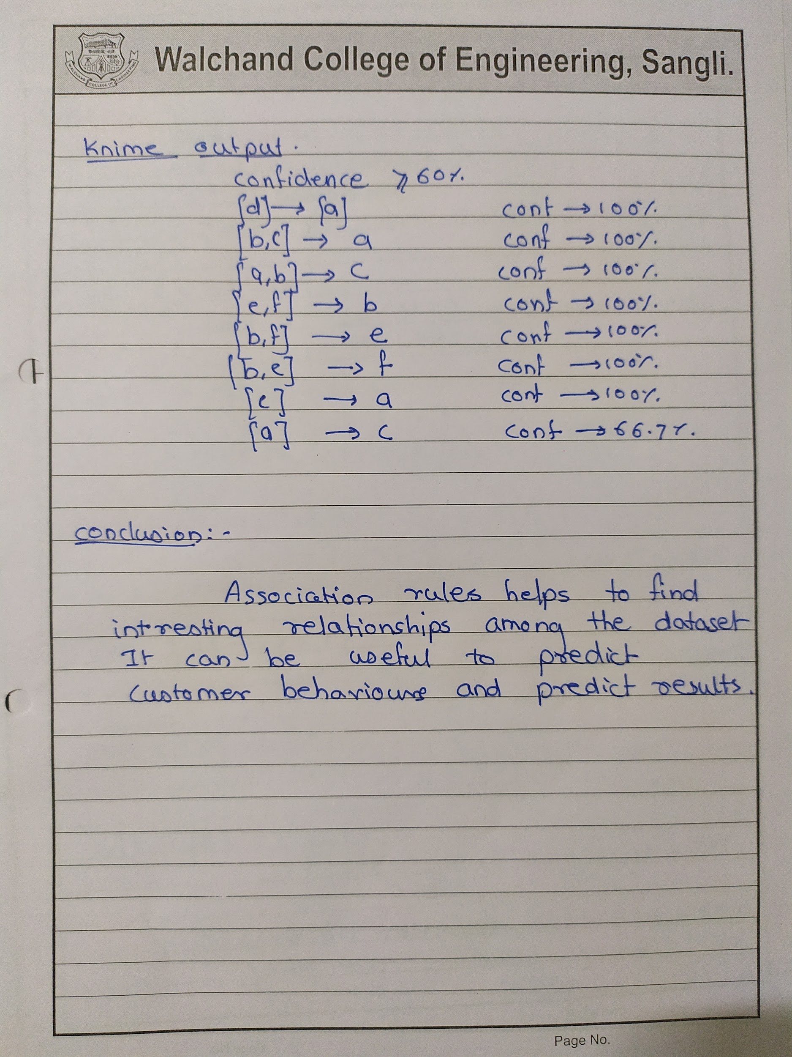

**Code :**

#include <bits/stdc++.h>

#include <map>

using namespace std;

ifstream fin;

double minfre;

vector<set<string>> datatable;

set<string> products;

map<string, int> freq;

double confidence;

vector<string> wordsof(string str)

{

vector<string> tmpset;

string tmp = "";

int i = 0;

while (str[i])

{

if (isalnum(str[i]))

tmp += str[i];

else

{

if (tmp.size() > 0)

tmpset.push_back(tmp);

tmp = "";

}

i++;

}

if (tmp.size() > 0)

tmpset.push_back(tmp);

return tmpset;

}

string combine(vector<string> &arr, int miss)

{

string str;

for (int i = 0; i < arr.size(); i++)

if (i != miss)

str += arr[i] + " ";

str = str.substr(0, str.size() - 1);

return str;

}

set<string> cloneit(set<string> &arr)

{

set<string> dup;

for (set<string>::iterator it = arr.begin(); it != arr.end(); it++)

dup.insert(*it);

return dup;

}

set<string> apriori_gen(set<string> &sets, int k)

{

set<string> set2;

for (set<string>::iterator it1 = sets.begin(); it1 != sets.end(); it1++)

{

set<string>::iterator it2 = it1;

it2++;

for (; it2 != sets.end(); it2++)

{

vector<string> v1 = wordsof(*it1);

vector<string> v2 = wordsof(*it2);

bool alleq = true;

for (int i = 0; i < k - 1 && alleq; i++)

if (v1[i] != v2[i])

alleq = false;

v1.push_back(v2[k - 1]);

if (v1[v1.size() - 1] < v1[v1.size() - 2])

swap(v1[v1.size() - 1], v1[v1.size() - 2]);

for (int i = 0; i < v1.size() && alleq; i++)

{

string tmp = combine(v1, i);

if (sets.find(tmp) == sets.end())

alleq = false;

}

if (alleq)

set2.insert(combine(v1, -1));

}

}

return set2;

}

int countOccurences(vector<string> v)

{

int count = 0;

for (auto s : datatable)

{

bool present = true;

for (auto x : v)

{

if (s.find(x) == s.end())

{

present = false;

break;

}

}

if (present)

count++;

}

return count;

}

ofstream fw1("assocationRulesOutput.csv", ios::out);

void subsets(vector<string> items, vector<string> v1, vector<string> v2, int idx)

{

if (idx == items.size())

{

if (v1.size() == 0 || v2.size() == 0)

return;

int count1 = countOccurences(items); // Total support

int count2 = countOccurences(v1);

double conf = (((double)count1) / count2) * 100;

if (conf >= confidence)

{

fw1 << "{ ";

for (auto s : v1)

{

fw1 << s << " ";

}

fw1 << "} ,"

<< "-> "

<< ", {";

for (auto s : v2)

{

fw1 << s << " ";

}

fw1 << "} , " << conf << endl;

}

return;

}

v1.push_back(items[idx]);

subsets(items, v1, v2, idx + 1);

v1.pop_back();

v2.push_back(items[idx]);

subsets(items, v1, v2, idx + 1);

v2.pop_back();

}

void generateAssociationRules(set<string> freqItems)

{

for (auto it = freqItems.begin(); it != freqItems.end(); it++)

{

vector<string> items = wordsof(*it);

subsets(items, {}, {}, 0);

}

}

int main()

{

fin.open("apriori.csv", ios::in);

if (!fin.is_open())

{

perror("Error in opening file : ");

}

cout << "Enter Support % :";

cin >> minfre;

cout << "Enter Confidence % : ";

cin >> confidence;

string str;

while (!fin.eof())

{

getline(fin, str);

vector<string> arr = wordsof(str);

set<string> tmpset;

for (int i = 0; i < arr.size(); i++)

tmpset.insert(arr[i]);

datatable.push_back(tmpset);

for (set<string>::iterator it = tmpset.begin(); it != tmpset.end(); it++)

{

products.insert(*it);

freq[*it]++;

}

}

fin.close();

cout << "No of transactions: " << datatable.size() << endl;

minfre = minfre * datatable.size() / 100;

cout << "Min frequency:" << minfre << endl;

queue<set<string>::iterator> q;

for (set<string>::iterator it = products.begin(); it != products.end(); it++)

if (freq[*it] < minfre)

q.push(it);

while (q.size() > 0)

{

products.erase(*q.front());

q.pop();

}

int pass = 1;

cout << "\nFrequent " << pass++ << " -item set : \n";

for (set<string>::iterator it = products.begin(); it != products.end(); it++)

cout << "{" << *it << "} " << freq[*it] << endl;

int i = 2;

set<string> prev = cloneit(products);

while (i)

{

set<string> cur = apriori_gen(prev, i - 1);

if (cur.size() < 1)

{

break;

}

for (set<string>::iterator it = cur.begin(); it != cur.end(); it++)

{

vector<string> arr = wordsof(*it);

int tot = 0;

for (int j = 0; j < datatable.size(); j++)

{

bool pres = true;

for (int k = 0; k < arr.size() && pres; k++)

if (datatable[j].find(arr[k]) == datatable[j].end())

pres = false;

if (pres)

tot++;

}

if (tot >= minfre)

freq[*it] += tot;

else

q.push(it);

}

while (q.size() > 0)

{

cur.erase(*q.front());

q.pop();

}

// cout << "Flag : " << flag << "\n";

bool flag = true;

for (set<string>::iterator it = cur.begin(); it != cur.end(); it++)

{

vector<string> arr = wordsof(*it);

if (freq[*it] < minfre)

flag = false;

}

if (cur.size() == 0)

break;

cout << "\n\nFrequent " << pass++ << " -item set : \n";

for (set<string>::iterator it = cur.begin(); it != cur.end(); it++)

cout << "{" << *it << "} " << freq[*it] << endl;

prev = cloneit(cur);

i++;

}

generateAssociationRules(prev);

return 1;

}

**Input file :**



**Output :**

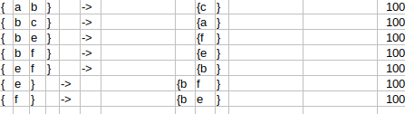

**Knime result :**



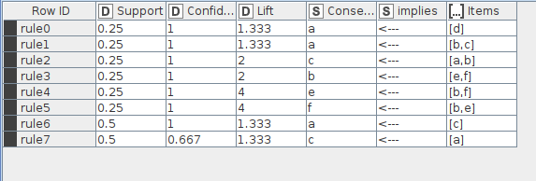

**Weka Result:**

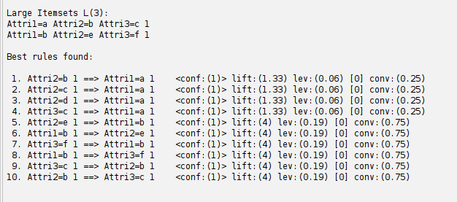

**Conclusion:**

Association rules help to find interesting relationships among the dataset It can be used to predict customer behaviors under market basket analysis

## Experiment No 8

**Find correlation between items/entities.**

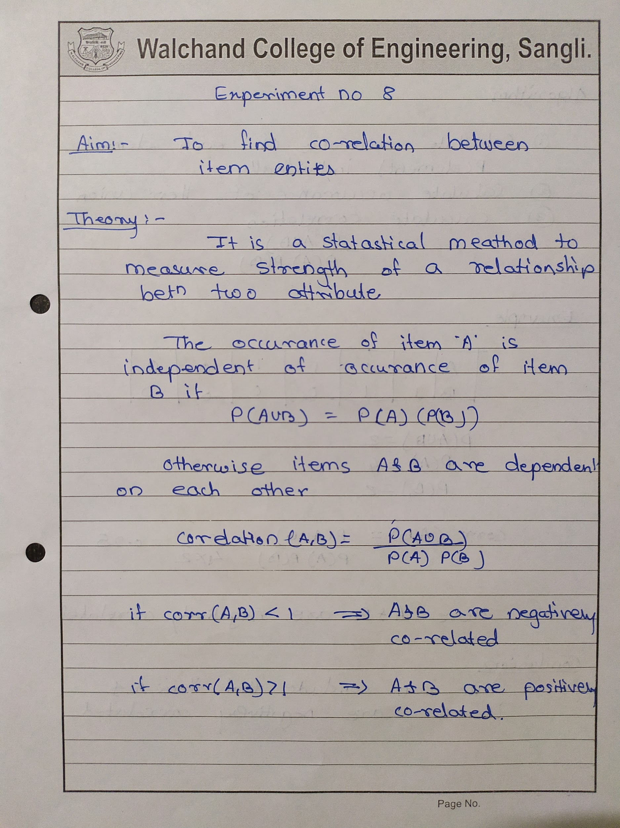

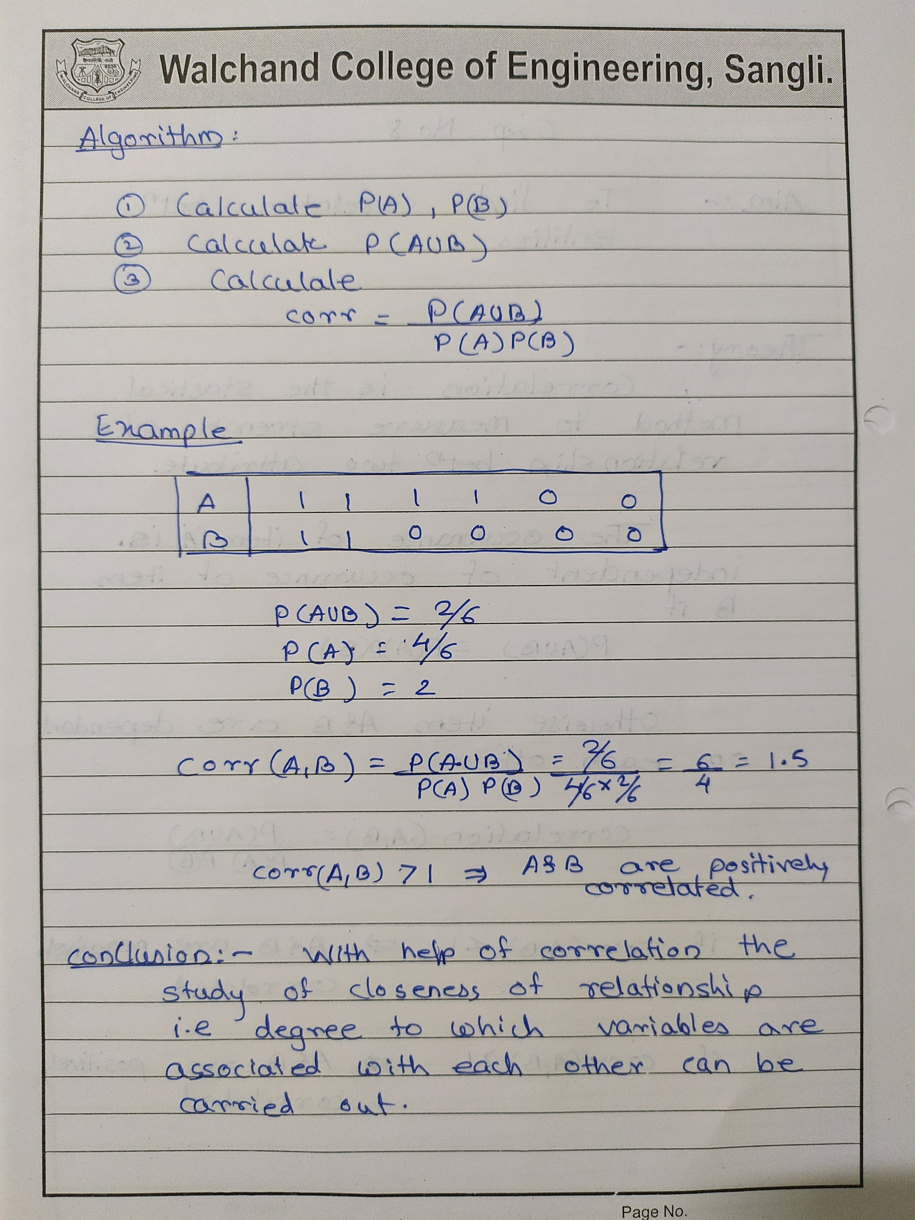

**Code:-**

const xlsx = require("xlsx");

const prompt = require("prompt-sync")();

var wb = xlsx.readFile("data.xlsx");

var ws = wb.Sheets["data"];

var data = xlsx.utils.sheet_to_json(ws);

var corr;

var a = 0,

b = 0,

a_b = 0;

for (var i = 0; i < data.length; i++) {

if (data[i].A == 1 && data[i].B == 1) a_b++;

if (data[i].A == 1) a++;

if (data[i].B == 1) b++;

}

corr = a_b / (a * b);

console.log(corr);

var newdata = [];

var obj = { correaltion_Between_A_and_B: corr };

newdata.push(obj);

var newWB = xlsx.utils.book_new();

var newWS = xlsx.utils.json_to_sheet(newdata);

xlsx.utils.book_append_sheet(newWB, newWS, "Correlation");

xlsx.writeFile(newWB, "Correlation.xlsx")

**Input:-**

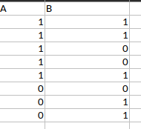

**Output:-**

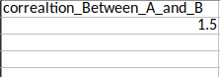

**Conclusion:**

With help of correlation, the study of the closeness of the relation between two variables can be carried out i.e degree to which two variables are associated with each other.

## Experiment 9

**Distance and cluster**

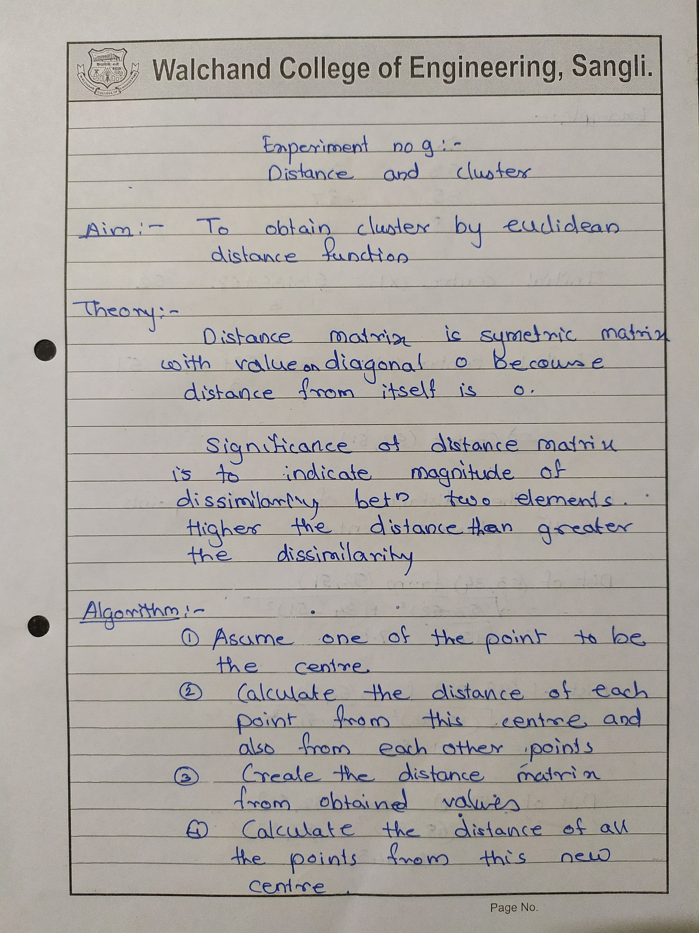

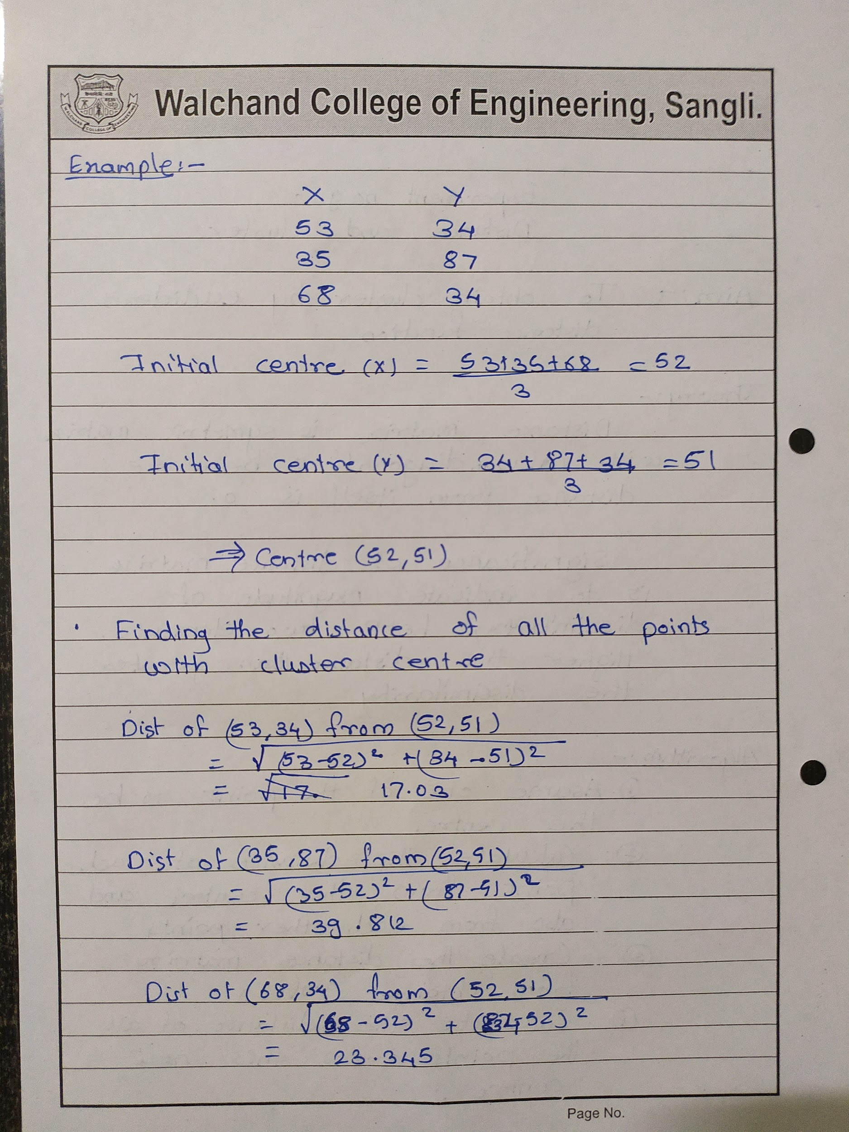

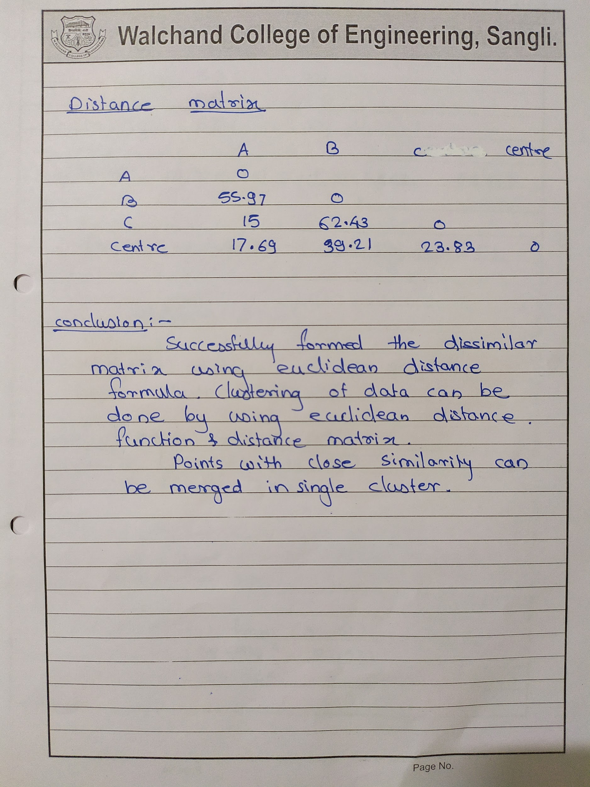

**Code:**

const xlsx = require("xlsx");

const prompt = require("prompt-sync")();

var wb = xlsx.readFile("data.xlsx");

var ws = wb.Sheets["data"];

var data = xlsx.utils.sheet_to_json(ws);

var x_centre = 0,

y_centre = 0;

for (var i = 0; i < data.length; i++) {

x_centre += data[i].x;

y_centre += data[i].y;

data[i].isIncluded = 0;

}

x_centre = x_centre / data.length;

y_centre = y_centre / data.length;

console.log("Centre(" + x_centre + "," + y_centre + ")");

data.push({ point: "centre", x: x_centre, y: y_centre });

console.log(data);

var index = 0;

var matrix = [];

var j = 0;

for (var i = 0; i < data.length; i++) {

var obj = {};

for (j = 0; j <= i; j++) {

var eucDist = Math.sqrt(

(data[j].x - data[i].x) * (data[j].x - data[i].x) +

(data[j].y - data[i].y) * (data[j].y - data[i].y)

);

obj["point"] = data[i].point;

obj[data[j].point] = eucDist;

}

matrix.push(obj);

}

console.log(matrix);

var newWB = xlsx.utils.book_new();

var newWS = xlsx.utils.json_to_sheet(matrix);

xlsx.utils.book_append_sheet(newWB, newWS, "matrix" + index);

xlsx.writeFile(newWB, "matrix" + index + ".xlsx");

**Input:**

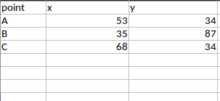

**Output:**

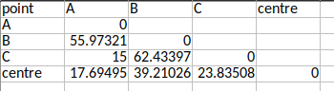

**Knime cluster center**

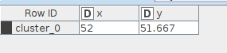

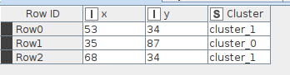

**Weka output:**

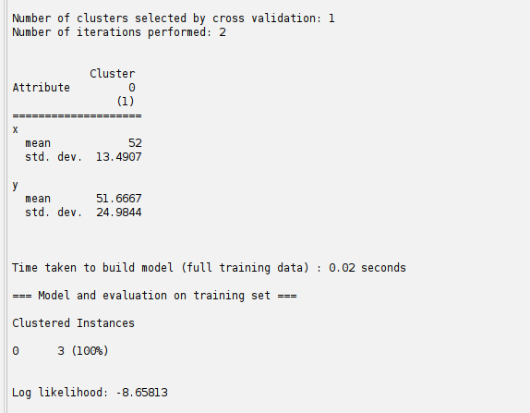

**Conclusion:**

Clustering can be done using a distance matrix and distance function. Points close together can be merged to form a cluster. Points with closeness can be merged to gether to form a single cluster.

## Experiment 10

**Write a program for Agglomerative Hierarchical clustering using single linkage method**

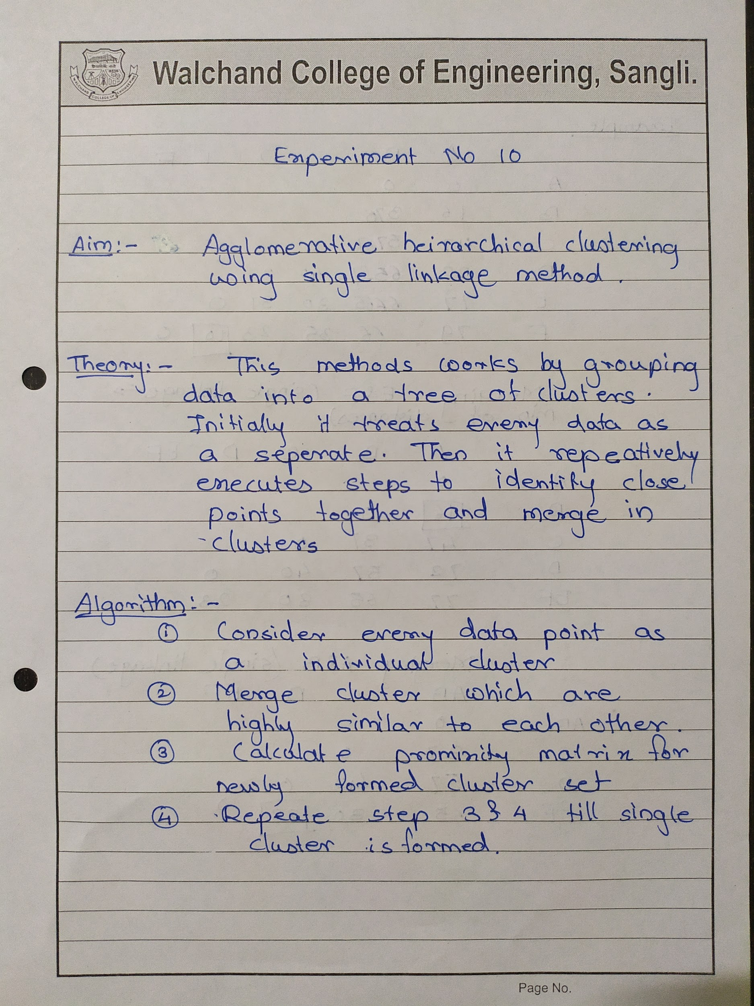

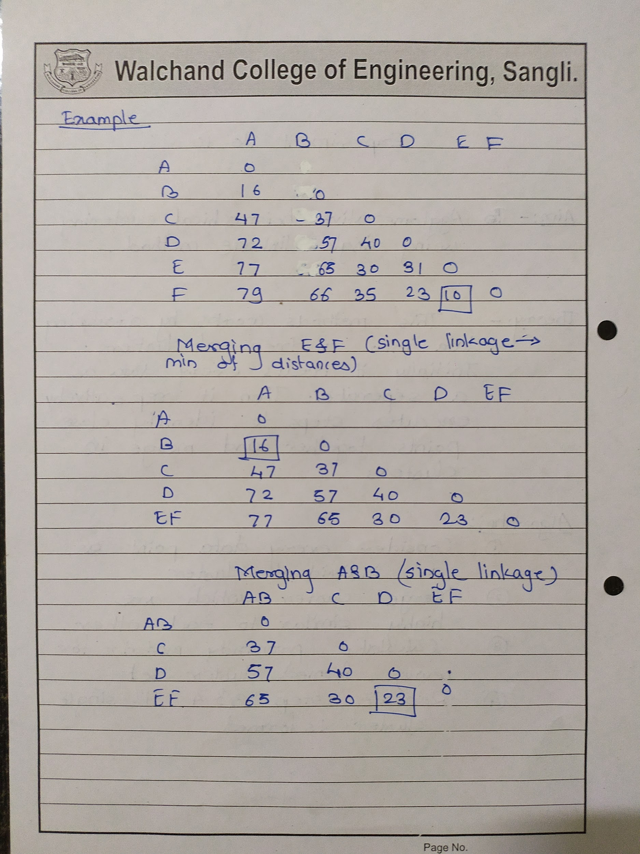

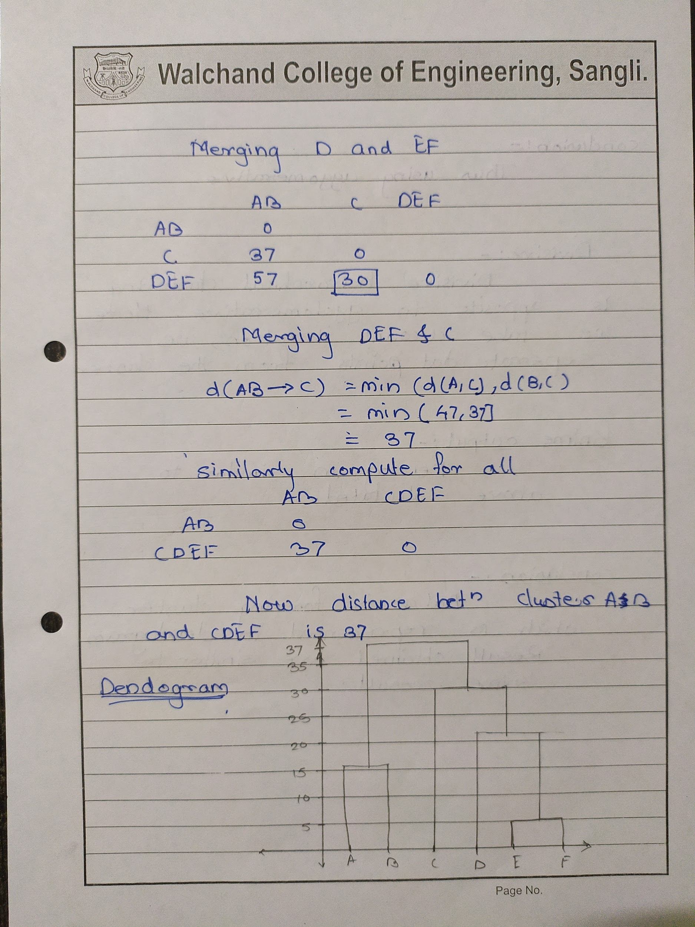

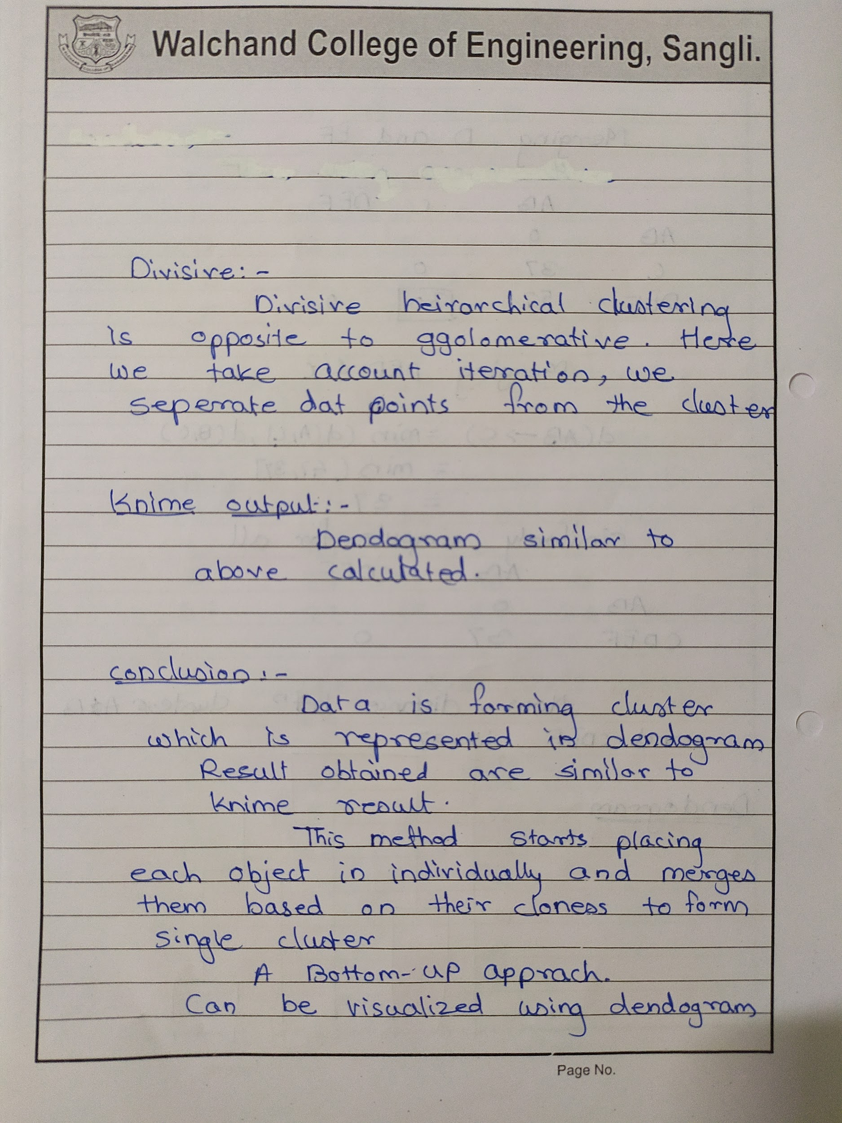

**Code:**

**A.Generate distance matrix from given points**

const xlsx = require("xlsx");

const prompt = require("prompt-sync")();

var wb = xlsx.readFile("data.xlsx");

var ws = wb.Sheets["data"];

var data = xlsx.utils.sheet_to_json(ws);

console.log("data input\n" + data);

console.log(data);

console.log("\n");

var index = 1;

var matrix = [];

var j = 0;

for (var i = 0; i < data.length; i++) {

var obj = {};

for (j = 0; j <= i; j++) {

var eucDist = Math.sqrt(

(data[j].x - data[i].x) * (data[j].x - data[i].x) +

(data[j].y - data[i].y) * (data[j].y - data[i].y)

);

obj["point"] = data[i].point;

obj[data[j].point] = eucDist;

}

matrix.push(obj);

}

console.log("matrix" + index + "\n");

console.log(matrix);

console.log("\n");

var newWB = xlsx.utils.book_new();

var newWS = xlsx.utils.json_to_sheet(matrix);

xlsx.utils.book_append_sheet(newWB, newWS, "matrix" + index);

xlsx.writeFile(newWB, "matrix" + ".xlsx");

**Agglomirative :**

const xlsx = require("xlsx");

const prompt = require("prompt-sync")();

var index = 1;

var wb = xlsx.readFile("matrix.xlsx");

var ws = wb.Sheets["matrix" + index];

var datamain = xlsx.utils.sheet_to_json(ws);

while (index < datamain.length - 1) {

var outputobj = {};

var ws = wb.Sheets["matrix" + index];

var data = xlsx.utils.sheet_to_json(ws);

var minfirst = Number.MAX_VALUE;

var minptsecond;

var minptfirst;

for (var i = 0; i < data.length; i++) {

for (var j = 1; j <= i; j++) {

const key = Object.keys(data[i])[j];

if (data[i][key] != 0 && minfirst > data[i][key]) {

minfirst = data[i][key];

minptfirst = i;

minptsecond = j - 1;

}

}

}

var matrix = [];

var j = 0;

for (var i = 0; i < data.length; i++) {

var obj = {};

for (j = 0; j <= i + 1; j++) {

const key = Object.keys(data[i])[j];

if (key != "point") {

if (

(data[i].point == data[minptfirst].point ||

data[i].point == data[minptsecond].point) &&

j != minptsecond + 1 &&

j != minptfirst + 1

) {

var d1 = Number.MAX_VALUE;

var d2 = Number.MAX_VALUE;

var d3 = Number.MAX_VALUE;

var d4 = Number.MAX_VALUE;

if (data[minptfirst][key]) {

d1 = data[minptfirst][key];

}

if (data[minptsecond][key]) {

d2 = data[minptsecond][key];

}

const key1 = Object.keys(data[j - 1])[minptfirst + 1];

if (data[j - 1][key1]) {

d3 = data[j - 1][key1];

}

const key2 = Object.keys(data[j - 1])[minptsecond + 1];

if (data[j - 1][key2]) {

d4 = data[j - 1][key2];

}

obj["point"] = data[minptfirst].point + data[minptsecond].point;

obj[key] = Math.min(d1, d2, d3, d4);

} else if (

(data[i].point == data[minptfirst].point ||

data[i].point == data[minptsecond].point) &&

(j == minptsecond + 1 || j == minptfirst + 1)

) {

if (

!Number.isNaN(

Math.min(data[minptfirst][key], data[minptsecond][key])

)

) {

obj["point"] = data[minptfirst].point + data[minptsecond].point;

obj[data[minptfirst].point + data[minptsecond].point] = 0;

}

} else if (

data[i].point != data[minptfirst].point &&

data[i].point != data[minptsecond].point &&

(j == minptfirst + 1 || j == minptsecond + 1)

) {

const key1 = Object.keys(data[data.length - 1])[minptfirst + 1];

const key2 = Object.keys(data[data.length - 1])[minptsecond + 1];

if (Math.min(data[i][key1], data[i][key2])) {

obj["point"] = data[i].point;

obj[data[minptfirst].point + data[minptsecond].point] = Math.min(

data[i][key1],

data[i][key2]

);

} else if (

!Number.isNaN(

Math.min(data[minptfirst][key], data[minptsecond][key])

)

) {

obj["point"] = data[i].point;

obj[data[minptfirst].point + data[minptsecond].point] = Math.min(

data[minptfirst][key],

data[minptsecond][key]

);

}

} else {

const key = Object.keys(data[i])[j];

obj["point"] = data[i].point;

obj[key] = data[i][key];

}

}

}

matrix.push(obj);

}

var obj1 = Object.keys(matrix[minptfirst]).size;

var obj2 = Object.keys(matrix[minptsecond]).size;

if (obj1 < obj2) {

matrix.splice(minptfirst, 1);

} else {

matrix.splice(minptsecond, 1);

}

var newWS = xlsx.utils.json_to_sheet(matrix);

index++;

xlsx.utils.book_append_sheet(wb, newWS, "matrix" + index);

xlsx.writeFile(wb, "matrix" + ".xlsx");

}

**Input:**

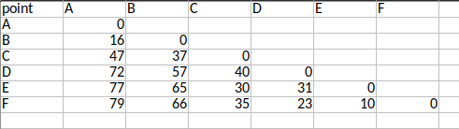

**Output:**

**Matrix 1**

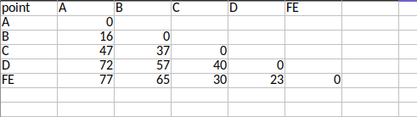

**Matrix 2**

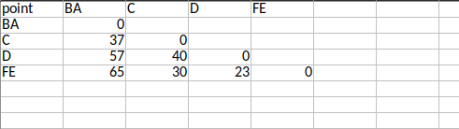

**Matrix 3**

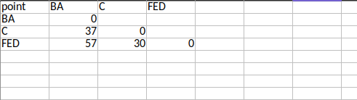

**Matrix 4**

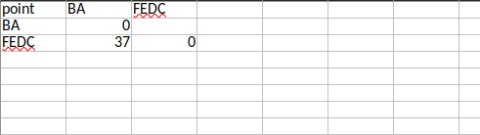

**Knime Dendogram:**

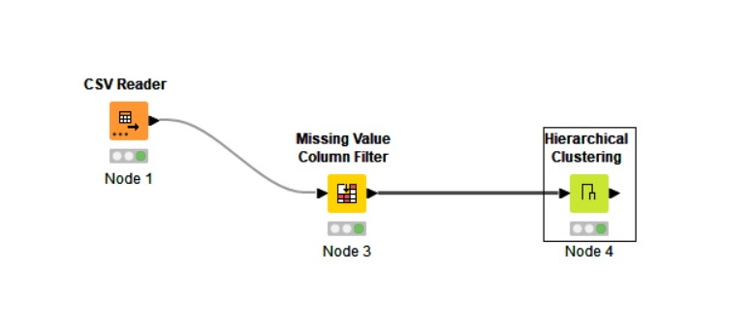

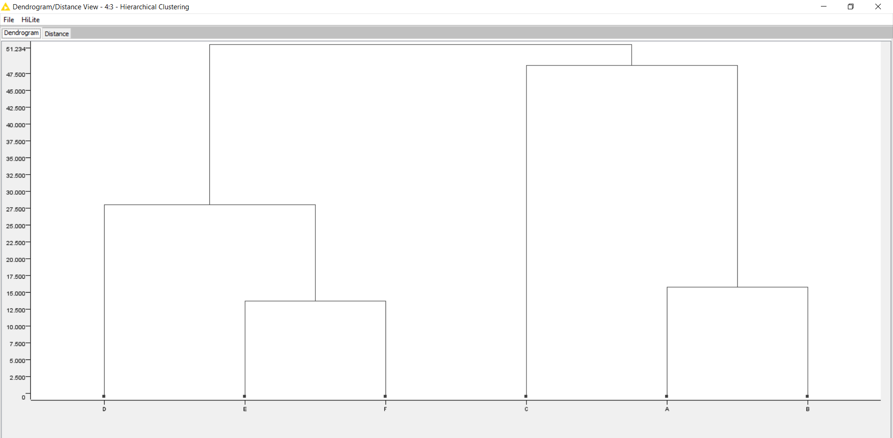

**Conclusion:**

This bottom-up approach places each object in the individual cluster and gradually merges them based on their closeness to form a single cluster. Can be visualized by using Dendrogram.

## Experiment 11

**Attribute for classification, Write a program to find**

**A. Gain**

**B. Gini index**

**For categorical and numerical values**

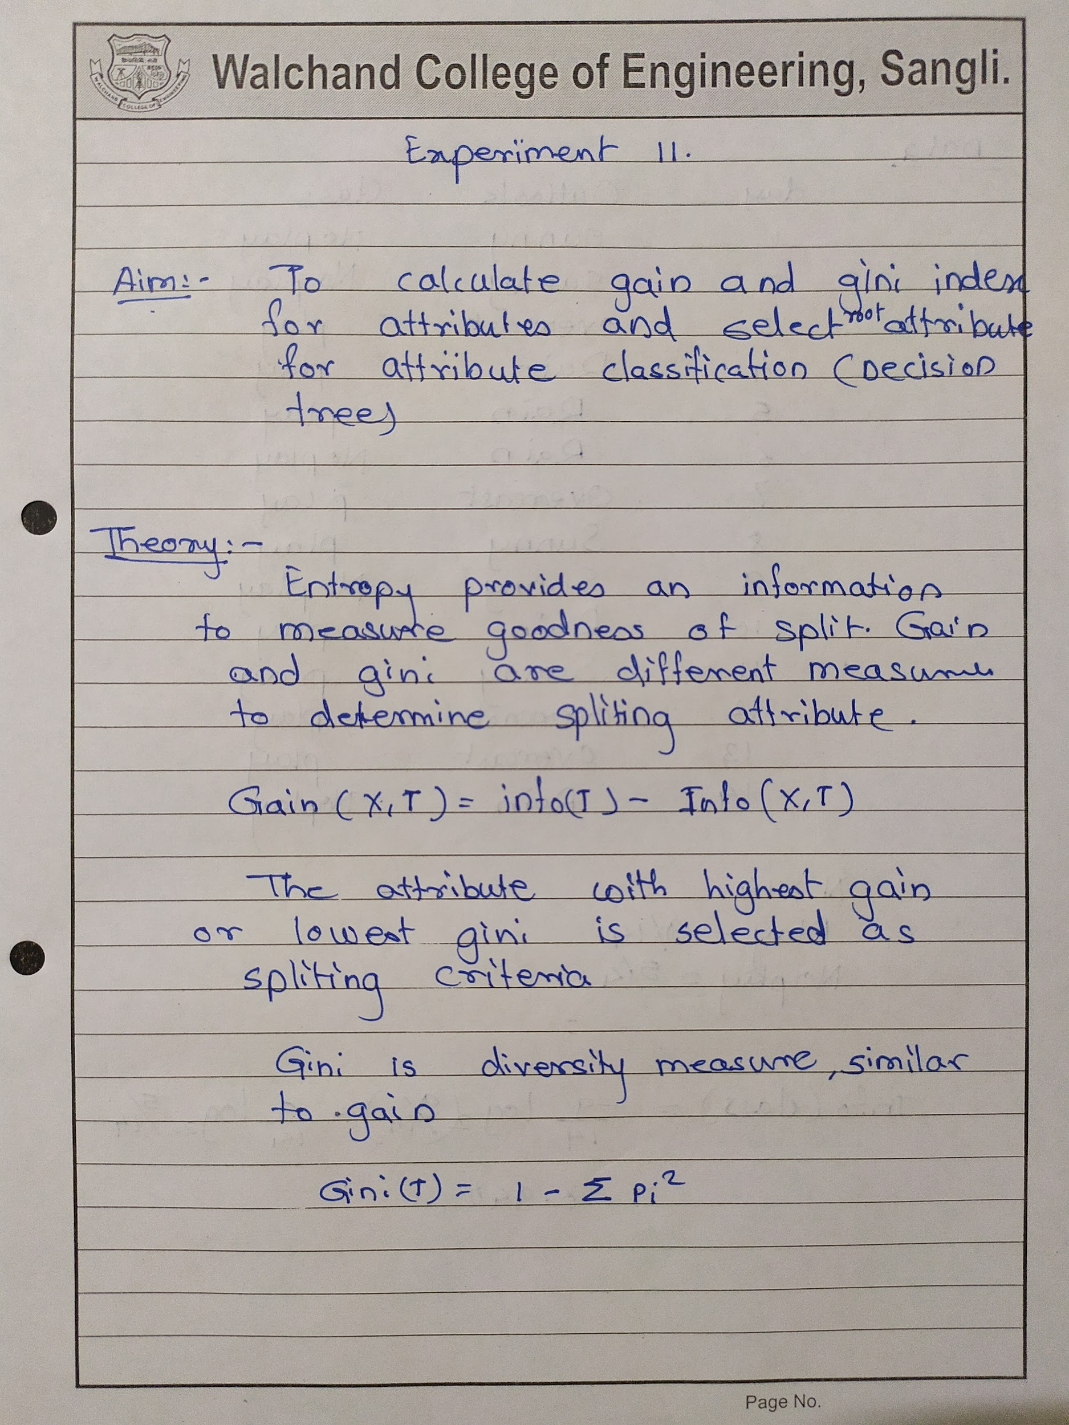

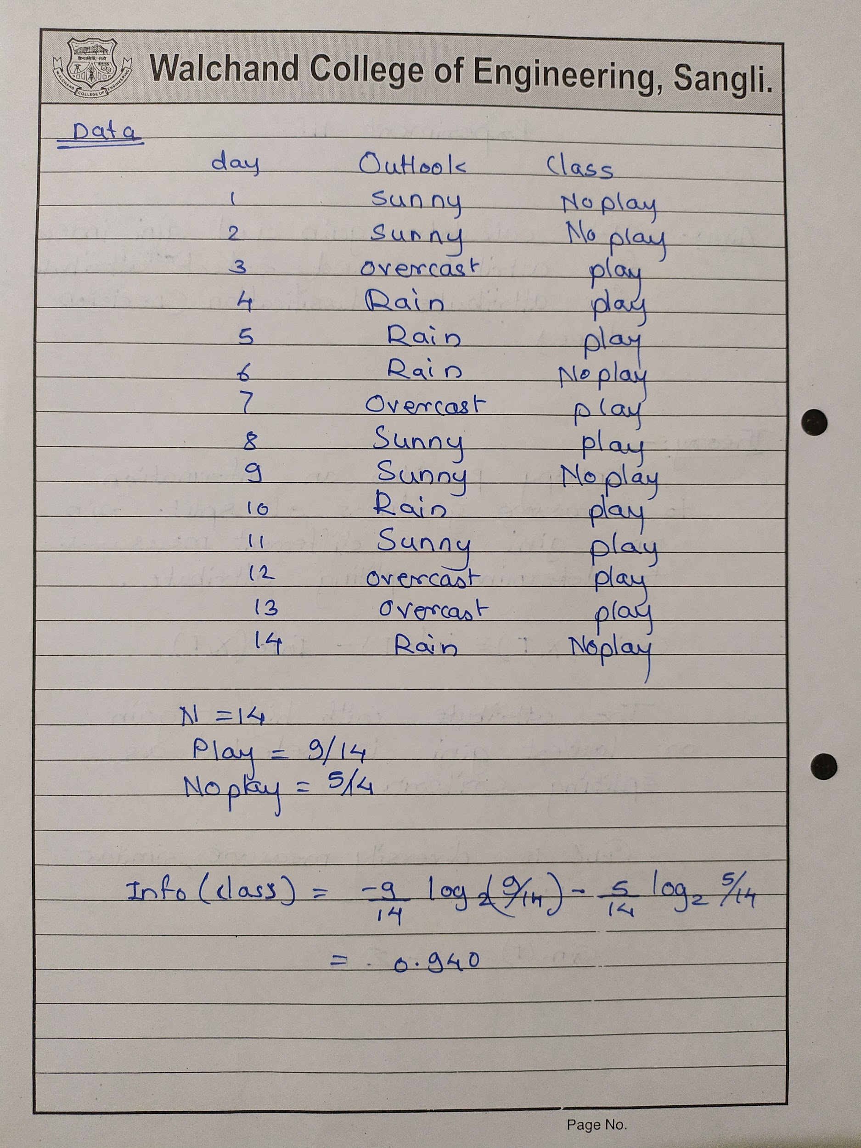

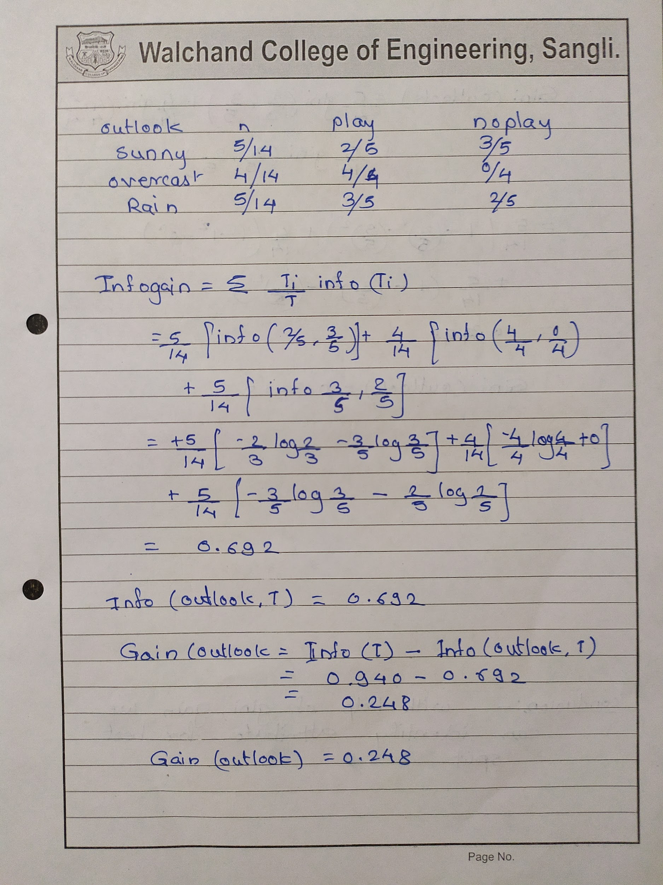

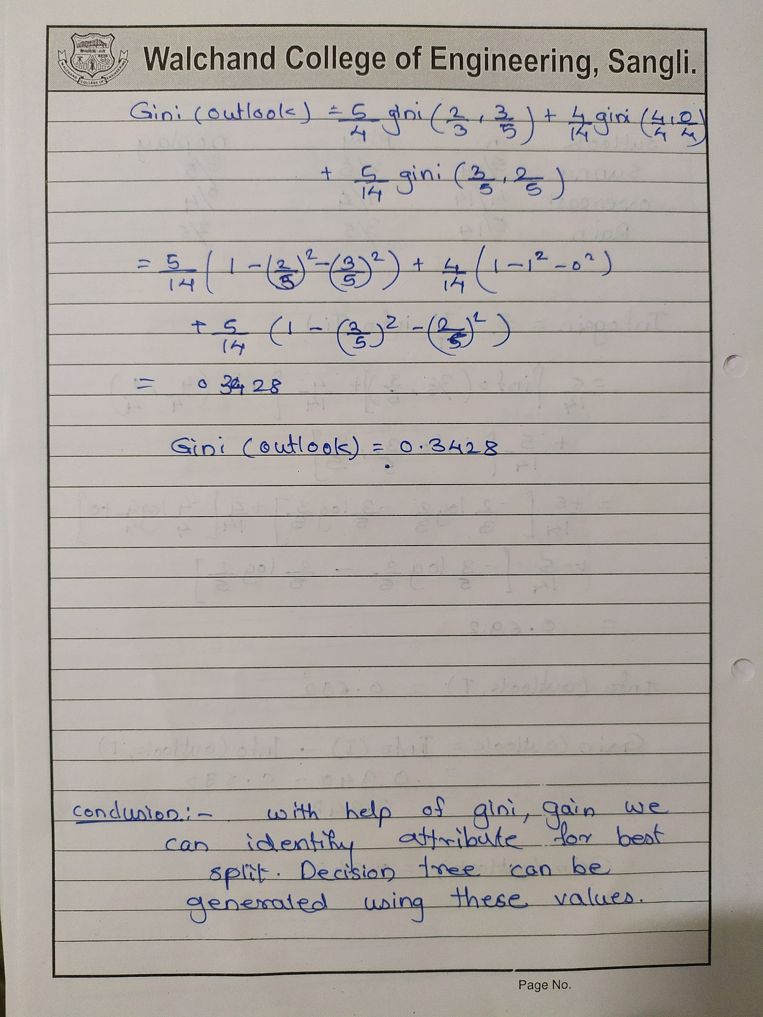

**Code:**

const xlsx = require("xlsx");

const prompt = require("prompt-sync")();

var wb = xlsx.readFile("data.xlsx");

var ws = wb.Sheets["data"];

var data = xlsx.utils.sheet_to_json(ws);

var attri = new Map();

var count = new Map();

for (var i = 0; i < data.length; i++) {

for (var key in data[i]) {

var name = data[i][key] + data[i].class;

if (!count.has(name)) {

count.set(name, 1);

} else {

count.set(name, count.get(name) + 1);

}

if (!attri.has(key)) {

attri.set(key, {});

}

var obj = attri.get(key);

if (!(data[i][key] in obj)) obj[data[i][key]] = 0;

obj[data[i][key]]++;

attri.set(key, obj);

}

}

console.log(count);

console.log(attri);

for (let [key, value] of attri.entries()) {

if (key != "class") {

var gini = 0;

for (attribute in value) {

var temp = value[attribute] / data.length;

var temp2 = 1;

var classObj = attri.get("class");

for (classname in classObj) {

var name = attribute + classname;

if (count.get(name)) {

temp2 =

temp2 -

(count.get(name) / value[attribute]) *

(count.get(name) / value[attribute]);

}

}

gini = gini + temp * temp2;

}

console.log("gini index for " + key + " is " + gini);

}

}

**Input:**

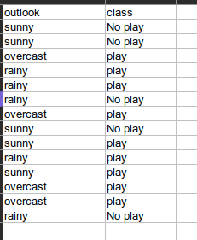

**Output:**

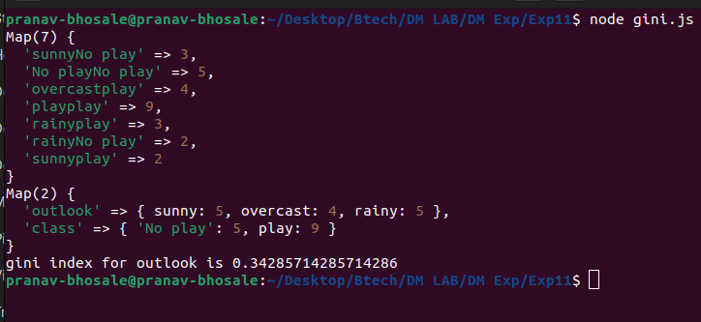

## **Knime:**

## 

## **Decision tree**

## 

## **Weka:**

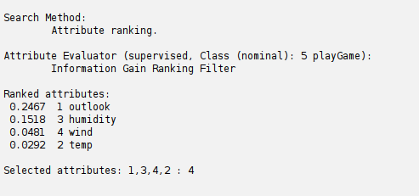

**Conclusion:**

With help of Gini and gain we can identify attributes for the best split.

A decision tree can be generated using these values.

## Experiment 12

**WAP for Baye's classification**

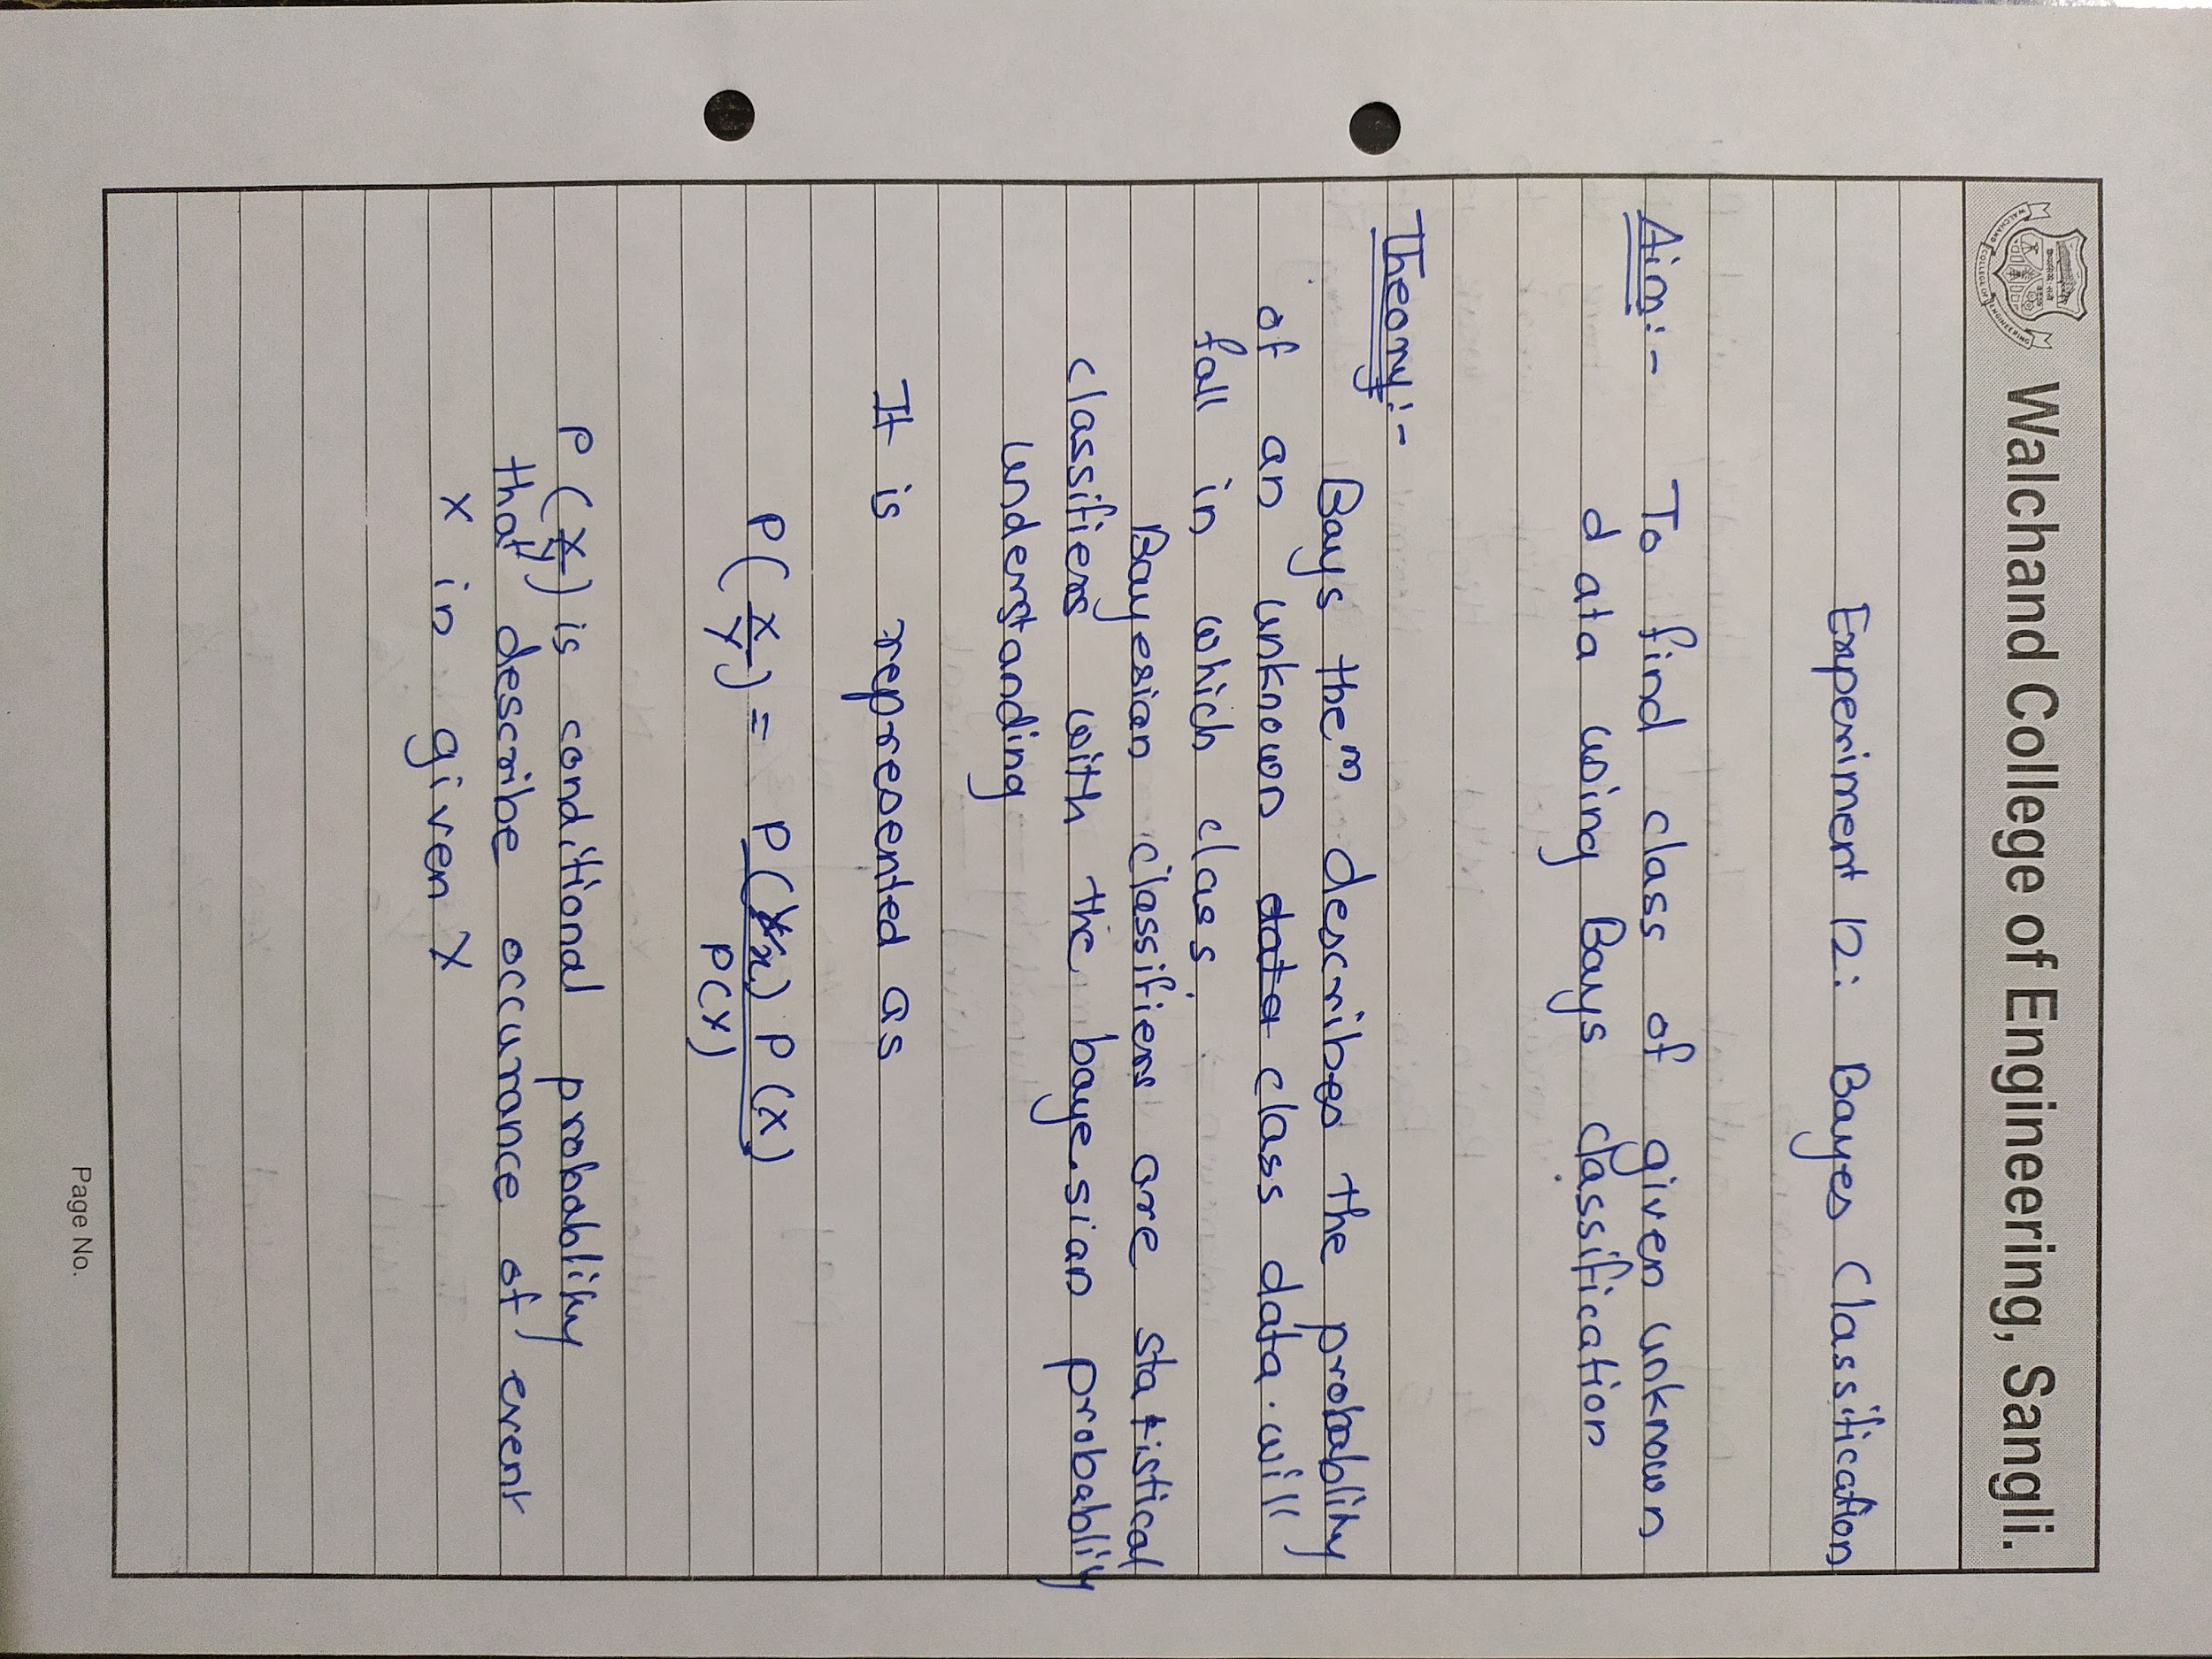

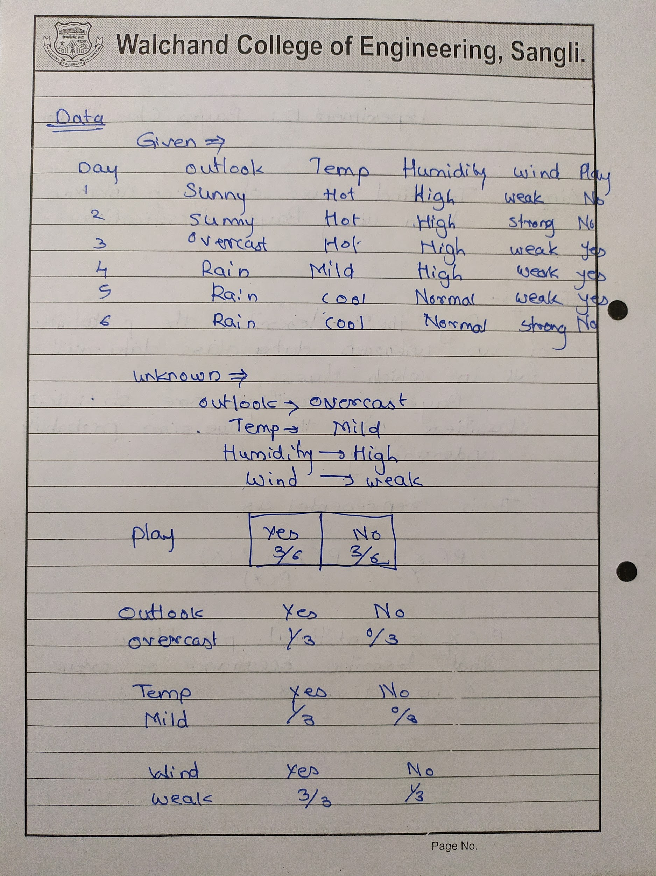

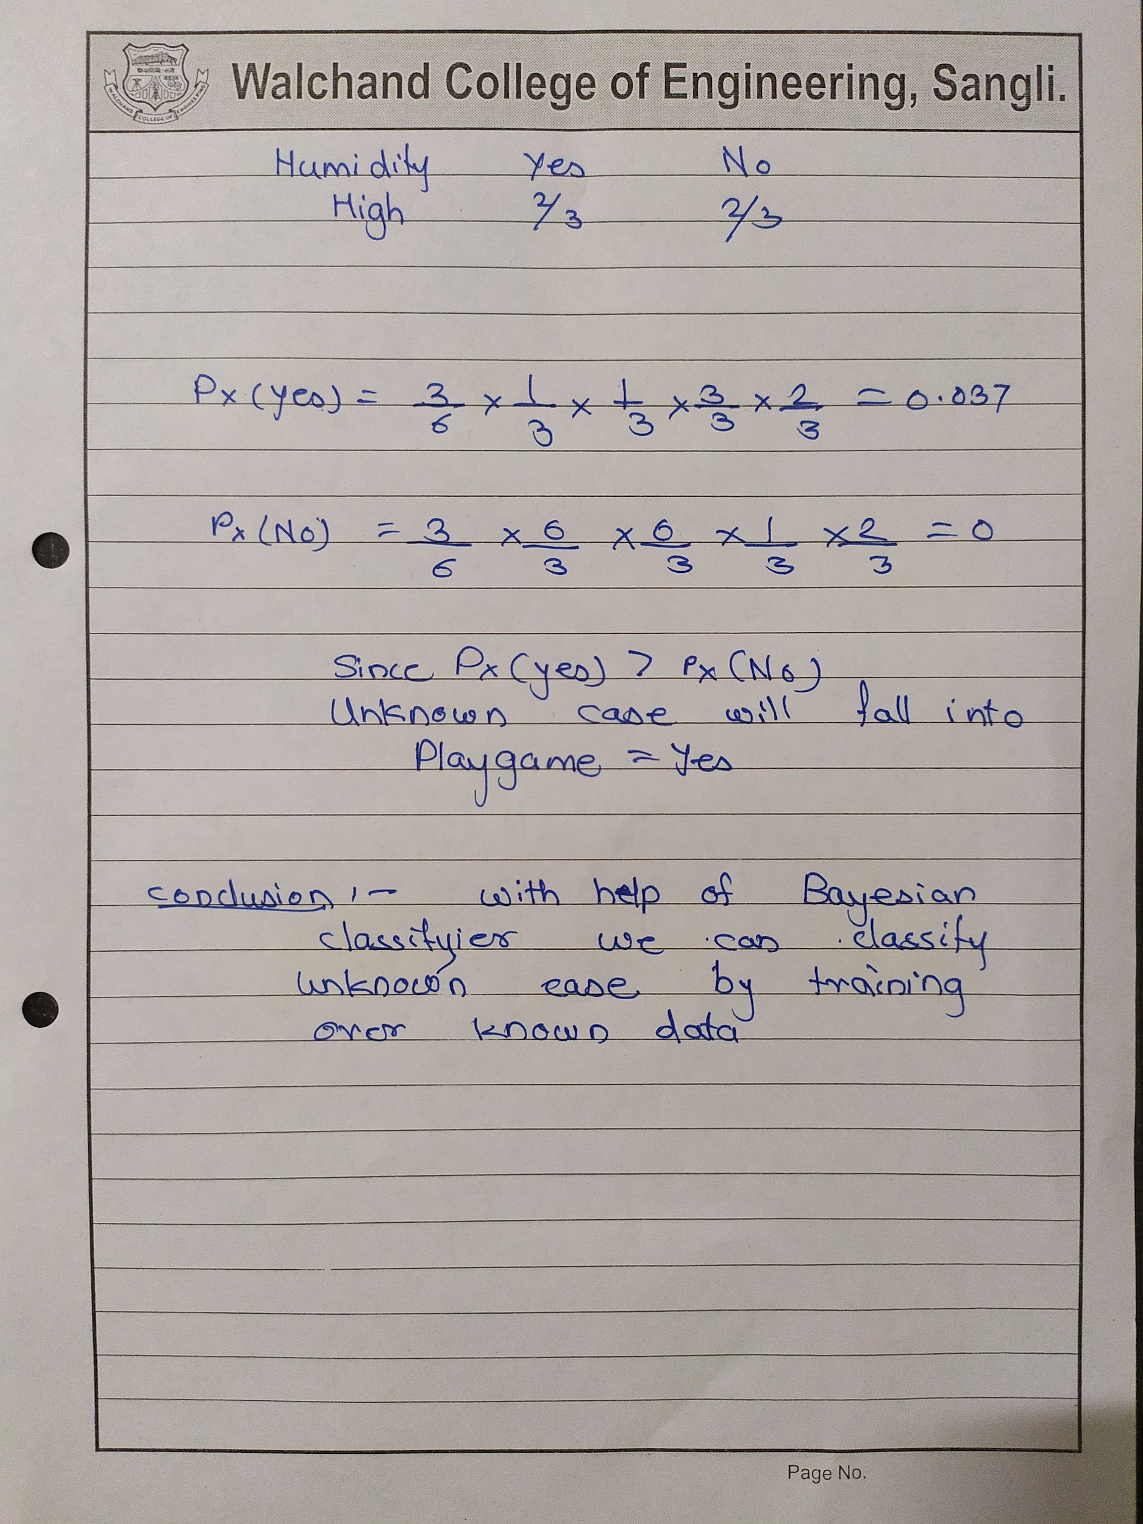

**Code:**

const xlsx = require("xlsx");

const prompt = require("prompt-sync")();

var wb = xlsx.readFile("data.xlsx");

var ws = wb.Sheets["data"];

var data = xlsx.utils.sheet_to_json(ws);

var parentattri = "class";

var obj = {};

for (var i = 0; i < Object.keys(data[0]).length; i++) {

let arr2 = {};

const key = Object.keys(data[0])[i];

for (let i = 0; i < data.length - 1; i++) {

if (!(data[i][key] in arr2)) {

arr2[data[i][key]] = { 1: 0, 0: 0 };

}

var res = data[i][parentattri];

if (res == 0) {

arr2[data[i][key]]["0"]++;

} else if (res == 1) {

arr2[data[i][key]]["1"]++;

}

}

obj[key] = arr2;

}

console.log(obj);

var prob = {};

for (classkey in obj["class"]) {

var value = 1;

var classtot = obj["class"][classkey][classkey];

for (var i = 0; i < Object.keys(data[data.length - 1]).length; i++) {

const key = Object.keys(data[data.length - 1])[i];

value = value * (obj[key][data[data.length - 1][key]][classkey] / classtot);

}

value = value * (classtot / (data.length - 1));

prob[classkey] = value;

}

console.log("====================================");

console.log("probablities");

console.log("====================================");

console.log(prob);

**Input:**

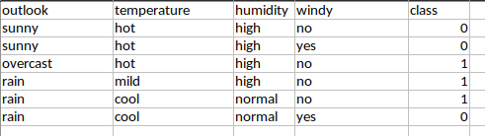

**Output:**

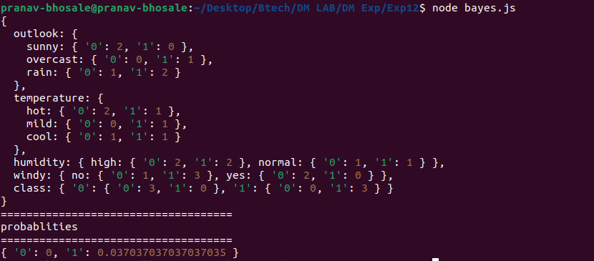

**Weka**

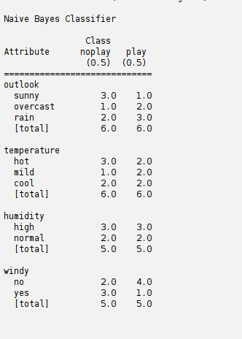

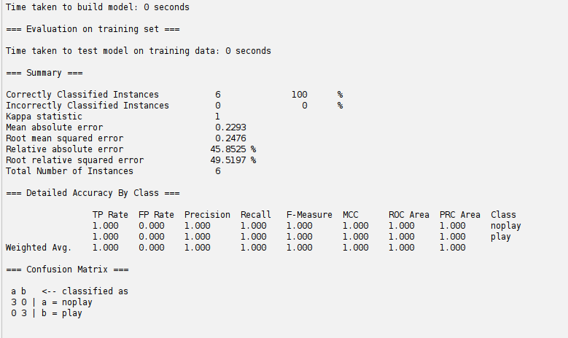

**Knime Output**

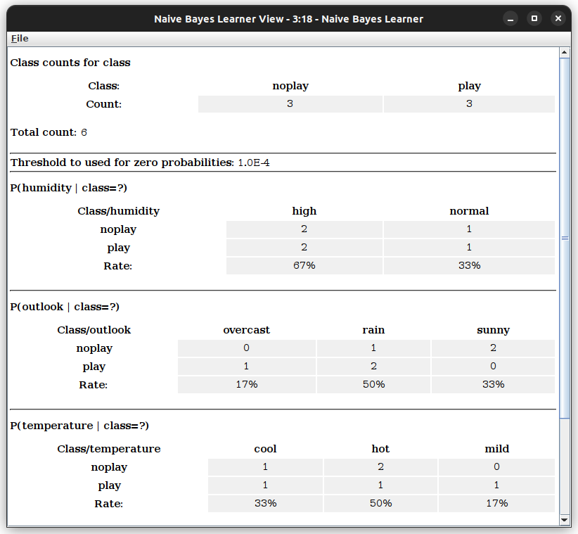

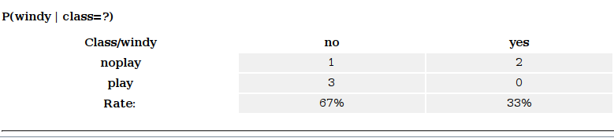

**Conclusion:**

With help of the bayesian classifier we can classify unknown cases by training over known data

## Experiment 13

**WAP a program to implement any DM concept on complex data type**

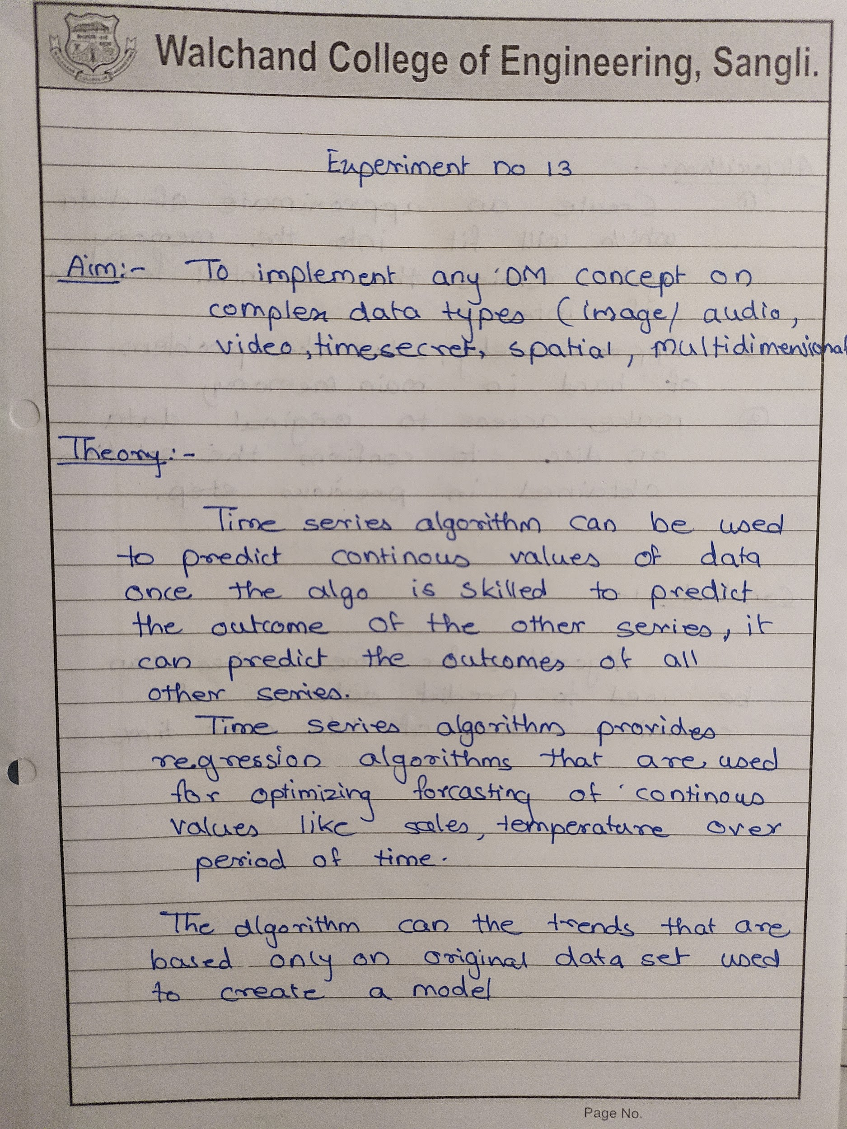

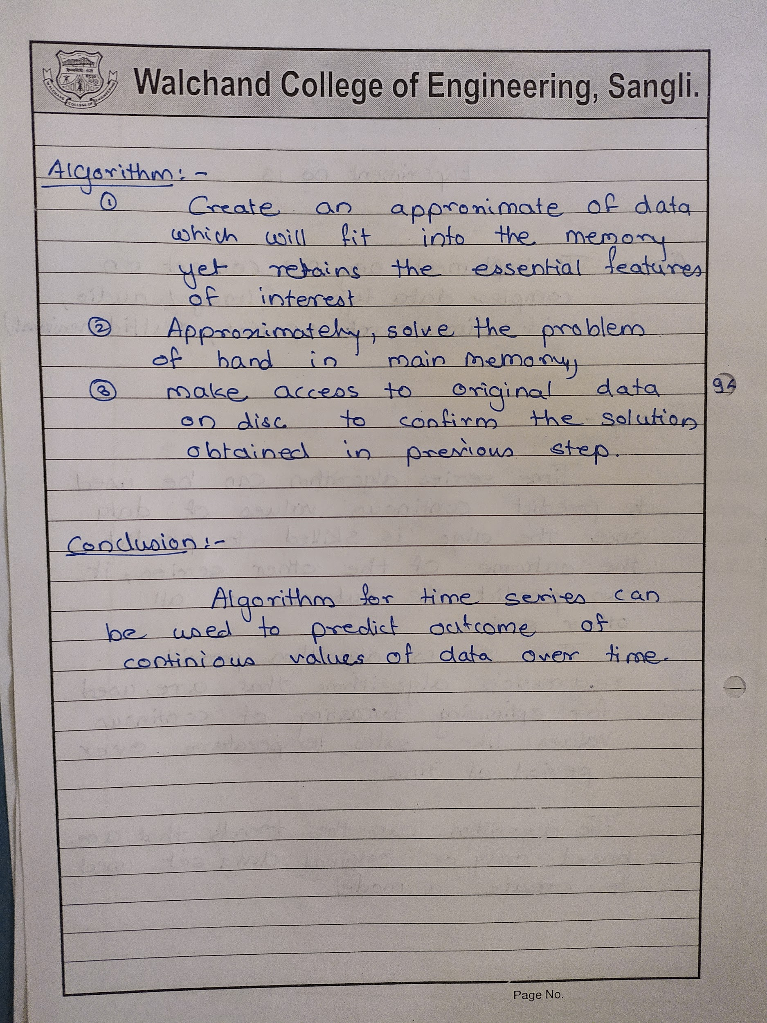

## Homework

**Lab assignment: Top SUVs Data**

